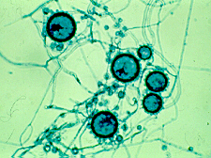**Histoplasma capsulatum**

Coccidioides immitis

**Histoplasma capsulatum**

Blastocyces dermatidis

Malassezia furfur

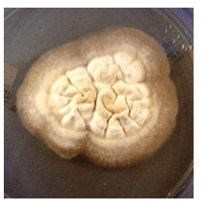

Growth on Blood Agar Blastomyces dermatitidis.

