1 | An MCHC > 37.0 may be an indication of a ___________, requiring the specimen be ___________ .  Cold Agglutinin , Warmed  Short Sample , recollected  Clotted Specimen, recollected |  |  | Explanation  Cold agglutinins cause RBCs to stick together, resulting in a falsely elevated MCHC. Warming the specimen to body temperature (37ºc) will help to reverse the agglutination and yield accurate results.
2 | A PT performed on the ACL TOP/ Elite Pro Instruments yielded a FAILED result. You review the clot curve shown in the image. This abnormal curve is due to which of the following?  Gross hemolysis or unspun sample  Contamination  Icterus  Lipemia | Explanation  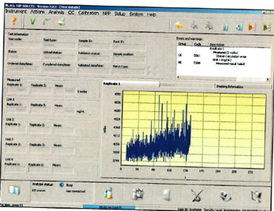  The presence of hemolysis or RBCs interferes with the analyzer’s optical system. The analyzer is unable to determine a baseline, acceleration, deceleration, or endpoint of the reaction.

3 | Provided is a wet mount preparation of a vaginal wet prep specimen. Examine the image and report your findings.  Yeast/ fungi present  Clue Cells present  Trichomonas present |  | 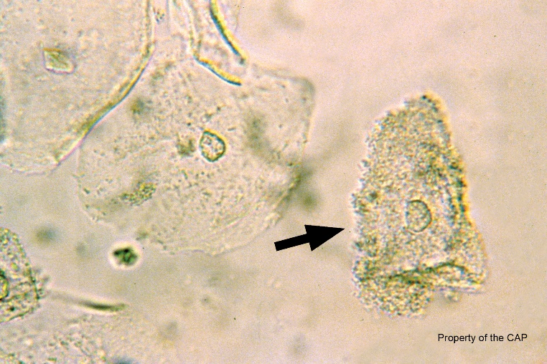Explanation  Clue Cells are squamous epithelial cells with shaggy borders due to the presence of numerous coccobacillary bacteria.
4 | It is acceptable to report an ESR of > 120 as long as the tube has been inspected for label interference, overfilled/ underfilled specimen, or lipemia, and marked settling has occurred.  True  False |  | Explanation  Per HEME.110, results >120 may be accepted if there are no error codes present, no label interference, not over/ underfilled, no lipemia, and marked settling has occurred.

5 | A specimen collected for PFA testing has been sent to the lab via the pneumatic tube system. You should:  Centrifuge and if hemolysis is not present, proceed with testing.  Reject the specimen and request recollection with proper transport to lab.  Centrifuge, remove plasma to a second tube, re-centrifuge, and test. |  | Explanation  Aggravation of platelets can affect the PFA result. Specimens must be hand-delivered to lab. A specimen transferred to lab via the tube system has been shaken and should be rejected.
6 | A background must be performed and verified to be within the established acceptable limits before an automated body fluid count may be performed.  True.  False. |  | Explanation  Background counts are required by CAP as part of Quality Control procedures. If background counts exceed acceptability levels, patient testing should not be performed until the issue is resolved.

7 | Which UMIC result fields require a result to be entered in order for the report to be completed in Soft (select all that apply).  WBC  RBC  Bacteria  Epithelial cells. |  | Explanation  If the RBC and/ or WBC field is left blank, the UMIC report will not finalized and will display as "in-lab" on the instant report. In Epic the result will show as incomplete.
8 | Describe the optimal area on a peripheral smear for microscopic examination.  RBCs are spread out, not touching or overlapping with minimal central pallor visible.  RBCs are touching, but not overlapping. Central pallor visible.  RBCs are touching, overlapping, and central pallor is visible. |  | Explanation  The RBC distribution is indicative of the thickness of that part of the smear. The appearance of RBC morphology may be altered in areas that are too thin or too thick. Larger WBCs may be disproportionately present in the thinner areas of the smear, and thicker areas may make it difficult to differentiate WBCs.

9 | Results have autoverified on a CBCWD when you are notified that the floor mislabeled the specimen. The results are now in the wrong patient’s chart. The correct procedure to follow, in addition to notifying the patient’s physician/ nurse, is to:  Reject the specimen in Soft  Cancel the test in Soft  Change the results to “NA” and type an appropriate comment explaining the situation.  Delete results by replacing with “.DNR” |  |  | Explanation  Once results are on the chart, CAP requires that a corrected report be entered into the LIS. The corrected report must show the original results and the newly corrected results (the new result will be NA when there is no result to replace the wrong result with).
10 |  | While performing a crystal examination on synovial fluid, you have the compensator handle pushed all the way to the LEFT. How would you report your findings?  Cholesterol Crystals  Uric Acid, intracellular  Uric Acid, extracellular  CPPD, intracellular  CPPD, extracellular |  |  |  | 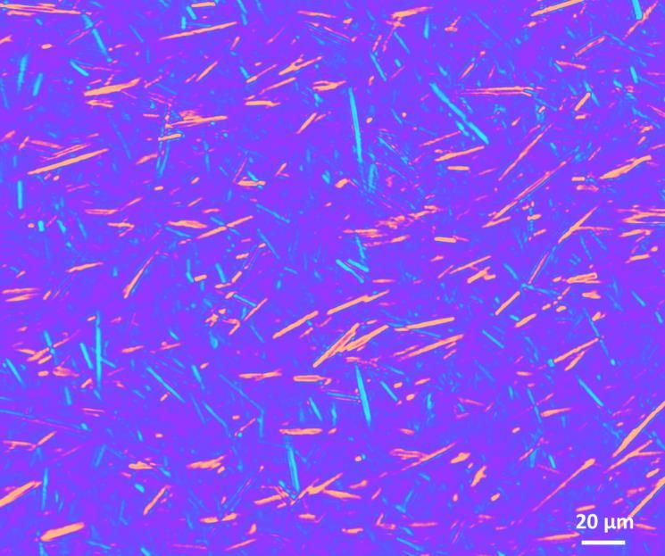  Explanation  The crystals parallel to the compensator axis appear as blue, indicative of CPPD crystals.

11 | You’re performing a UHCG test. There is a line in the “T” region of the test cassette, but there is no line in the “C” region. What should you do?  Report the results. This is the expected result for a positive test.  Report as long as the cassette is not expired.  Repeat testing using a new cassette. |  | Explanation  The absence of a line in the control (C) region indicates the internal quality control has failed. It is not acceptable to report patient results if the control has failed.

12 | The specific gravity of bright orange urines should be resulted. All other results should be reported as Color Interference and a UMIC should be ordered and performed if not already done.  True  False |  | Explanation  Highly pigmented urines from drugs (pyridium, etc.) will likely produce erroneous results through the Clinitek. Only report the color, clarity, and microscopic results.

13 |  | When a PT result is <9.0 and/ or a PTT result is <20.0, the result is:  Acceptable and no further action needs to be taken.  Suspicious and the tube should be checked for a clot. |  | Explanation  These results are highly abnormal, and they indicate the clotting process was already activated before testing began
14 | After viewing 10 fields, it is determined that there are approximately 45% elliptocytes per hpf. What would the best fit for grading be?  1+  2+  3+  4+  occ |  |  | Explanation  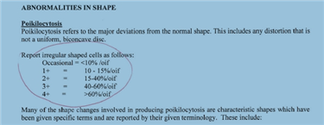

15

Copyright © MTS 2019 |
When changing DXH Cell Lyse reagent, what step must be taken before placing the instrument back into use for patient testing?  Daily Checks.  No action needed.  Run at least one level of 6C QC and comment the reagent lot number/ expiration date. |  | Explanation  The performance of the reagent must be verified by

