# Purpose

The purpose of this document is to describe procedures for microtomy of paraffin-embedded tissues.

# Scope

This procedure applies to all staff, students and researchers who cut tissue sections on microtomes located within the histopathology laboratory.

# Responsibilities

* All staff involved in this procedure are responsible for ensuring that methods are followed in accordance with this document.
* All staff must be aware of the safety aspects of microtome use before performing procedures.

# Definitions

**Level**  A section taken after cutting (facing) an additional 30 microns into the tissue block.

**Deeper** A section taken after cutting (facing) to expose the full face of a block

**Serial** A section taken from the current surface of the tissue block. i.e. no re-facing of the block so that sequential sections are maintained

**Recut** A section taken from the current surface of the tissue block for the purposes of replacing a damaged slide, eliminating artefacts, for special stains, IHC or to provide additional slides for teaching, research or send away.

# Important safety information.

 **Microtome blades are extremely sharp and must be treated with respect. The cutting edge can cause serious injuries. Always focus on what you are doing when cutting sections.**

 **Users must take care to ensure their own safety and the safety of those who work in the area.**

**The following rules must be followed:**

* **Always concentrate on what you are doing whilst trimming blocks or sectioning. Always focus on where your fingers are placed in relation to the knife edge.**
* **Never walk away from a microtome with a blade fitted unless the knife guard is put in place to cover the edge of the blade and the hand wheel is in the lock position.**
* **Never place the knife holder on the bench with a blade in place. Always remove the blade before detaching the knife holder from the instrument.**
* **Always lock the hand wheel of the microtome when fitting or removing blocks from the specimen clamp. Use the knife guard to protect fingers.**
* **Always cover the blade with the knife guard prior to any manipulation of the knife holder, or specimen clamp.**
* **Remove the blade safely: Disposable blades must always be removed using forceps, brush handle or a similar instrument.**
* **A Biological sharps container or used blade receptacle must be kept adjacent to the microtome to reduce the distance that a blade is moved**
* **When cleaning debris from the blade edge always wipe in an upwards motion away from the cutting edge.**
* **Always turn the hand wheel in a clockwise motion otherwise; the brake mechanism will not work properly.**
* **Do not attempt to clamp or orientate the block during the retraction phase. If a block is orientated during retraction, the block will advance by the retraction value PLUS the selected section thickness before the next section. There is a risk in this situation that the specimen will collide with the blade.**
* **Always take precautions when sectioning hard or brittle specimens. Specimens may fracture causing irreparable damage.**
* Do not use any solvent containing acetone or xylene for cleaning the microtome. Use Para-Kleaner or a similar cleaning product designed for paraffin removal.
* Switch the instrument off, ensure the power is off and the blade is removed before applying any liquid cleaners to the microtome.
* When using liquid cleaners, always comply with the safety instructions of the manufacturer.
* Never place containers of liquids on the top of the microtome and ensure liquid does not enter the interior of the instrument during use or when cleaning.

# Microtomy Procedures.

 **It is essential laboratory staff remember every block they cut represents a patient.**

**The quality of slides produced by the laboratory affects the ability of the pathologist to render their diagnosis.**

* A number of rotary microtomes are available for sectioning. Each microtome is provided with a brush, forceps, disposable blades and a heated floatation bath. Rectangular glass dishes for 20% ethanol or cold water are available if required
* Biopsy blocks must be sectioned as soon as possible; however, quality should not be sacrificed for speed.
* Immediately after embedding is completed, blocks are collected from the embedding centre cold plate, arranged in cases, and excess wax is scraped from the cassettes.
* Take care to ensure blocks are not forced from embedding moulds before they are fully set. Premature removal can damage the block surface and lead to residual tissue being left behind in the mould with the potential for cross-contamination.
* Blocks requiring further sections, levels and further stains are retrieved from the files.

**NOTE:** Requests for extra work are placed in the designated compartment of the "Extra Work Requests" box in the Histology Laboratory. Forms may be removed to enter details into computer but should otherwise remain in this box until cut.

* Once blocks are cut, the “Extra Work Requests” are placed in the "Requests To Be Completed" box above the sorting bench. Appropriate notations are made on the forms at each stage of processing.
* The section supervisor is responsible for distributing blocks between rostered microtomists. Microtomy should commence as early as possible, giving priority to urgent and small cases.

## Disposable Blades

Always ensure fingers are kept away from the sharp cutting surface of the blade.

* Slide the trigger to dispense a single blade from the dispenser before returning the trigger to the home position. Do not use force, blades are designed to be easily dispensed

1.  Misuse of the dispenser may result in jamming of the device or the dispensing of multiple blades. Ensure the trigger is drawn all of the way back before returning to the home position at the opposite end of the dispenser. Returning the trigger to the home position engages the release mechanism for optimal dispensing of blades. Should a dispenser become jammed in any way, do not continue to use. Continued use may result in injury.

* Place blade (cutting edge up) into blade holder of the microtome machine and clamp the holder tightly onto the blade.
* When starting a new blade, start sectioning from one end of the blade and as each part becomes blunt work along the length of the blade.
* Used blades may be kept for re-use with block trimming (see below) or cleaned and used in cut-up. Blades for disposal should be placed into the bottom of the blade container that forms part of the blade dispenser or into a SHARPs bin for disposal.
* Disposable blades must always be removed using forceps or a similar instrument. Do not remove the blade holder from the microtome with a blade present or transport the housing with the blade present.

## Block Trimming

* Make sure the handle lock is on and the knife guard is in place before placing blocks into the cassette clamp.
* Place the block into the microtome cassette clamp. Position the face of the block close behind the blade edge. Do this by either moving the blade holder unit back to the block or advancing the block holder to the blade
* Blocks are first trimmed (faced) to expose the full surface of the tissue using a used disposable blade. Great care must be taken when trimming blocks. Use even, gentle strokes, with trimming thickness set at 20 um. Several thin sections should be cut after coarse trimming to remove tissue roughened by the trimming process.
* When facing core biopsies or small biopsies such as endoscopic biopsies or skin punch biopsies take care not to go too deep before taking the first section. It is better to provide levels on the way towards a full face than risk losing diagnostic tissue whilst trimming. If a core does not look flat in the block before trimming starts then take the time to re-embed it.
* Place trimmed blocks on the refrigerated cold plate in numerical order within a case (A1, A2, A3 etc). Allow a block to cool for 10 – 20 minutes before sectioning.
* When all blocks are trimmed and chilled, section cutting can commence.

## Cold Plates

* Place blocks on the cold plate to cool before sectioning. Allow a block to cool for 10 – 20 minutes.
* Ensure blocks from multiple block cases are sorted into order onto the cold plate.
* Clean the cold plate after use to remove any wax, section debris, frost or residual water.
* Take care to ensure towels, request forms or other items do not block vents on the back of cold plates. A blocked vent can cause overheating and can compromise the refrigeration compressor.

## Floatation baths

* Fill floatation baths with deionised water to prevent section contamination with organisms.
* Check the temperature dial is at correct setting. Floatation baths should be set between 5°oC and 10°C below the Melting Point of the wax. For Leica Paraplast, a temperature of 47°C to 49°C is recommended.
* Ensure bubbles are removed from the surfaces of the glass insert by wiping with a Kimwipe before use.
* At the end of the day, ensure water is poured out of the floatation bath. Remove wax debris and dry the inside dried with lint free cloth

## Sectioning

* Scan the block. Just prior to cutting the section, scan the 2D barcode on the block face whilst PTOE function of Pathnet is open on the workstation. Scanning will generate the appropriate slide label(s), which have been ordered for that block

**Note:** Some special staining protocols require adhesive (charged) slides. These are noted in the staining methods and stain protocol lists.

* Ensure the microtome handle is locked in place.
* Insert a new blade into the blade holder and put the blade guard in place.
* Place the block back into the chuck and realign the block with the knife edge. Make sure the knife holder and chuck have been tightened.
* Set the microtome cutting thickness to the appropriate micron setting for the tissue or stain the section is being cut for (see table in 6.5.1 below).Routine sections are cut at 3 μm.
* Release the handle lock and rotate the microtome handle until a full face is achieved. Cut a section using a nick free area of the disposable microtome blade. Move or replace the blade as necessary to ensure sections do not contain artefacts.
* Dispose of unwanted sections using forceps or a brush. Always clean in a direction away from the knife edge.
* Rotate the handle in a steady continuous motion to cut a section.
* Using forceps or a brush, remove sections carefully and place on the floatation bath using a gentle dragging/sweeping motion. Ensure forceps and brush are clean to prevent cross contamination from any previous sections. Always float sections with the smooth (shiny) side down.
* Inspect the section and compare with the block face to make sure there is a full face. If not full face trim deeper or cut a second level. Remove any folds in the section. The use of a separate glass Wheaton dish filled with 20% ethanol can aid in the removal of wrinkle and compression. Float the section onto the 20% ethanol then transfer to the floatation bath using a slide. The surface tension changes will help flatten the section. Leave the section on the floatation bath just long enough to flatten. Over expansion can disrupt morphology in susceptible sections.
* Sections containing large folds or tears should be discarded.
* Individual sections, or groups of sections, may be separated by cutting along the wax junctions with a scalpel prior to floating out, or separated on the floatation bath by teasing with fine forceps or a slide.

## Section Thickness

Some tissues and special stains require a different section thickness. Refer to the table in the Appendix or to the Histology Procedures and Special Stains manual for further details.

## Picking Up Sections

Once a satisfactory section is obtained, pick up onto an appropriately labelled slide. Ensure the slide is of the correct type (plain or adhesive) for the staining required and of the appropriate colour (frosted end) according to case reporting urgency or delegation (see table)

|  |  |  |  |
| --- | --- | --- | --- |
| **Slide Type** | **Slide Frost Colour** | **Application Group** | **Specifics** |
| Plain | Purple | Urgent Cases and core biopsies (except prostate cores) |  |
| Plain | Orange | Neuropath and Neuromuscular Reporting | Cases for CML/SS |
| Plain | Blue | Controls |  |
| Plain | Double Frost/White | Alfred routine | All Alfred routine sections |
| Plain | Green | Northern Routine | All NPV routine sections |
| Adhesive | White (Dako) | IHC | All sections for IHC |
| Adhesive | White (Menzel / Matzunami | Specials, Bone, VNLS | Retic, LFB, |

* Slide label(s) generated by scanning the block or printed from PTOE are attached to blank slide(s) on the frosted end.
* Handle the slide with care and avoid touching the surface of the slide to prevent fingerprints and transfer of squamous cells.
* Pick-up flat, wrinkle free sections onto a clean, labelled microscope slides. To pick the section up, hold the slide at the top and immerse the slide in the water close to the section. Slope the slide away from the section and advance the slide gently until it encounters the section. Avoid dipping fingers into the water.
* Keeping the slide sloped away from the section; lift the slide slowly out of the water. The section will adhere to the slide as it is lifted from the floatation bath. Make sure to pick up the section onto the correct side of the slide, as some slides (eg adhesive) have a front and back orientation.
* Position sections centrally on the slide. Avoid placing on the very edges by leaving a 3mm margin on each side. Where multiple slides are prepared from one block the positioning and orientation of sections must the same across all the slides.
* **A cross check of the block labelling details (case accession, patient name and block number) against the slide label must occur after section pick up.**
* **In PTOE, scan the labelled slide to match the slide to the block.**

## Avoiding Cross Contamination and Case Mismatch

To avoid any risk of contamination or mix up of specimens the following procedures must be followed:

* + Alert the histology supervisor to any block with a block face defect which suggests tissue may remain adherent to the base mould used at embedding. It is essential for staff to raise an alert to the potential of a contaminated base mould and the potential for cross contamination of another block.
  + During sectioning, sections from only one block at a time are to be floated out on a floatation bath. Never park sections on the floatation bath and move to another block.
  + The surface of the floatation bath must be skimmed with a Kimwipe, between sectioning different blocks.
  + Skim the surface of the 20% alcohol water dish between each block where an alcohol dish is used.
  + Change the water in the floatation bath if it displays any evidence of contamination with organisms
  + Regularly wipe the tips of forceps to remove wax and tissue debris. Do the same for brushes. Be mindful of the potential for cross contamination of tissue between cases from tissue debris inadvertently being picked up onto slides.
  + Wherever possible, print labels on demand through scanning the barcode at the point of sectioning. Avoid the use of pre-printed label rolls if possible
  + Always check slide labelling details (accession, name and block number) against the block that has just been cut, before moving to the next block.
  + Never pick up a diagnostic section onto a blank unlabelled slide.

## The Importance of Section Orientation on the Slide

Considered and consistent orientation of tissue on the slide is an important component of quality work.

* Sections should be mounted centrally on the slide.
* Serial sections or levels should be mounted consistently with respect to both position and orientation.

In the image below, each of the 20 slides represents a serial section in a tumour identification case. Note how sections are placed at the top, middle, or bottom of slide. Note also, how the tissue has no standard orientation, being placed horizontally, vertically, diagonally and rotated 90° through to 180 °.

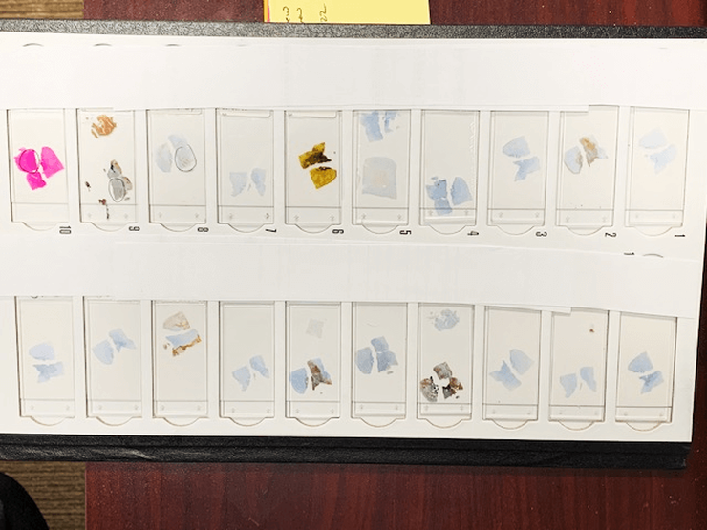

There are multiple reasons to avoid this practice.

1). Poor staining. Tissue can stain inappropriately where a section is placed too close to the label end, or too close to the edge, particularly if automated staining instruments are used.

2). Poor mounting. Tissue can fall outside of the coverslip zone, tissue can also be obscured by excess mountant at the edge of the coverslip or by the edges of the coverslip itself.

3). Difficulty in locating areas of interest. A pathologist does not order levels, special stains or immunohistochemistry for no reason. They are trying to identify something in a particular area of the tissue. When randomly placed on the slide, it takes more time for the pathologist to find the appropriate area. Putting the section in the same location consistently assists diagnosis and improves reporting efficiency and accuracy.

4). It looks unprofessional. Using consistent orientation on each slide demonstrates a higher level of skill from the scientist cutting the case and consideration for the pathologist and patient.

## Cutting Levels

### **Definitions of Deeper Sectioning**

It is essential that the language around additional section cutting is standardised and understood. If in doubt check with the requesting pathologist as to what they require.

* **Level**  A level is a section taken after cutting (facing) an additional 30 microns (10 turns of the microtome handle) into the tissue block. The first level starts from the first full face section that can be cut and allow for realignment of the block.
* **Deeper** A section taken after cutting (facing) to expose the full face of a block. Generally, this would start at approximately 40 microns but will be case specific.
* **Serial** A serial section is taken from the current surface of the tissue block. i.e. there is no re-facing of the block or trimming to a deeper level before taking a section. Sequential sections are produced and mounted such that each section represents a section only 3 micron deeper than the previous.
* **Recut** A section taken from the current surface of the tissue block for the purposes of replacing a damaged slide, eliminating artefacts, for special stains, IHC or to provide additional slides for teaching, research or send away
* **Cut Through**  If the pathologist orders the block to be cut through, always ask them how many slides they want and space them accordingly. A cut through request is a serious request that will exhaust tissue in a block. Always confirm this is the intention.

 With all requests for additional sections, if the lab staff senses the request will exhaust the tissue in the block, then communicate that to the pathologist before cutting.

### **Routine Levels by Specimen Type**

Particular specimen types require levels and special stains to be cut according to routine panels. See tables in the Appendix for specific requirements for set specimen types

### **Routine Levels onto the One Slide**

In order to reduce slide numbers, certain small biopsies have levels placed onto the one slide. It is important that the position of the levels is consistent. Position sections down the slide starting with the first level at the top.

In order to ensure correct labelling, the use of single slides levels must only occur for appropriately defined specimens. Slide labels will indicate the levels on each slide.

As Cerner assigns each new slide as a level, this will mean that any additional specials or IHC slides will not necessarily not reflect the true level that the tissue is at.

### **When to Avoid Serial Sections on One slide**

At times it is important not to cut serial sections onto one slide. When cutting lymph node clearances (eg colon, stomach, etc) do not cut serial sections. Cut one section only. The node count is important for reporting purposes. The presence of serial sections makes the total lymph node count harder to interpret.

## Drying Sections

* Transfer slides to a slide drying warming plate and leave until collected for staining. The temperature should be adjusted so the wax does not melt when the slide is supported in an inclined position.
* Slides for routine H & E staining are collected into staining racks then dried at 60oC for 10 minutes before staining.

Note: The Autostainer features an in-built heated chamber that can be incorporated in the staining schedule. Program 10 incubates the sections at 60oC for 10 minutes prior to staining.

* Sections for special stains are collected into steel staining racks and grouped with the control sections for staining by the Scientist rostered on special stains.
* On completion of cutting, all blocks are arranged in numerical order on the sorting bench.
* Core biopsies and small specimens such as cardiac’s, transbronchial bx should be re-cut on the same microtome as original to reduce tissue loss.

**Important Note:**

* + Sections dried on the slide drying benches for several hours do not require heating in the oven prior to staining.
  + Sections should not remain in the 60oC oven for more than 1 hour.

## Sectioning Hard and Difficult Specimens

### **Brain sectioning:**

* Reduce the flotation bath temperature to 40 oC to reduce the splitting and over-expansion of sections.
* Charged slides provide improved adhesion of brain sections and should be used for H&E, special stains and IHC.
* Brain sections from necropsy blocks adhere better if left to dry in the 37°C oven overnight before staining.

### **Hard Tissue Sectioning**

Sectioning hard tissue such as tendon, keratin masses and dense fibrous tissue may encounter problems such as -

* + Excess compression
  + Only part of the block cuts
  + Alternate thick and thin sections
  + Block detaches from cassette mount.

These problems may be overcome by applying a softening agent (Molliflex) to the block face for 5 - 10 minutes before sectioning.

### **Sectioning Nail**

* Nail may be softened in Nair and fixed in Neutral buffered formalin overnight.

### **Sectioning Calcified tissue**

Calcified foci may go unnoticed during macroscopic examination of the specimen but become apparent during microtomy and require surface decalcification. Surface decalcification is achieved by immersing the blocks in decalcifying solution (10% nitric acid) for 15 - 30 minutes. After rinsing with water several sections may be cut before further calcified tissue is exposed.

### **Sectioning Blood Clot**

Tissues containing blood clot often fragment on sectioning. A piece of facial tissue damped with water applied to the block face for 5 minutes will improve results.

### **Sectioning Brittle Specimens**

Brittle specimens such as thyroid or over processed specimens may produce micro-chatter when cut: To overcome this problem;

* Face into biopsy block
* A piece of facial tissue damped with water applied to the block face for 5 minutes will improve results
* Soaking the block in Molliflex may also help if the tissue is brittle and hard.

## Molecular Sectioning

Precautions must be taken when sectioning blocks to produce scrolls or slides for molecular (PCR and ISH) testing. Eliminating potential contamination by foreign DNA or RNA derived from the person cutting the block or through debris from other patients is essential.

* Tissue for molecular testing sourced from the Anatomical Pathology files must have an appropriate tumour block selected by a pathologist on review of the H&E slide.
* The amount of tissue required for testing depends on the test itself. Refer to the Pathology handbook for details regarding the number and thickness of sections required and if slides or scrolls are preferred.
* Tissue samples should be cut on the dedicated microtome in the immunohistochemistry laboratory if possible using a clean-cut technique. DNA/RNA denaturing reagents (DNA/RNA zap) are used to decrease the possibility of nucleic acid contamination during sectioning.
* A fresh clean disposable microtome blade must be used for each case. Gloves must be worn during sectioning. Forceps and brushes must be clean (dewaxed and rinsed in RNA zap).

### **Tissue Scrolls for Molecular**

* 8-10 tissue rolls of 12µm each are collected into a labelled PCR tube (specific RNAase free tubes are required).
* Tubes are placed into a biohazard specimen bag with a copy of any paperwork.
* Ensure accurate patient identification is on the tubes and external surface of the bag

### **Sections on Slides for Molecular**

* 10 Single sections cut at 10 µm (if the amount of tissue in the block allows) each are picked on to clean labelled slides. Floatation bath must be clean and fresh water used (use of a clean Wheaton dish inserted into the waterbath is preferred).
* Waste sections are NOT permitted to remain in the waterbath. Remove unused sections with a clean Kimwipe
* Paraffin sections must be dried at 37oC overnight. Drying at 60 oC must be avoided.
* Once dry, slides must be placed into a clean cyto-mailer (use gloves and don’t over handle) and into a biohazard bag with a copy of any paperwork. Ensure accurate patient identification is on the slides and external surface of the bag

# Embedding Problems

If prior to sectioning or whilst performing sectioning itself it is apparent that a block is poorly embedded, has cracks or holes, poor adhesion to the cassette base, has poorly infiltrated (processed) tissue, loose tissue in the wax, contains staples, contaminants or other issues; it must be brought to the attention of the section supervisor.

Re-processing or re-embedding of tissue must always be considered in preference to producing a suboptimal section.

# Maintenance of the Microtome

Knife holders are required to be kept clean and free of section debris between blocks to ensure cross contamination of sections does not occur.

Use a brush or tissue to remove debris and always clean in an upward motion away from the blade edge.

* Thorough cleaning of the microtome, including the knife holder and universal cassette clamp, should be performed at the end of each day.
* A thorough clean which includes dismantling the knife holder and universal cassette clamp should be performed at least one per week (see appendix 3).
* Lubrication of the instrument should be done once per month (see appendix 4)

Refer to the manufacturers “User Manual” for full instructions on the operation of the instrument. Manuals are located in the Equipment Maintenance and Records cupboard. PDF versions of user manuals are also located on the Pathology Server

(H:\AAA_Operations\UNIT_Anat_Path_o\AP Admin_Equipment_Maintenance & Manuals\Microtomes & Cryostats\User Guides)

# References

* Bancroft J.D., and Gamble M. Theory and Practice of Histological Techniques, 6th Edition (2008) Churchill Livingstone, Elsevier Limited
* Leica RM2245 User Guide
* Microtomy and Paraffin Section Preparation, Leica Scientia Education Series
* Microtome Use and Cleaning, SuRF-HIS-005.02, The University of Edinburgh

# Appendix

## Section Thickness for Specimen Types

|  |  |  |
| --- | --- | --- |
| **Tissue** | **Thickness** | **Comment** |
| Brain biopsy | 5 μm | Use adhesive slide |
| Brain Post Mortem | 5-7 μm | Use adhesive slide |
| Lymph Node | 2 μm |  |
| Renal | 1 to 1.5 μm | Varies according to stains in the renal panel.  Refer to Renal procedure in the histology manual |
| Tonsils | 2 μm |  |
| All other routine tissues | 3 μm |  |

## Section Thickness for Histology Special Stain Types

|  |  |  |  |
| --- | --- | --- | --- |
| **Special Stain** | **Thickness** | **Special Stain** | **Thickness** |
| AB & ABPAS | 3 μm | Orcein Giemsa | 3 μm |
| Aldehyde Fuchsin | 3 μm | Orcein Masson | 3 μm |
| Carmine Bests | 3 μm | PAS | 3 μm |
| Colloidal Iron | 3 μm | PASM (renal) | 1.5 μm |
| Congo Red (Renal) | 5 μm | PASM-MT (renal) | 1 μm |
| Congo Red (Cardiac) | 3 μm | Perls (iron) | 3 μm |
| Copper | 3 μm | Perls (asbestos) | 10 μm |
| CAE (Leders) | 3 μm | Picro Sirius Red (collagen) | 5 μm |
| Garvey Silver | 10 μm | Retic | 5 μm |
| Giemsa | 3 μm | Sirius Red (amyloid) | 5 μm |
| Glees silver | 8 μm | Toluidine blue | 3 μm |
| Gram | 3 μm | Van Gieson | 3 μm |
| Grocott GMS | 3 μm | Verhoeff elastic | 3 μm |
| Halls Bile | 4 μm | Wade Fite | 3 μm |
| Luxol Fast Blue | 10 μm ++ slide | Warthin Faulkner (spiro) | 3 μm |
| Masson | 3 μm | ZN | 3 μm |
| Mucicarmine | 3 μm |  |  |
| Orcein (Hep) | 3μm |  |  |

## 10.3 Section Thickness for IHC Stains

|  |  |  |  |
| --- | --- | --- | --- |
| **Antibody** | **Thickness** | **Antibody** | **Thickness** |
| Her2 ish | 4 μm | Send away slides | Laboratory and test dependant |
| 1p19Q FISH | 5 μm | All other IHC slides | 3 μm |
| Skin IFs | 4 μm |  |  |
| Renal Panel | 1.5 μm |  |  |

## Routine Levels & Specials by Specimen Type

|  |  |  |  |
| --- | --- | --- | --- |
| **Specimen** | **Description** | **Protocol** | **PTOE Code** |
| Artery | Temporal | Levels x5: H&E L1,2,3,4, OG L5 | GS TART |
| Artery | other | H&E + OG | SS OG |
| Bladder bx | Bladder Bx | Levels x3 | SS H&E L1-3 |
| BMT | Routine | H&E x2, Retic | GS BMT |
| BMT | Lymphoma | H&E x2, Retic, H&E X2(L4, L5) | GS BMTL |
| BMT | Immuno-compromised | H&E x2, Retic, ZN, Fite, PAS | GS BMTH |
| Bronchial bx | TBBX | Levels x3 | GS BROB |
| Cardiac bx | Transplant | See [CD_AP_0036](http://AHSHAREDAPP02/Fasttrack/Portal/CD_AP_0036.docx) | GS CARB |
| Cardiac bx | Diagnostic | See [CD_AP_0036](http://AHSHAREDAPP02/Fasttrack/Portal/CD_AP_0036.docx) | GS CARD |
| Cell block | Cytology | Levels x1 | 1B 1L |
| Cervical bx | Cervix routine | Levels x3 | SS H&E L1-3 |
| Endoscopic bx | Oesophageal | Levels x3, ABPAS (L3) | GS OESB |
| Endoscopic bx | Gastric | Levels x3 | SS H&E L1-3 |
| Endoscopic bx | Duodenal | Levels x3 | SS H&E L1-3 |
| Endoscopic bx | Small intestinal | Levels x3 | SS H&E L1-3 |
| Endoscopic bx | Colonic | Levels x2 | SS H&E L1-2 |
| Endoscopic bx | Rectal | Levels x2 | SS H&E L1-2 |
| Liver Core bx | Routine | H&E x 2, Liver specials (Pas, PasD, PPB, Masson, Orcein, Retic) | GS LIVB |
| Liver Core bx | Tumour or mets | Levels x2 | SS H&E L1-2 |
| Liver Core bx | Research | H&E, O-Ma | GS LIVR |
| Needle Core | Tru-cut | Levels x2 | SS H&E L1-2 |
| Renal Core bx | Native | 24 slides. See [CD_AP_0036](http://AHSHAREDAPP02/Fasttrack/Portal/CD_AP_0036.docx) | GS RENB |
| Renal Core bx | Transplant | 13 slides. See [CD_AP_0036](http://AHSHAREDAPP02/Fasttrack/Portal/CD_AP_0036.docx) | GS RENT |
| Sentinel LN | Breast SLN | Levels x 3 | LVL3 |
| **Specimen** | **Description** | **Protocol** | **PTOE Code** |
| Sentinel LN | Melanoma SLN | Levels x3 H&E, Levels x3 Melanoma mix | GS SLNM |
| Skin bx - punch | Inflammatory | Levels x4, PAS (L2)  H&E separate slides | GS SKPB |
| Skin bx - punch | Non-inflamm. | Levels x2  H&E separate slides | SS H&E L1-2 |
| Skin bx - punch | Pigmented | Levels x2  H&E separate slides | SS H&E L1-2 |
| Skin bx - shave | Routine shave | Levels x2  H&E separate slides | SS H&E L1-2 |
| Lung biopsies | Lung Routine | H&E, Masson, O-Ma | GS LUNB |
| Lung biopsies | Immuno-compromised | H&E, Masson, O-Ma, GMS | GS LUNBI |
| Transbronchial bx | TBBX Transplant | See [CD_AP_0036](http://AHSHAREDAPP02/Fasttrack/Portal/CD_AP_0036.docx) | GS TBRB |
| Transbronchial bx | TBBX Diagnostic | See [CD_AP_0036](http://AHSHAREDAPP02/Fasttrack/Portal/CD_AP_0036.docx) | GS BROB |

## Cleaning the Knife Holder

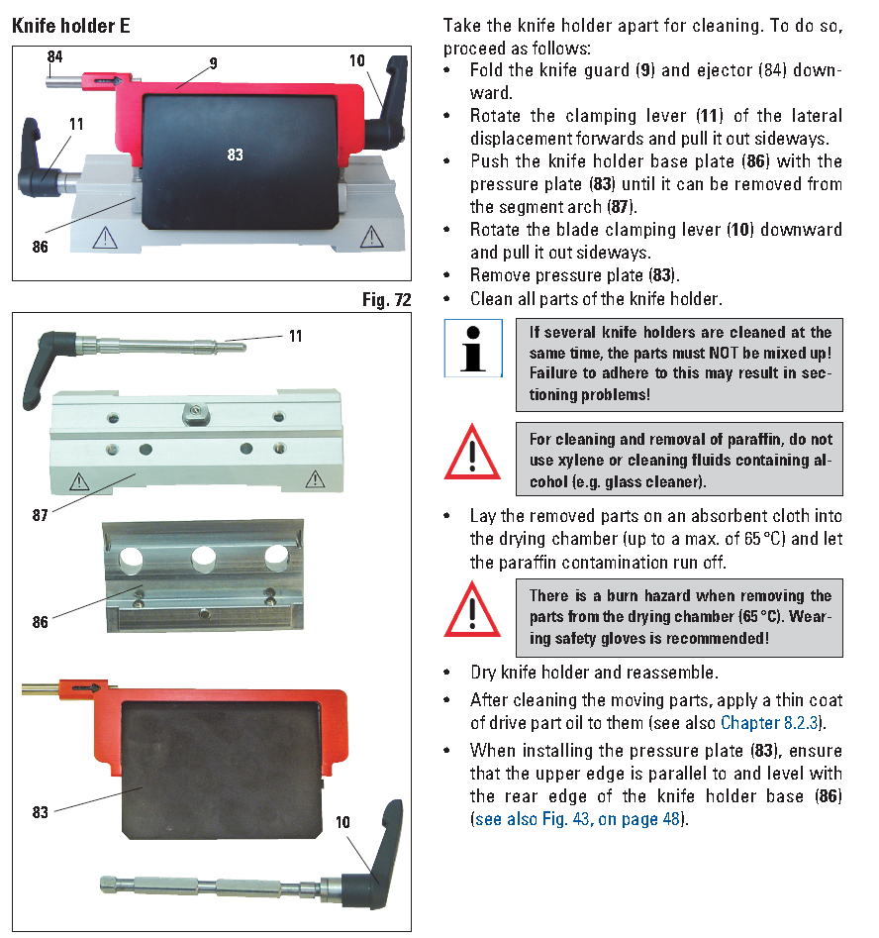

## Lubricating the Microtome

