NOTE: | THE COLLECTOR MUST LABEL AND SIGN or INITIAL EVERY SPECIMEN (TUBE) and  MUST COMPLETE THE DECLARATION ON THE REQUEST FORM.
Tube Guide for Common Tests
CAP | TESTS | CAP | TESTS
HEPARIN PLASMA with GEL, 5.0 mL |  | EDTA, 3 mL
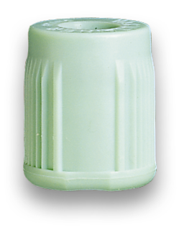  PALE GREEN  (367375)  Common Biochem  plus→ | - Most urgent BIOCHEMISTRY and any patient on anti-coagulation medication.  NOT for Lithium, Holo-TC Vit B₁₂  or PEP  - UE, LFT, Lipids, CA (NOT Ionised CA), IP, MG, AST, CK, CRP, Drug Levels, Haptoglobin, Iron Studies, Osmolality, TFT, Troponin.  - Plasma Free Haemoglobin. | 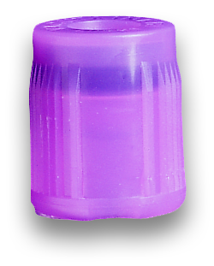  PALE LILAC  (367838) | - Essential for— FBE, Hb, DCT, Retics  Separate tube for—  - CD4/8, CD2/3, Cell Surface Markers, Flow Cytometry  - HbA1c  - BNP (not NTproBNP), Red Cell Folate  - Cyclosporin, Everolimus, Sirolimus, Tacrolimus  - Posaconazole, Voriconazole  - Factor V Leiden, Prothrombin 20210  - ACTH,Ammonia, and Homocysteine on ice.

PLAIN BLOOD (Serum) with GEL, 8.5 mL
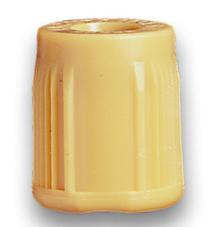  GOLD  (367958) | - Ionised Calcium, Aldosterone, PEP, Immunoglobulins, Free Light Chains, IgG subclasses, Lithium, Vit D, Methotrexate, Thiopentone, NT-pro BNP, PSA,  - free PSA, Holo-TC, Vit B₁₂.  - HITS Screen, IgE, RAST, Tryptase.  - Calcitonin, VitA, VitE, C-Peptide all on ice.  (NB: Vit A, Vit C & Vit E - protect from light) | GOLD  (367958) | - SEROLOGY  (extra tube if more than 4 of these tests)  ASOT, CMV, Cryptococcus, EBV,  Hep A, B, C, HIV, Herpes, Rubella, Syphilis, Toxoplasma, Varicella  Autoantibodies, Anticardiolipin Antibodies, GAD, IF, B2GP1, ACL, ENA, MPO, PR3 and Gliadins
FLUORIDE OXALATE, 2 mL |  | EDTA, 6 mL—‘CROSSMATCH’
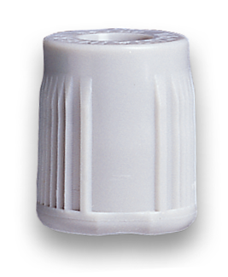  GREY  (367934) | - Lactate  - Fasting or Timed Glucose,  Glucose Challenge Test  Glucose Tolerance Test | 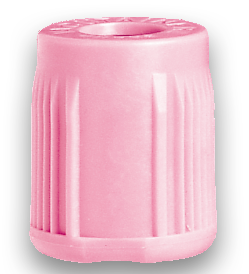  PINK  (367941) | - Essential for—  Crossmatch, G&S, G&H  - Cold Agglutinins  (must be kept at 37°C—call lab first)  Remember to date, time and sign TUBE
CITRATE, 2.7 mL (must be complete fill) |  | EDTA, 10 mL
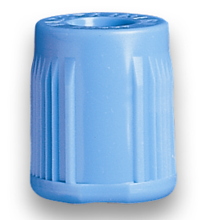  PALE BLUE  (363095) | - COAG—PT, INR, APTT, Fibrinogen,  D-Dimer, Anti-Xa  - Factor VIII, Factor IX, VWF, RCOF, ATIII, Protein C, Protein S, Lupus Screen. | 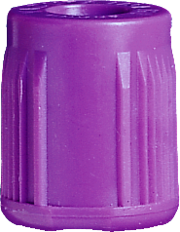  PURPLE  (367525) | - PTH, Renin (no ice)  - Haemoglobin Electrophoresis  - CryoFibrinogen (call Lab first)  - CMV viral load, HIV/HBV/HCV Viral Loads, Hep C PCR, Parvovirus PCR and other Viral PCR’s.
PLAIN BLOOD (= Serum) without GEL, 10 mL |  | ACD, 8.5 mL
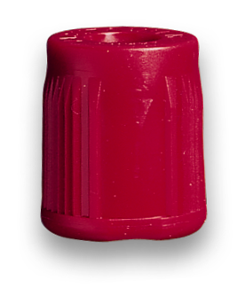  RED  (367895) | - CryoGlobulins,  (must be kept at 37°C—call lab first)  - Cytotoxic antibodies, Platelet antibodies | 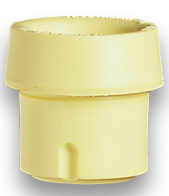  YELLOW  (364606) | - HLA Tissue Typing—  see Pathology Handbook for further details  - HLAB27, HLA H
- See Next Page (over) for Special Tubes, Paediatric Tubes and Order-of-Draw Chart.
- Tests printed in Blue & Underlined must be delivered On Ice.
- Some tests require multiple or separate tubes, consult the Pathology Handbook (intranet) for details.
- Hazard Warning: Never inject blood into the tube from needle and syringe.

NOTE: | THE COLLECTOR MUST LABEL AND SIGN or INITIAL EVERY SPECIMEN (TUBE) and  MUST COMPLETE THE DECLARATION ON THE REQUEST FORM.
CAP | TESTS |  | CAP |  | TESTS
METAL-FREE EDTA, 6 mL |  |  | SPECIAL TUBE& (Special Fill Citrate)
DARK BLUE  (368381) | - Trace & Toxic Metals—  Aluminium, Cadmium, Copper,  Lead, Mercury, Selenium, Zinc |  | 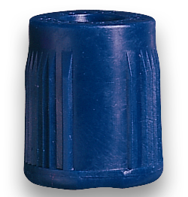  BLACK  (Vacu-tek®)* |  | ESR  (not suitable for any other tests)
PAEDIATRIC (MICRO) COLLECTION CONTAINERS
Tests: as per Tube Guide on page 1
SPECIMEN |  | DETAILS |  | USE |  | TUBE
PLAIN BLOOD (= Serum) with GEL, 600 μL |  | MICROTAINER  Cat. No. 365967 |  | Paediatric & finger-prick collections |  | 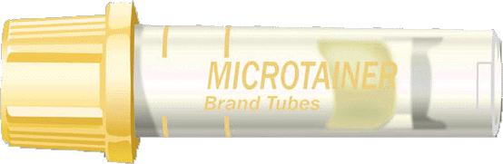
EDTA  500 μL |  | MICROTAINER  Cat. No. 365974 |  | Paediatric & finger-prick collections |  | 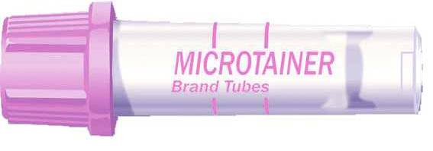
HEPARIN PLASMA  with GEL, 600 μL |  | MICROTAINER  Cat. No. 365985 |  | Paediatric & finger-prick collections |  | 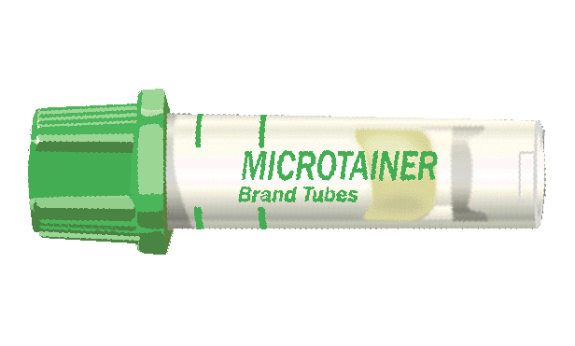
CITRATE, 1.8 mL |  | VACUTAINER  Cat. No. 363093 |  | Difficult bleeds |  | 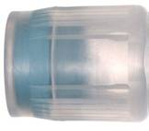
CITRATE 1.0 mL |  | MINICOLLECT®  Cat. No. 450413 |  | Paediatric collections  (NOT finger-prick for Coagulation tests) |  | (image not available)
ORDER OF DRAW CHART
1. Sterile samples (eg: Blood Cultures)
2. SST™II Gel [] Plain Serum tubes []
3. Citrate tubes* [] ACD tubes []
4. PST™II Gel tubes [] Heparin tubes []
5. EDTA tubes [] []
6. Fluoride Oxalate (glucose tubes) []
* Coagulation Tests—When collection is by vacuum tube the coagulation tube should be collected second to avoid artefactual shortening of coagulation assays due to trauma of venesection. If no other tube is required then collect two blue-top tubes and discard the first.
When blood is collected from an arterial line discard the first 20 mL of blood to clear any heparin from the line before collecting the blood for coagulation tests.
&ESR—In accordance with NCCLS¹ recommendations, ESR tubes should be placed at position 3 above. However, because their position in the order is not as critical as for citrate specimens for coagulation testing, it is common practice to place this tube at the end of the list to provide greater priority to tubes that will generally be required for more clinically important tests.
- NCCLS document H3-A5 “Procedures for the Collection of Diagnostic Blood Specimens by Venipuncture”. 5th Edition, Dec. 2003.

