Possible questions 2019

1. A result of >300 was given for a vancomycin level. Possible reasons for this may be:
2. Incorrect dosage
3. Sample taken above infusion site
4. Sample taken immediately after infusion
5. Analyser error
6. All of the above

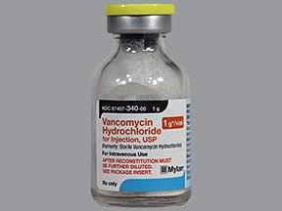

1. A decreased sodium can be caused by:
2. Dehydration
3. Very High glucose
4. Hypoadrenalism (Addison’s disease)
5. Anorexia Nervosa
6. All of the above

* Dehydration – loss of body fluids mainly water, is greater than the fluid intake (can be due to diarrhea, vomiting, excessive sweating etc). Along with water, a loss of electrolytes may occur.
* Very High glucose – causes a flow of water from within the cells into the circulation $→$ lowering of sodium concentration
* Hypoadrenalism - Hyponatremia is mediated by increased release of antidiuretic hormone (ADH) which results in water retention and a reduction in the plasma sodium concentration. Both cortisol and aldosterone deficiency contribute to this problem
* Anorexia Nervosa – shortage of sodium due to insufficient representation in diet

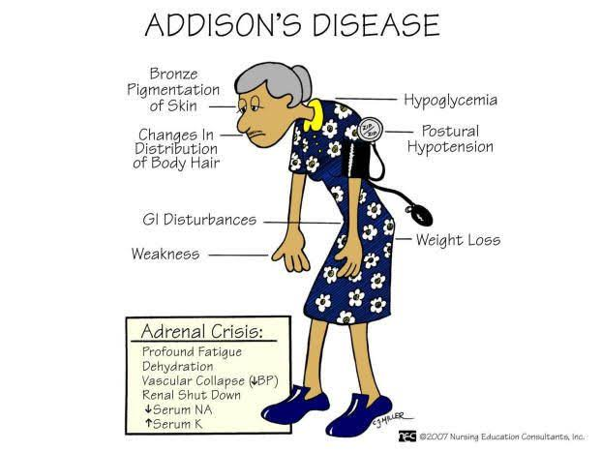

1. What is direct bilirubin?
2. Unconjugated bilirubin
3. The sum of the conjugated fractions of bilirubin
4. Total bilirubin – conjugated bilirubin
5. Conjugated bilirubin

The terms “direct” and conjugated hyperbilirubinemia often are used interchangeably. However, this usage is not always accurate because direct bilirubin may include both the conjugated fraction and bilirubin bound to albumin (delta bilirubin). Delta bilirubin is formed by covalent bonding between conjugated bilirubin in the serum and albumin; it is metabolized with albumin and has a similar half-life of 21 days. The presence of delta bilirubin often prolongs direct hyperbilirubinemia while results of the other liver tests are normalizing. Many hospitals continue to measure direct bilirubin by a method that includes both direct and delta bilirubin. Clinicians should consider asking for a breakdown of the direct bilirubin fraction if the jaundice is prolonged or presenting atypically.

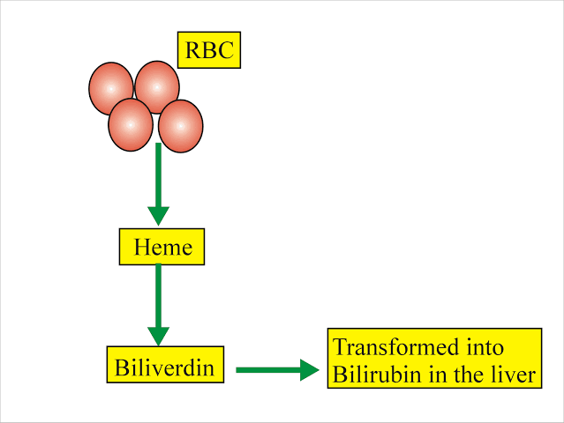

1. Pleural fluid pH should be measured in less than an hour
2. True
3. False

Pleural fluid pH measurements are subject to substantial variability during collection.

Pleural fluid should be collected avoiding inclusion of air or other additives with the

sample - particularly lidocaine - and analysed in less than 1 hour.

A delay in pH analysis in samples open to air results in CO2 diffusing out of pleural

fluid with time, resulting in an increased pH.

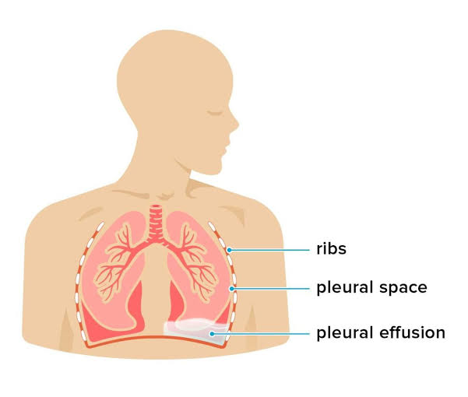

1. Common changes occurring in chronic kidney disease include:
2. Low uric acid
3. High ferritin
4. Low folate
5. High troponin
6. b,d and c

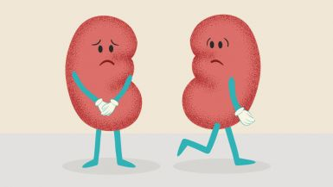

1. A female patient is admitted to emergency with the following symptoms: Uncontrollable movements, agitation, slurred speech, vomiting, confusion. The EUC results showed renal impairment. The patient had a history of bipolar disorder. Which drug level should be tested for toxic levels in this patient?
2. Phenytoin
3. Lithium
4. Carbamazepine
5. Progesterone

Lithium is commonly used in treatment of bipolar disorder and toxicity can cause all of the listed effects. A safe blood level of lithium is 0.6 and 1.2 mmol/L. Lithium toxicity can happen when this level reaches 2.0 mmol/L or higher. Severe lithium toxicity happens at a level of >2mmol/L, which can be life-threatening in rare cases. Levels of 3.0 mmol/L and higher are considered a medical emergency.

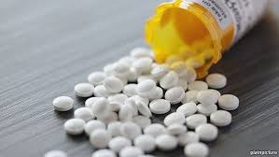

1. A small child is sent for a lactate test. He is very upset, struggling and crying while the blood is collected. His mother indicated that he had just had a MacDonalds meal and was not fasting. With this pre analytical history you would expect to see:
2. Normal lactate results
3. Raised lactate results
4. Low lactate results

Lactic acid is a product of anaerobic metabolism. Levels rise with exercise and between 20-50%

after food intake.



1. The best time to take a blood sample for iron analysis is
2. Night time
3. Early morning
4. Lunchtime
5. Anytime

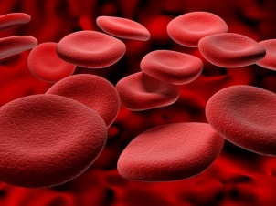

Serum iron is reduced in late morning or afternoon collection – levels show a marked diurnal variation, with afternoon levels often 30-50% lower than early morning

1. A request for a BNP is marked urgent and sent in by a GP. The result is 16794 ng/L.

The previous result (1 week prior) was 14599 ng/L. You should

1. Phone and fax this result to the GP
2. Fax the result only
3. Authorise and allow to download to GP as normal because close to last result
4. Leave for a more senior person to deal with

The Critical limits document (DSPL-BI-TP-0028) indicates that all results above the reference range and marked urgent should be phoned and faxed.



1. At what percentage difference, +/-, to the previous result should a serial troponin result be phoned?
2. ≤50
3. ≥30
4. ≥25
5. Doesn’t need to be phoned at all
6. Phone only if value is rising

