True or False. Please circle the correct answer.

1. Blood specimen must be collected in a tube without anticoagulant.

True False

2. Serum may be stored refrigerated at 2ºC - 8ºC for up to three (3) days prior to testing.

True False

3. Three drops of serum is added vertically to the sample well of the test cassette and read at 5-6 minutes.

True False

4. The result of Lot# 9020102 (1x106 pmol/L Bcf) is NEGATIVE.

True False

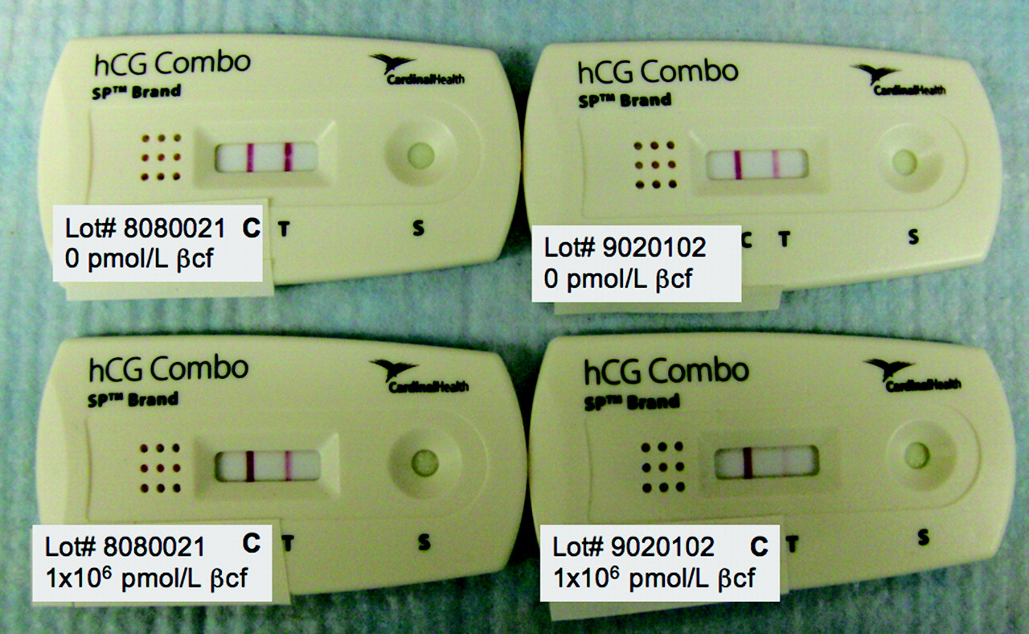

5. If no control line appears after 5 minutes, repeat the test with a new test cassette.

True False

Reviewed by:

Kristina Chiu, BSMT, ASCP, AMT

Lead Chemistry Tech