Common Crystals
Triple Phosphate
Triple phosphate Crystals usually appear as colorless, 3-dimensional, prism-like crystals ("coffin lids"). Occasionally, they instead resemble (vaguely) an old-fashioned double-edged razor blade (lower frame).  Triple phosphate crystals are often seen in urine from clinically normal individuals. Though they can be found in urine of any pH, their formation is favored in neutral to alkaline urine.  Urinary tract infection with urease-positive bacteria can promote triple phosphate crystals by raising urine pH and increasing free ammonia. | 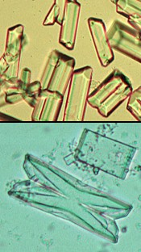

Calcium Carbonate
Calcium carbonate crystals usually appear as large yellow-brown or colorless spheroids with radial striations. They can also be seen as smaller crystals with round, ovoid, or dumbbell shapes.
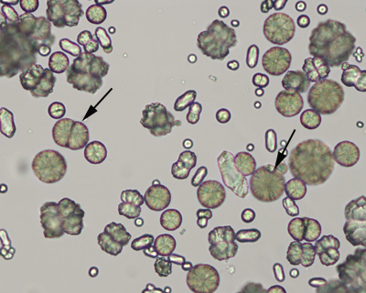

Amorphous" crystals
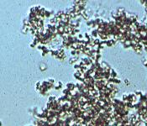
"Amorphous" crystals appear as aggregates of finely granular material without any defining shape at the light microscopic level.
Amorphous urates (Na, K, Mg, or Ca salts) tend to form in acidic urine, and may have a yellow or yellow-brown color.
Amorphous phosphates are similar in general appearance, but tend to form in alkaline urine and lack color.
Calcium oxalate dihydrate crystals sometimes also can present as "amorphous" when the individual crystals are very small. Examination at higher magnification will reveal the typical "envelope" appearance.
Generally, no specific clinical interpretation can be made based on the finding of amorphous crystals. Small amorphous crystals can be confused with bacterial cocci in some cases, but can be distinguished by Gram-staining.

Calcium Oxalate Dihydrate
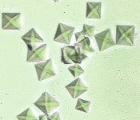
Calcium oxalate dihydrate crystals typically are seen as colorless squares whose corners are connected by intersecting lines (resembling an envelope). They can occur in urine of any pH, but most often in acidic urine. The crystals vary in size from quite large to very small. In some cases, large numbers of tiny oxalates may appear as amorphous unless examined at high magnification. These crystals often are seen in normal urine.

Less Common Crystals
Cystine
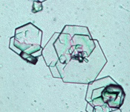
Cystine crystals are flat colorless plates and have a characteristic hexagonal shape with equal or unequal sides. They often aggregate in layers. Their formation is favored in acidic urine.
Cystine crystalluria or urolithiasis is an indication of cystinuria, which is an inborn error of metabolism involving defective renal tubular reabsorption of certain amino acids including cystine.

Biurates
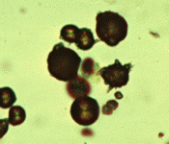
Ammonium urate (or biurate) crystals generally appear as brown or yellow-brown spherical bodies with irregular protrusions ("thorn-apples"). Though possible in urine of any pH, their formation is favored in neutral to alkaline urine.

Bilirubin
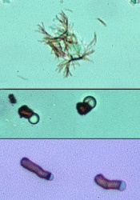
Bilirubin crystals tend to precipitate onto other formed elements in the urine. In the top picture, fine needle-like crystals have formed on an underlying cell. This is the most common appearance of bilirubin crystals. In the lower two pictures, cylindrical bilirubin crystals have formed in association with droplets of fat, resulting in a "flashlight" appearance. This form is less commonly seen.

Drug Crystals
Many drugs excreted in the urine have the potential to form crystals. Hence, a review of the patients drug history is prudent when faced with unidentified urine crystals.  Most common among these are the sulfa drugs. Both panels on the right are from patients receiving trimethoprim-sulfadiazine. The differing appearance may relate to variation in drug concentration, urine pH, and other factors. The inset in the lower panel shows the crystals as they appeared when polarized.  Other examples include radiopaque contrast agents (Hypaque, Renografin) and ampicillin which may precipitate in acid urine as fine needle-like crystals (not shown). | 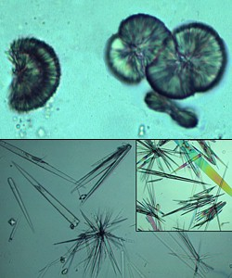

Tyrosine
Tyrosine crystals are usually seen as fine brownish needles. These can be associated with severe liver disease in humans. | 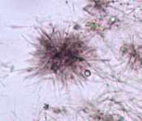

Calcium Oxalate Monohydrate
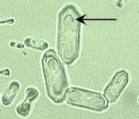
Calcium oxalate monohydrate crystals vary in size and may have a spindle, oval, or dumbbell shape. Most commonly, they appear as flat, elongated, six-sided crystals ("fence pickets") such as shown to the right. The arrow in the photo indicates a "daughter" crystal forming on the face of a larger underlying crystal.

Infectious Agents
Candida
Yeasts in unstained urine sediments are round to oval in shape, colorless, and may have obvious budding (upper panel). They often represent contaminants, and are especially suspect if the sample is voided and/or old.  In other circumstances, however, their significance should not be discounted. The lower photo shows pseudohyphae formation by the yeasts, which were identified on culture as Candida albicans. | 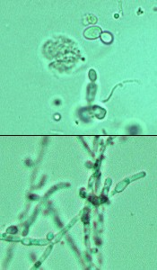

Bacteria
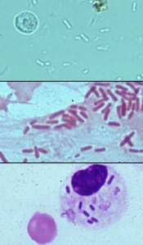
Bacteria can be identified in unstained urine sediments when present in sufficient numbers. Rod-shaped bacteria and chains of cocci are often readily identifiable. The images at right show E.coli bacilli. However, small amorphous crystals, cellular debris, and small fat droplets can either mask or mimic cocci. If there is any doubt about the presence of bacteria, a Gram-stained smear of urine sediment (middle panel) could be examined.
Urine in the bladder is sterile. Though bacteria from the distal urethra and/or genital tract may contaminate voided specimens, they are usually too few to see if a good mid-stream collection was obtained.
Although phagocytized bacteria cannot be seen in unstained wet mounts of urine sediment, they may found in stained smears of sediment. The lower panel at the right shows a neutrophil containing phagocytized bacteria. Notice that the nucleus in this cell is round; nuclei tend to become round as neutrophils age in urine.
Bacteriuria of clinical significance, e.g., bacterial cystitis, is usually accompanied by increased numbers of white cells (pyuria). The presence of a few bacteria without pyuria is very rarely significant of infection.

Fungi
Fungal hyphae in urine sediment preps most commonly represent overgrowth of contaminants in samples where analysis was delayed.  If seen in a fresh sample, fungal infection of the kidneys and/or bladder should be suspected.  Aspergillus terreus (shown at right) has been documented to cause systemic infection including colonization of the renal pelvis. | 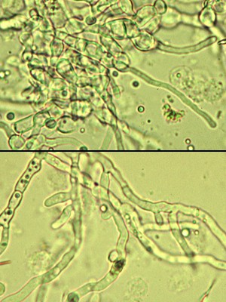

Contaminants

Starch Granules
Granular starch (Biosorb) is used as powder on surgical and examination gloves. These granules are commonly encountered as contaminants not only in urine sediments, but also in cytology smears of various types. They are variable in size, round to polygonal in shape, colorless, refractile (due to their crystalline nature) and usually have a circular or Y-shaped "dot" in the center.
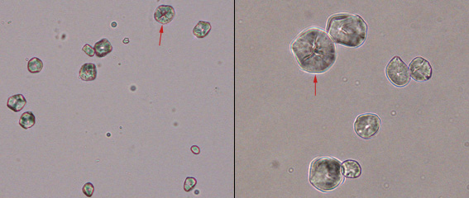
The panel on the left shows a low power view (20x high dry objective) of starch granules in a urine sediment. The panel on the left shows a higher power view of the starch granules in the same urine sample. The characteristic "Y-shaped" central dot is evident in the crystals identified by the red arrow in both panels.

Fibers
Cotton, plant, and paper fibers may be confused for parasite larvae or urinary casts. Care in sample collection and handling will minimize the presence of such material. | 