CLIA test complexity: Waived. This test is intended to quantitatively measure glucose in venous whole blood, in arterial whole blood, neonatal heelstick, or fresh capillary whole blood samples drawn from fingertips as an aid in monitoring the effectiveness of glucose control. This system is not for use in diagnosis or screening of diabetes mellitus, nor for testing of neonatal cord blood samples.

I. POLICY

Measurement of blood glucose using the Accu-Chek Inform II shall occur under the following guidelines by trained personnel:
A. Upon a physician's order (to include frequency and time of testing)
B. Upon suspected signs and/or symptoms of hypoglycemia or hyperglycemia, a registered nurse may initiate blood glucose testing without a physician order.
C. Use of the hospital meter is for PATIENTS ONLY. Self-testing or testing of visitors, friends, relatives, or fellow employees is not permitted. NOTE: For purposes of this testing, a “code” meets the criterion of “patient”.
D. Only hospital meters (Accu-Chek Inform II) validated by the Clinical Laboratory may be used for patient care, clinical decision-making, or treatment.
E. Extremes in blood glucose can have urgent and serious or life-threatening implications. The physician has authority to determine whether:
- There is no need for repeating the test.
- The test should be repeated on the glucose meter, by capillary puncture or by venous or arterial specimen. (Meter function can be verified by repeating controls. See QUALITY CONTROL below).
- A venous or arterial specimen should be drawn and sent to the Clinical Laboratory for testing.
- The test should be repeated using the iSTAT (for clinical units that have iSTAT available), by capillary puncture, or on a venous or arterial specimen. iSTAT testing may only be performed by certified iSTAT operators.

II. PRINCIPLE

The Accu-chek Inform II meter, along with the Accu-chek Inform II test strips, is intended to quantitatively measure glucose in venous whole blood, in arterial whole blood, neonatal heelstick, or fresh capillary whole blood samples drawn from fingertips as an aid in monitoring the effectiveness of glucose control. The enzyme on the test strip, a mutant variant of quinoprotein glucose dehydrogenase (Mut. Q-GDH), from Acinetobacter calcoaceticus, recombinant in E. coli, converts the glucose in the blood sample to gluconolactone. This reaction creates a harmless DC (direct current) electrical current that the meter interprets for the blood glucose result. The sample and environmental conditions are also evaluated using a small AC (alternating current) signal. The system reports a plasma-like glucose result.

III. TESTING PERSONNEL

Only trained/certified personnel may perform testing. Competency must be demonstrated initially and annually thereafter. Employees must perform testing in accordance with all written policies/procedures. Regulatory agencies (CAP, CLIA, CMS, Joint Commission, etc.) mandate documentation of employee education and continuing competency in order for the hospital to continue to perform patient testing.

All training and competency activities will be coordinated with Point of Care Testing. POC Testing will provide educational documentation for training and/or recertification. The Point of Care Coordinators will maintain a current list of trained/certified personnel. A copy of this list will be provided periodically to the clinical units.

NOTE: Per CCHMC policy, UAPs (unlicensed assistive personnel) may perform glucose meter testing under delegation by an RN. They must have a high school diploma and must fulfill the above training/competency requirements.

NOTE: The meter software will “lock out” individuals who have not been trained/certified, as well as those individuals whose certifications have expired. “Lock out” means that the individual cannot access the meter software, and consequently cannot perform testing.

IV. REAGENTS/SUPPLIES/EQUIPMENT
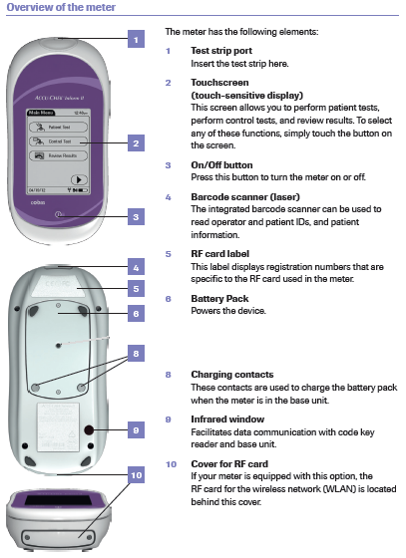
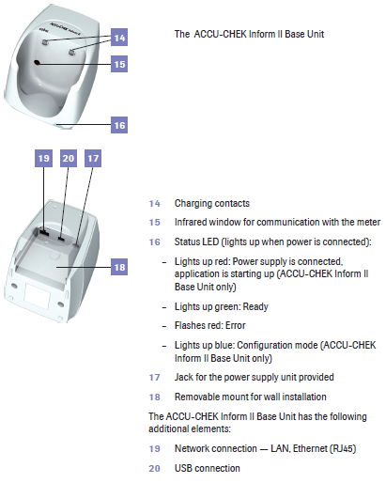

All reagents are commercially prepared and labeled. Both strips and controls will be available from the CCHMC storeroom (one lot for approximately six months). Some units may access these supplies via Pyxis.
A. Equipment
1. Accu-Chek Inform II blood glucose meter, base unit, and storage case, Roche Diagnostics, Indianapolis, IN 46256
2. Hospital-approved lancet device
B. Materials
1. Accu-Chek Inform II test strips, Roche Diagnostics, Indianapolis, IN 46256
2. Accu-Chek Inform II controls, Level 1 (Lo/gray cap) and Level 2 (Hi/white cap), Roche Diagnostics, Indianapolis, IN 46256
3. Accu-Chek Inform II linearity test kit, Roche Diagnostics, Indianapolis, IN 46256 (used by Point of Care Coordinators only)
C. Supplies
    - Skin preparation pad (alcohol or CHG wipe, per hospital policy)
    - Gloves
    - Lancet device
    - Gauze pads (2 X 2) Gauze is preferable over cotton because cotton may leave small fibers on the skin, jeopardizing good blood flow).
D. Storage and Stability:
- Store test strips in the original capped container at room temperature 2 – 30 °C or 36 – 86 °F. Do not freeze. Use the test strips at temperatures between 16 – 35 °C or 61 – 95 °F. Store unused test strips in the original container with the cap closed. Do not remove test strips from the test strip container and put them into another container such as a plastic bag or pocket, etc. Close the container tightly immediately after removing a test strip to protect the test strips from humidity. Use the test strip immediately after removing it from the container. Strips (opened or unopened) expire upon manufacturer’s expiration date. Discard expired strips.
2. Store control and linearity solutions at room temperature 4 – 30 °C or 36 – 86 °F. Do not refrigerate or freeze. Identify expiration date as 3 months after opening or manufacturer’s expiration date, whichever comes first. Date controls upon opening. Do not write dates on top of the barcode. Discard expired controls.

V. MAINTENANCE

All specimens are potentially infectious. Observe Standard Precautions and safe work practices at all times.
A. Clean exterior of meter per hospital policies, using Clorox® Bleach wipes (blue lid).  Refer to IC-2.1 Maintaining Clean Patient Rooms and Equipment.
NOTE: The manufacturer and the FDA have also approved the PDI Super Sani Cloth (purple lid) for meter cleaning/disinfection. However, as of the date of this SOP, the PDI Super Sani Cloth is not available within Cincinnati Children’s Hospital Medical Center.
Procedure:
1. Wear gloves.
2. Turn the meter off prior to cleaning. Verify that there is no test strip in the test strip port. Do not spray anything on the meter. Do not immerse the meter in liquid.
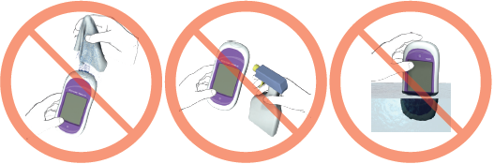
3. Place the meter on a level surface. (This is to prevent liquid from running into the test strip port).
4. Using a fresh Clorox Bleach wipe, wipe the outside of the meter 3 times horizontally, 3 times vertically, and wipe AROUND the outside of the test strip port area, making sure that no liquid enters the test strip port. Allow the surface of the meter to remain damp for one minute.
5. Clean:
a. The area around the test strip port
b. The touchscreen
c. The meter housing
6. Avoid getting liquid into the test strip port. Do not allow pooling of liquid on the touchscreen. Do not clean the meter while a strip is still inserted into the test strip port. Do not use spray cleaners. Do not immerse the meter in liquid.
7. Dry the meter thoroughly with a dry cloth or gauze. Meter must be dry before returning it to the base unit. If a wet meter is returned to the base unit, an electrical short may be created. This may result in the meter and the base unit having to be reset by the Point of Care Coordinators. Additionally, returning a wet meter to the base unit causes corrosion of the glucose meter and base unit charging contacts.
NOTE: Electricity – which flows across the contacts when the meter is in the base unit – and moisture DO NOT MIX. It is imperative that the glucose meters must be completely dry when they are returned to the base unit. Never place the meter in the base unit if it is not completely dry.
B. The base unit charges the battery, transfers results, and configures the meter. The meter’s “home” is the base unit, so that it receives information, results are posted to the patient’s electronic medical record in a timely manner, and the meter’s rechargeable battery maintains charge. A download warning displays if the meter has not been downloaded within two hours.
C. The meter should always be turned off with the power button after use and before returning to the base unit.

VI. TURNING METER ON AND ENTERING OPERATOR ID

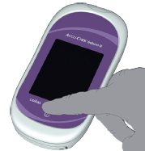
      - Press and release the On/Off button. The meter is now on.
      - The Power Up screen appears and self-checks are performed. The battery icon shows the current battery level. A completely filled icon indicates a fully charged battery, and a partial charge is displayed as a partially filled battery icon.
      - The Operator ID screen appears.
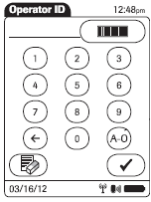
      - Use the numerals on the keypad to enter your 6-digit operator ID, and then press √. Your operator ID is your hospital employee ID with enough zeros in front to make six digits. Use the ← button to erase a single incorrect numeral. The button erases the entire entry. If the operator ID you have entered is not valid, an error message is displayed. Confirming the message allows you to re-enter your correct operator ID. Once a valid operator ID has been entered, Main Menu appears.

VII. BARCODE SCANNING

- Once the appropriate screen is displayed, position the scanning beam, located on the top underside of the meter, approximately four to eight inches above the barcode. Press and release to trigger the scanning beam. Make sure the laser beam covers the entire barcode that is to be scanned. A beep indicates a successful scan of the barcode.

The button can be pressed to cancel a function and return to the Main Menu.
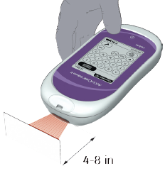
B. The meter contains a laser. DO NOT stare into the laser light or point it toward anyone's eyes.

VIII. TOUCHSCREEN AND BATTERY

- Use only your finger to touch the screen. Using a sharp implement may damage the screen.
- Do not store the meter in direct sunlight. This may decrease the life expectancy of the screen.
- The meter contains a rechargeable battery pack that charges when the meter is in the base unit.
- A Battery Low warning on the meter display indicates that the meter must be returned to the base unit for recharging as soon as possible.
- A Battery Critically Low warning on the meter display indicates that the meter must be returned to the base unit for recharging as immediately. No more tests can be performed.

IX. CODE KEY

A new code key is packaged with every box of reagent strips. The code key is identical for all strips that are the same lot. (The hospital will purchase a large quantity of strips of the same lot so that there are minimal lot changes). A code key (for the entire lot) is read into the code key reader. The code key reader is used by the POC Coordinators ONLY, to enter the required strip lot data into the system. POCCs: Refer to the Operator’s Manual for additional information.

X. QUALITY CONTROL

POCT clinical personnel are responsible for performing quality control (QC) as specified by this procedure. Control specimens must be tested in the same manner and by the same personnel as patient samples, i.e., control specimens must be analyzed by personnel who routinely perform patient testing. This does not imply that every operator must perform QC daily, so long as QC is performed at the required frequencies. However, a variety of analysts must participate in QC on a regular basis. The individuals performing the QC must also perform patient testing in that clinical area. QC duties may NOT be assigned to any individual who does not regularly perform PATIENT TESTING in that same clinical area.

A. Control frequency (both levels):
1. Every 24 hours of patient testing
2. If a vial of test strips has been found left open
3. When test results contradict a patient’s clinical symptoms
B. Control procedure: Both Level 1 (Lo) and Level 2 (Hi) controls are required.
1. Turn meter on and press ►. Enter operator ID and press √. The Main Menu screen is displayed.
- Select Control Test.

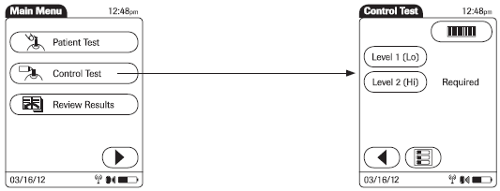
- Scan the control barcode.
- Scan the strip barcode.
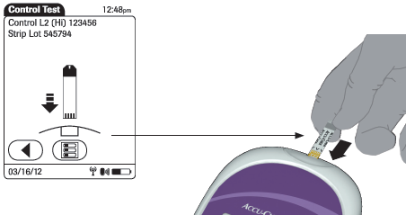
- Hold the test strip with so that the lettering ACCU-CHEK is facing upward. Slide the test strip into the test strip port as far as it goes. The meter beeps. Reclose the strip vial immediately and completely.
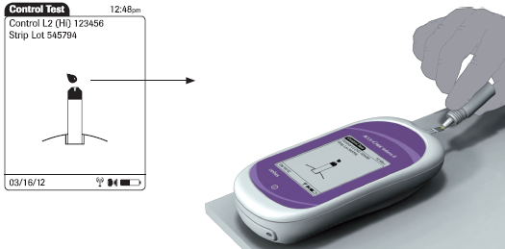
6. Wait until the flashing drop appears in the display before applying the control solution. Apply a drop of control solution to the front edge of the test strip. Do not apply control solution to the top of the strip. The solution will be pulled into the strip. Wipe vial tip and replace cap on control vial. Once sufficient control solution has been detected, the meter beeps and measurement begins.
7. The hourglass icon indicates the test is running. When the test is completed and the result is read, the meter beeps again.
8. PASS or FAIL displays.
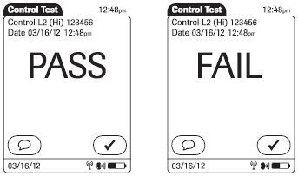
9. If you inadvertently run a low control and call it a high, or vice versa, enter the comment PROCEDURE ERROR.
10. If the control fails, entry of a comment is required. See QC corrective action below.
11. Remove the strip and discard.
12. Repeat this process for the remaining control.
C. Control evaluation
- The operator performing the quality controls is responsible for performing any necessary corrective actions. See QC corrective action below.
- Failed control results may indicate:
a. Procedural error (low control substituted for high or vice versa)
b. Old or contaminated glucose control solution. NOTE: Allowing control material to pool and/or dry around the tip of the vial can falsely increase the control result.
c. Test strip deterioration
d. Meter malfunction
D. QC corrective action
1. If the result is FAIL, press Enter Notes and select appropriate comment(s). If you have inadvertently run a low control and called it a high control, or vice versa, enter the comment PROCEDURE ERROR. Press OK.
2. Evaluate unacceptable control results as follows:
  - Verify that controls are not expired. Discard controls that are expired.
  - Verify that a low control has not been substituted for a high and vice versa.
  - Repeat any out of range control, verifying that the control procedure above has been followed carefully. NOTE: If top of vial has dried control residue, wipe and discard 1 -2 drops before retesting.
  - Replace controls and repeat.
  - Replace strips and repeat.
  - If still unresolved, contact Point of Care Testing.

XI. SPECIMEN

Observe Standard Precautions and safe work practices at all times when handling patient specimens or controls.
A. Confirm patient identification prior to testing, in compliance with hospital policies. No special patient preparation is needed. Identify the sample immediately, at the patient’s bedside with two patient identifiers, in compliance with hospital policy F-117. A computer screen display is never an acceptable source of patient ID. Even when testing is being performed at the Point of Care, if the sample leaves the patient's side, it MUST be labeled with two identifiers. It is never acceptable to leave the patient’s side with an unlabeled sample.
B. Acceptable specimens:
- Venous whole blood, arterial whole blood, neonatal heelstick, or fresh capillary whole blood samples drawn from fingertips may be tested.
- Do not test cord blood.
- Lithium heparin, sodium heparin, or EDTA anticoagulants may be used.
- Do not use fluoride or iodoacetate.
- Do not use serum or plasma samples.
- If a specimen has been refrigerated (this will be uncommon), it must be brought to room temperature before testing.
NOTE: Venous and capillary blood may differ in glucose concentration by as much as 70 mg/dL, depending on the time of blood collection after food intake (within 2 hours).
1. Capillary blood: See PATIENT TEST PROCEDURE below.
2. Venipuncture, arterial puncture, or line draw: Lines must be adequately flushed before obtaining samples for testing.
3. Capillary blood must be tested immediately. Venous and arterial blood samples must be tested within 30 minutes to minimize glycolysis. If using fresh whole blood in the absence of an anticoagulant, test immediately to prevent clotting. When whole blood in a test tube or syringe is used, mix well before testing. This can be accomplished by gently inverting the capped tube, or by inverting and rolling the syringe. Syringes and/or vacuum tubes must be labeled (see above).

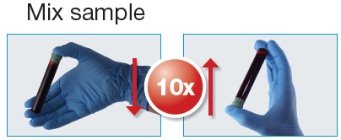

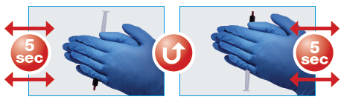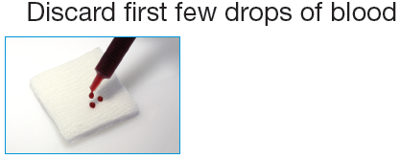

C. Unacceptable specimens:
1. Any sample that is not acceptable as defined above
2. Clotted sample
3. Sample older than defined above
4. Incorrectly identified OR unlabeled specimen
5. Sample drawn from a line without adequate flushing of line
6. Sample drawn with fluoride or iodoacetate
7. Cord blood samples cannot be tested on this meter.

XII. PATIENT TEST PROCEDURE

A. Steps for capillary puncture procedure:
Assemble the materials necessary to perform the test.
    - Vial of test strips
    - Skin preparation pad (alcohol or CHG wipe, per hospital policy)
    - Gloves
    - Lint-free tissues
    - Lancet device
    - Gauze pads (2 X 2) Gauze is preferable over cotton because cotton may leave small fibers on the skin, jeopardizing good blood flow).

- Turn meter on and press ►. Enter operator ID and press √. The Main Menu screen is displayed.
- If controls are due, perform controls according to the control procedure (above). From the Main Menu, press Patient Test.
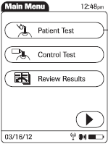

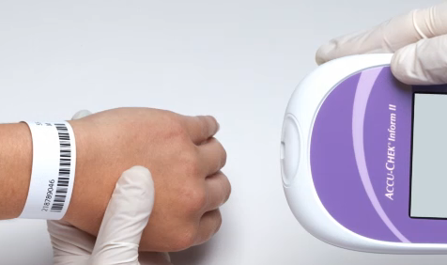
- Enter the patient's CSN (financial) number by scanning the patient’s armband. Press and release to scan the 1-D barcode on the armband. Do NOT scan stickers. For the patient ID, do not scan anything other than the patient armband. Extraneous stickers may appear to scan, but results will not cross the interface. The software can identify whether or not an actual armband (as opposed to extraneous barcodes/stickers) was scanned, and it will stop the results if something else (sticker) was scanned. Additionally, using extraneous stickers is a violation of hospital policies that require the patient to be identified by his/her armband. Alternatively, enter the patient ID manually and press √. Enter the 9-digit CSN (financial number) exactly, without modification, and without adding or subtracting any digits. Use the ← button to erase a single incorrect numeral. The button erases the entire entry.

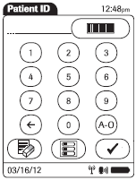
- After scanning the patient’s barcoded armband or manually entering the patient’s 9-digit CSN, the following will display:
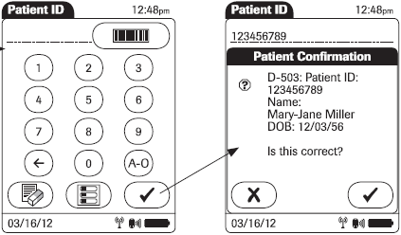
After verifying that the correct patient is displayed, select the check mark to confirm that the correct patient ID is displayed. (NOTE: This feature is not available for physician offices or for the Oak research location).

If the patient information displayed is NOT the patient being tested, select the X.

On occasion (for example, a recent admission for which the hospital’s admission/discharge/transfer feed has not yet caught up with the meter database), the meter will indicate that the patient ID that is not found. If the meter indicates that the patient ID was not found, then it is very important to double-check that the correct patient’s 9-digit CSN has been entered correctly. If you are sure that the correct patient’s correct 9-digit CSN has been entered, answer affirmatively when the meter asks, “Do you want to proceed?” You will still be able to perform the test.
NOTE: If testing must be done before a financial number is assigned to the patient, use all zeros. This is for exceptional circumstances only. Please do not make up false patient IDs beginning with five, as these may be actual patient IDs for other patients. It is necessary to email the Point of Care Coordinators with the correct patient name and 9-digit CSN when it becomes available. The person who performs the test is responsible for providing this information to the POC Coordinators. The POC Coordinators can be emailed at pointofcaretesting@cchmc.org .

- Scan the strip barcode.
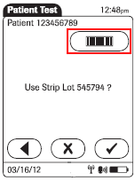

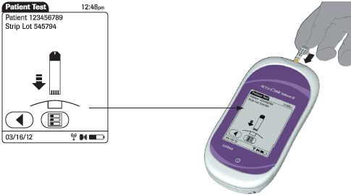
- Hold the test strip with the lettering ACCU-CHEK facing upward. Slide the test strip into the test strip port as far as it goes. The meter beeps. Reclose the strip vial immediately and completely. You are prompted to apply a blood sample.
- Wait until the flashing drop appears on the display. Obtain specimen.
- Heelstick: Blood flow may be increased by using a warm washcloth or a heel warmer. Cleanse the heel with the skin preparation pad. Dry with gauze.
- To perform a heelstick, place your thumb on the inside bottom of the foot and push the skin across the heel toward the outside of the heel. Choose the most medial or most lateral portions of the plantar or bottom surface of the heel. Puncture depth should not exceed 2.0 mm.

- Fingerstick: Select a finger for puncture. Avoid cold, cyanotic, bruised, cut or swollen fingers. Use the non-dominant hand if possible. The middle or ring finger is preferred. Each test should be performed from a new skin puncture. Hold the finger firmly with one hand and place the disposable lancet device against the finger, selecting either side of the fleshy pad.

- Blood flow may be increased by warming the site for 3 – 5 minutes by using a warm washcloth or appropriate warming device. Next, gently massage the finger five or six times from the palm to the base of the finger and up to the tip of the finger.
- Cleanse the finger with the skin preparation pad.

NOTE: Whether alcohol or chlorhexidine gluconate (CHG) is used, it is imperative that the skin be dry prior to puncture. CHG dries more slowly than alcohol.

- Dry the finger with gauze. Position the hand at a level below the heart.
- Hold the patient’s finger firmly with one hand and place the disposable lancet device against the finger.
- Trigger the lancet device. Wipe away the first drop of blood. Hold the puncture site downward and gently apply intermittent pressure to the surrounding tissue. Do not apply strong repetitive pressure (“milking”). This may cause unreliable test results.
- See SPECIMEN for directions for handling venipuncture specimens.
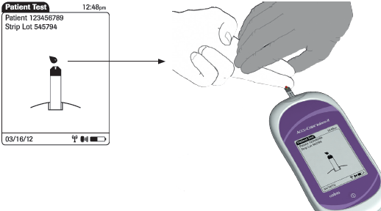
16. Apply the drop of blood to the front edge (yellow dosing area) of the test strip. Do not apply the blood to the top of the strip. Blood will be pulled into the test strip. Once sufficient blood has been pulled into the test strip, the meter beeps and measurement begins.
NOTE: Do not place the meter on bed or bedding. Blood can be wicked out of the strip when the meter is placed on bedding after applying blood to the strip. Place the meter on a flat, hard surface while the test is in progress.

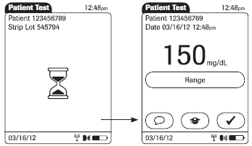
17. The hourglass icon indicates the test is running. Once the test is completed, the result displays. If you do not wish to enter a comment, press √ to return to the Main Menu
18. If appropriate, press  to enter a comment. Press √ to return to the results screen, and press √ again to return to the Main Menu.
19. Use of the comment PROCEDURE ERROR prevents the electronic reporting of the test result.
20. If the result is below the lower limit or above the upper limit of the reportable range, the following flags may appear:
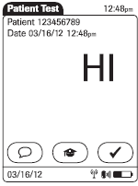
- LO – below the System Measurement Range, i.e. less than 10 mg/dL
- HI – above the System Measurement Range, i.e. greater than 600 mg/dL
21. For results outside of System Measurement Range, upon physician request, a numerical result may be obtained by sending a specimen to the Clinical Laboratory for analysis. Refer to POLICY (above) for additional information.
22. Remove the strip and discard.
- Return the meter to its home in the base unit.
B. If a patient is experiencing symptoms that are not consistent with the blood glucose result obtained, proceed with the following steps:
1. Review LIMITATIONS AND INTERFERENCES. Some patient samples must be tested by another method to obtain reliable results.
2. Repeat controls to verify correct meter function.
3. Refer to POLICY (above) regarding repeat testing.

        - ERROR MESSAGES/TROUBLESHOOTING

Error Message | Possible Solutions
Meter display does not turn on. | Wait 10 seconds and try again. If meter still does not turn on, place the meter in the base unit and confirm that it is charging, i.e., charge the battery by placing the meter in the base unit.
Type bad dose | Insufficient blood on the test strip. Repeat the test using a new test strip, ensuring proper sample application.
Battery Low or Battery Critically Low | Charge the battery by placing the meter in the base unit.

Refer to the Operator’s Manual on Compliance 360 for additional detail regarding these and other error messages.

General troubleshooting:
Quality control fails:
- Refer to the QUALITY CONTROL section of this procedure.

Operator is performing a glucose test and gets the error “A HW error has occurred. If problem persists, see your System Administrator”.
- The operator has applied the control solution or the patient’s blood to the strip too soon. Repeat, follow the on screen meter prompts. Be sure to wait until the meter display tells you to apply control solution or blood to the strip.

“My result is not in Epic”.
- If a server roll or Cerner or Epic downtime is happening, this is expected. Results continue to be available in the meter itself. The results will also eventually post, after the fact. If desired, the results can meanwhile be typed into nursing notes.
Per Dr. Steele: “Please be aware that downloading of point of care results from glucose meters will not transmit the results to Epic immediately, because of the downtime; the results will eventually reach Epic, but please keep track of these results in a convenient location until then; going back to the analyzer that performed the test is one way to access these results.”
- Did the employee correctly enter the patients 9-digit CSN into the meter? If anything other than the 9-digit CSN has been entered, the results will not post. (No extra zeros or other digits, also).
- Did the employee scan a sticker instead of the patient armband? The results will not post.
- Did the employee enter the medical record number instead of the 9-digit CSN? The results will not post.
- Was the patient ID that was entered the CORRECT 9-digit CSN for the patient? (Check for typos using a different patient’s ID, or an ID that does not belong to any patient).

“The armband will not scan”.
- If the patient is a very small infant/child, and there is so much armband curvature on the wrist that the scanning beam cannot “see” all of the barcode, scanning will be unsuccessful. Manually enter the 9-digit CSN, using the armband as a visual source for the CSN.
- If the armband is blurred (age, patient showers, etc.), scanning will be unsuccessful. Manually enter the 9-digit CSN, using the armband as a visual source for the CSN.
- If armbands failing to scan is happening for numerous patients in your area, notify your manager. The manager can enter a helpdesk ticket to have the armband printer checked/adjusted/etc.

“My ID doesn’t work.”
- Were you officially trained?
- Has your educator/trainer submitted your paperwork to POC Testing?
- Are you entering your ID correctly, i.e. your employee ID from the back of your badge with enough zeros IN FRONT to make a total of 6 digits?
- Is your certification expired?
- If you are not a trained and currently certified operator, you will not be able to test until this situation is corrected. Contact your manager or educator. POC Testing enters/updates operators during normal business hours M-F.
- If your ID does not work, you may not use anyone else’s ID. If someone else’s ID does not work, do not give him/her your ID to use. This seriously violates hospital policy; see “USER STANDARDS for CCHMC INFORMATION TECHNOLOGIES MANUAL”.

XIV. REPORTING PATIENT RESULTS

Results are transmitted automatically to the patient’s electronic medical record via wireless transmission where wireless capability is available (most locations), or when the meter is placed in the base unit (all locations except Greensburg and Batesville physician offices). This is contingent upon entry of a valid patient CSN (financial number) into the patient ID field.

NOTE: Use of the comment PROCEDURE ERROR prevents electronic reporting of the test result.

XV. RECALLING PATIENT RESULTS

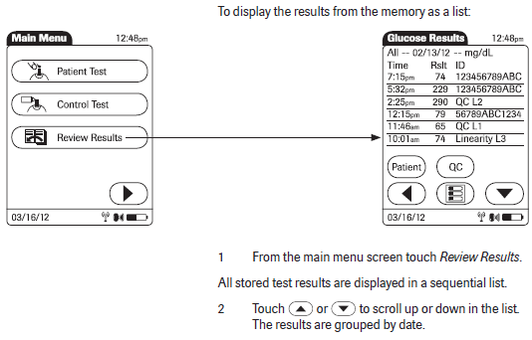
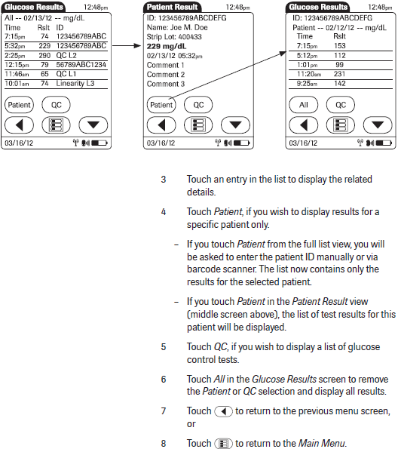

XVI. REFERENCE RANGE AND REPORTABLE RANGE

ANALYTE |  | REFERENCE RANGES |  |  |  | REPORTABLE  RANGES
 | 0 - 1 day | >1 day - 1 month | >1 month – 6 months | >6 months – 10 yrs | 10 yrs - adult
Glucose (mg/dL) | 41 - 110 | 47 - 110 | 54 - 117 | 54 - 117 | 65 - 106 | 10-600

XVII. CRITICAL VALUES

Glucose mg/dL | ≤40 ≥500

Document critical value notification per hospital policies. Ensure the critical results are given as soon as possible to the care provider who can influence care. The WRITE DOWN/READ BACK process must be repeated for each link in the chain of information exchange, including physician-to-physician reports. Refer to CPC-I-227 “Notification and Receipt of Critical Test Results from Clinical Lab or Radiology Including Notation and Read Back” for additional detail.

XVIII. ALTERNATIVE METHOD

In case of meter failure, use another meter, or a certified iSTAT operator may test on the iSTAT (for clinical units that have iSTAT available), or send a specimen to the Clinical Laboratory for testing. Notify Point of Care Testing of meter failures.

XVIX. METER MALFUNCTION

In the event of meter malfunction, call Point of Care Testing, leaving a phone message if the POC Coordinators do not pick up the phone immediately, and including callback information. Meanwhile, use a different meter, or borrow the spare meter from the Lab on B4 if your unit does not have another meter. The POC office is staffed during normal business hours M-F.

XX. LIMITATIONS AND INTERFERENCES

Sample source
There are significant differences between venous, capillary (finger or heel stick), and arterial blood glucose levels, with the venous glucose level tending to be the lowest of these three sources. These differences may be even greater depending on time elapsed since the individual has consumed food, etc. Such differences may be as much as 70 mg/dL. Unusual sample sites for capillary puncture, such as forearm, ear lobe, etc. may NOT be used for glucose testing, as even bigger differences may occur.

Shock or peripheral perfusion problems
When a patient is in shock and/or has peripheral perfusion problems, these differences are even greater. (Blood loss from trauma could be one cause). The normal processes by which glucose and other substances are distributed throughout the system are impaired. Capillary samples should not be used for these patients.

Diabetic ketoacidosis (DKA)
When a patient has a very high blood glucose (hyperglycemic-hyperosmolar state, ketotic or non-ketotic), the usual ways glucose moves between red cells and plasma, and between venous and capillary spaces, are changed. Capillary samples should not be used for these patients. Even a venous sample tested on a glucose meter may be unreliable. A venous or arterial sample may be tested by iSTAT or sent to the Clinical Laboratory for testing by standard laboratory instrumentation.

Time delay between POC test and draw of Clinical Laboratory specimen
A person’s glucose level is continuously changing. In addition, treatment (insulin, orange juice, food, exercise, etc.) may have been administered between obtaining of samples.

Hematocrit
Hematocrit should be between 10 and 65% for testing on this meter.

Specific interferences
Triglycerides >1800 mg/dL, galactose >15 mg/dL, and ascorbic acid >3 mg/dL may cause false overestimation of glucose results. (If a neonate demonstrates symptoms of galactosemia, do not use the meter; send a specimen to the Clinical Laboratory for analysis).

Glucose strip storage/reagent deterioration
Improperly stored test strips may result in unreliable results. See REAGENTS/SUPPLIES/EQUIPMENT (above).

Proper sample
Patients and samples must be identified properly and immediately. Always use correct sampling technique (see SPECIMEN and PATIENT TEST PROCEDURE above). Capillary samples must not be contaminated by substances on the patient’s fingers (cleansing agents, sugars from food, etc.) The skin prep fluid must be completely dry. Wipe away the first blood drop before testing; do not squeeze excessively. Samples drawn from or near IV lines may be contaminated with IV fluids.

Maltose
Maltose does NOT interfere with this test method.

Expected reproducibility
On the same sample tested at the same time, duplicate testing is expected to produce results ± 15 mg/dL if the glucose level is <75 mg/dL, and ± 15% if the glucose level is >75 mg/dL.

XXI. CALIBRATION VERIFICATION

Calibration verification is performed by the Point of Care Coordinator, using the manufacturer’s linearity test kit. Frequency GUIDELINE:
A. On every meter prior to initial placement for patient testing (two repetitions per level)
B. As part of the troubleshooting process when controls reflect an unusual trend or are consistently out of range; when the validity of results is questioned (one repetition per level)
C. Periodically, on a subset of meters (optional)

XXII. REFERENCES

- Accu-Chek Inform II Operator's Manual, Roche Diagnostics, Indianapolis, IN 46256, 03/2013
- Accu-Chek Inform II test strips package insert, Roche Diagnostics, Indianapolis, IN 46256, 2013
- Accu-Chek Inform II controls package insert, Roche Diagnostics, Indianapolis, IN 46256, 2012
- Accu-Chek Inform II linearity test kit package insert, Roche Diagnostics, Indianapolis, IN 46256, 2012
- CLSI Document 12-A3, Point-of-Care Blood Glucose Testing in Acute and Chronic Care Facilities; Approved Guideline – Third Edition, Vol. 33 No. 2, 01/30/2013
- Capillary Blood Sampling: An Interactive Learning Tool, Roche Diagnostics, Indianapolis, IN 46256, 2007
- Burtis C, Ashwood E, and Bruns D, editors, Tietz Textbook of Clinical Chemistry and Molecular Diagnostics – Fifth Edition, Elsevier Saunders, St. Louis, MO, 12/11
- College of American Pathologists (CAP) Commission on Laboratory Accreditation, Laboratory Accreditation Program, Point of Care Testing and All Common Checklists, 07/29/13

Revision History
Original Date
- 2/19/13 NEW. Replaces Accu-Chek GTS System (POC.191 Blood Glucose Monitoring by Accu-Chek Advantage)
- 10/18/13: Updated Configuration table. Updated references. Added/strengthened language regarding meter being dry before returning to the base unit. Added information regarding ADT verification display screens. Troubleshooting section has been expanded.

CONFIGURATION (POC COORDINATOR ONLY)

SUBJECT/ATTRIBUTE | CONFIGURATION | EXCEPTIONS
Device
ADT | On | Except: Doctors’ offices, training meters
Activity turn off | 5 minutes
Inactivity dim | 30 seconds
Beeper | High
Comments | Optional
Units of measure | mg/dL
Hours before upload warning | 2 hours | Batesville & Greensburg doctor’s office: 0 hours
Hours before upload lockout | 200 hours | Batesville & Greensburg doctor’s office: 0 hours
Delete algorithm | Automatic
Retention time | 10 days | Batesville & Greensburg doctor’s office: 200 days
Upload results before deletion | √
Strip limitation warning | Disable
Time format | 24 hours
Date format | MM/DD/YY
Date/time editing | Electronic only
Test capabilities | √ Allow linearity, √ Allow proficiency, √ Allow maintenance
Password | (Confidential to POC Coordinators)
Operator
Ability for operator to edit reagents | Password required
Time operator remains valid after power off | 0 seconds
Operator name display | Enable
Operator ID entry | Prompt (numeric)
Operator ID validation | List | Length on training meters
Operator ID entry control on glucose control | 0: no
Operator ID validation | 2: list | 1: length on training meters; max=6, min=6
Patient
Patient tab
Patient ID barcode mask | **$$$$$$$$$
Confirm patient ID | Name
Patient ID entry | Keyboard / Barcode scan
Patient ID validation | Length
Patient ID length | Minimum 9 Maximum 11
Patient ID filter lookup ID by | Account #
Filter ID by | Location
Patient ID list limit | 4000
Glucose result
Strip lot verification | Barcode scan
Critical result display | Value
Normal range | Low 54 High 117
Critical range | Low 40 High 500
Reportable range | Low 10 High 600
Critical range message | Enable; Critical – Follow hospital policy
Reportable range message | Enable; Results outside reportable range - Physician may request clinical lab test for numerical result
STAT tests allowed | 0: no
Reportable range HI limit | 600
Reportable range LO limit | 10
Reportable range message | 1: yes
Results outside of reportable range message | Results outside of reportable range - Physician may request clinical lab test for numerical result.
Strip limitations warning | 0: not displayed
Strip lot verification | 3: scan only
Linearity lot verification | 1: yes/no confirmation
QC
QC Result display | Pass/Fail
Lot verification: Control | Barcode scan
Lot verification: Linearity | Confirmation
STAT tests allowed | UNchecked
Lockout method | Hours
Passed QC lasts for | 24 hours
OTE
OTE functionality | Disabled
Power Up

QC Comments | Order
Procedure Error | 1
Repeat Test | 2
Replace QC | 3
Replace strips | 4
Take out of service | 5
Procedure Error comment removes that data point from QC statistics.

Patient Comments | Order
Procedure Error | 1
Repeat test | 2
Fasting | 3
Pre meal | 4
Post meal | 5
Received meds | 6
Lab drawn | 7
Research deidentify | 8
Procedure Error and Research deidentify comments stop patient result from crossing the interface.

