**Name______________________________________ Date_________________**

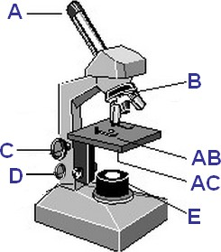

1. On the image, which letter represents the objective?

B

2. On the image, which letter represents the coarse adjustment knob?

C

3. On the image, which letter represents the fine adjustment knob?

D

4. On the image, which letter represents the stage?

AB

5. Turning which of the following knobs moves the objective lenses the greatest vertical distance?

1. coarse focus knob
2. fine focus knob

6. Which of the following regulates the amount of light passing through the slide specimen on the microscope stage?

1. Nosepiece
2. objective lens
3. iris diaphragm lever
4. fine focus knob

7. When using the high power objective, you should not adjust the:

1. coarse focus
2. fine focus
3. diaphragm
4. stage clips

8. Which of the following describes proper microscope care and technique?

1. Be sure to carry the microscope upright, with one hand on the arm and the other under the base.
2. To protect the optics of the microscope, place it down gently and don't drag it across the tabletop.
3. Always begin focusing with the lowest power lens available.
4. Only use the coarse focus knob with the scanning and low power lenses.
5. All the above are examples of correct microscope care and technique.

9. Microscopy testing is tracked by proper documentation on the “Provider Performed Microscopy Log”

1. True
2. False

10. Microscopy testing results must be documented in:

1. The patient’s EMR
2. The “Provider Performed Microscopy Log”
3. It is not necessary to document PPMP results