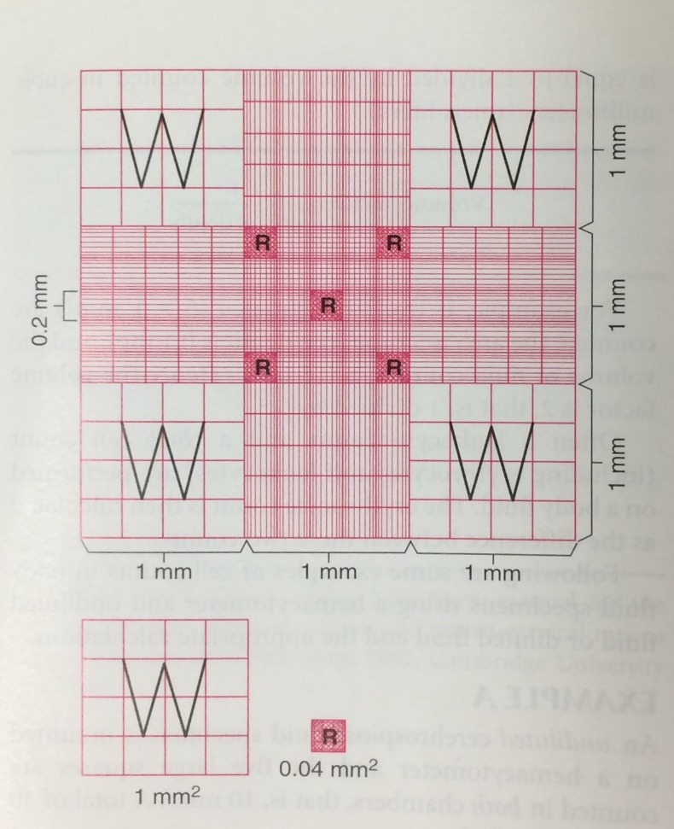

Side 1: Total # WBC 26 Side 2: Total # WBC 28 Side 1: Total # RBC 12 Side 2: Total # RBC 13

Average Total # WBC 27 Average Total # RBC 13

Dilution 1:10 Dilution 1:10

Total large WBC squares counted each side 9 Total small RBC squares counted each side 5