**DIFFERENT TYPES OF PIPETTES**

Pipettes are used in scientific labs. Their specific purpose is to suck up a liquid of the lab user's choosing, then contain the liquid so it can be transferred into another container. Some pipettes are not very precise and are meant more for transferring than measuring liquid, while others are very precise and measure the volume of liquid.

Volumetric Pipettes



Nicolas Loran/iStock/Getty Images

Volumetric pipettes are used to transfer a specific volume of a given liquid. It usually has a capacity of between 1 and 100 mL. They can be shaped somewhat like a rolling pin, with two thinner ends and a thicker bulge in the middle. These are used when precision in measuring the transferred liquid is important for recording.

Measuring Pipettes

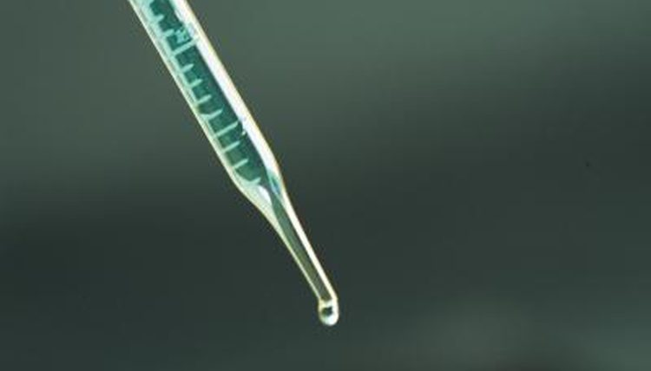

Jupiterimages/Photos.com/Getty Images

Measuring pipettes are straight tubes with one tapering end. They have clearly marked hash marks along the side of the tube, so multiple amounts of liquid can be measured with a single pipette. These kinds of pipettes can usually measure a volume between 0.1 mL and 25 mL. While they can measure multiple amounts of liquid at once, imperfections in their tube's internal diameter means they are not as precise in their measurements as volumetric pipettes.

VIDEO OF THE DAY

SAP_180126_Quitting_Your_Day_Job_and_Going_Freelance 16x9 V2

01:07

01:07

Brought to you by [Sapling](https://www.sapling.com/)

Brought to you by [Sapling](https://www.sapling.com/)

Mohr and Serological Pipettes



moodboard/moodboard/Getty Images

Measuring pipettes are further subtyped into Mohr pipettes and serological pipettes. The difference between these two types is that Mohr pipettes' hash marks, or gradations, always end before the pipette's tip, while serological pipettes have gradations that continue down into the tips. Additionally, some serological pipettes are also blow-out pipettes. These pipettes have an open top, much like a straw, where the user holds his thumb over the top to create the vacuum and seal the liquid in the pipette. Blow-out pipettes allow you to blow into this open end to get the last bits of liquid left in the pipette into your receiving container, for greater accuracy. Blow-out pipettes are clearly marked with a frosted band or two thin rings around the neck. Do not mistake a color coding from a manufacturer for the markings of a blow-out pipette. While you can use blow out pipettes in their intended manner, it is dangerous to do this with a pipette that is not clearly marked as being a blow-out.