**i-STAT Total B-hCG Cartridge**

**New User Quiz**

**NAME__________________________EMPLOYEE ID________________DATE___________**

**Please circle the correct answer**

1. What best describes acceptable specimen conditions for i-STAT B-hCG testing?
2. The blood tube should be filled to the manufacturer’s fill mark
3. Specimens should be gently but thoroughly mixed/rolled/inverted 10 times before testing
4. At least two drops of blood must be expelled as waste prior to filling the cartridge
5. All of the above

2. What type of sample collection tube is appropriate for i-Stat B-hCG testing?

1. Green Top (Lithium/Sodium Heparin)
2. Purple Top (EDTA)
3. White Top/Syringe (No Anti-coagulant)
4. All of the above

3. Interpret this result:

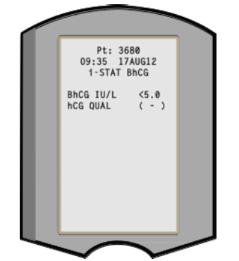

1. Negative
2. Positive
3. Indeterminate

4. Interpret this result:

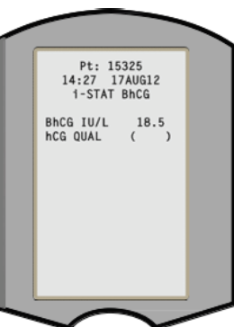

A. Negative

B. Positive

C. Indeterminate

5. Forbes Hospital Emergency Department protocol for Indeterminate B-hCG results requires a specimen be sent to the laboratory for a Total hCG.

1. True
2. False

6. Interpret this result:

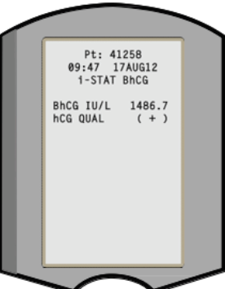

1. Negative
2. Positive
3. Indeterminate

7. Samples collected for B-hCG testing on the i-Stat must be tested within 30 minutes of collection.

1. True
2. False

8. Cartridge results, which are not reportable, based on internal QC rejection criteria, are flagged “***”

1. True
2. False

9. All i-Stat B-hCG results must have the interpretation manually entered in Epic using the Enter/Edit function.

1. True
2. False

10. i-Stat B-hCG results are ready in 10 minutes

1. True
2. False

**SCORE_____________________________EVALUATOR____________________DATE________**