Red blood cell inclusion bodies are pieces of stainable material within red blood cells, mainly due to retained remnants of cellular components.

* **Common Red Cell Inclusions**
* **Howell Jolly bodies** - DNA fragmentsSeen post splenectomy and in functional hyposplenism
* **Basophilic stippling** - RNA fragmentsSeen in haemoglobinopathies and heavy metal poisoning
* **Pappenheimer bodies** - clumps of ferritinSeen post splenectomy, in sideroblastic anaemia and in lead poisoning
* **Cabot ring** - strings of mitotic spindle remnantsSeen in megaloblastic anaemia, MDS and myelofibrosis
* **Heinz bodies** - clumps of denatured haemoglobinSeen on supravital staining in oxidative haemolysis, e.g. G-6-PD deficiency
* **HbH bodies** - clumps of haemoglobin H (four beta chains)Seen on supravital staining in HbH disease, i.e. alpha thalassaemia major

## Howell Jolly Bodies

Howell Jolly bodies are basophilic inclusions within the cytoplasm, made up of DNA fragments.



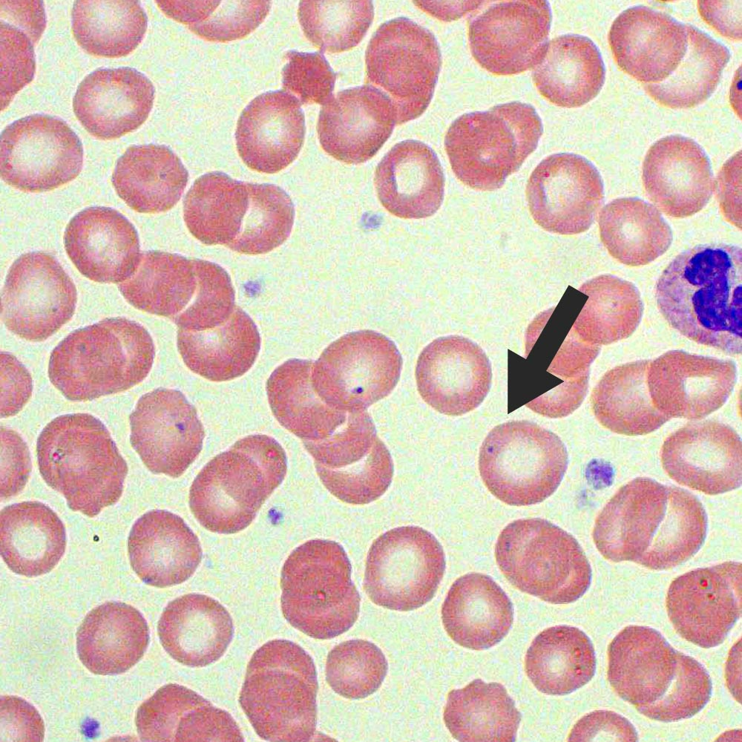

Howell Jolly bodies are classically seen following splenectomy, though may also occur in patients with any cause of hyposplenism.

### Causes of Howell Jolly Bodies

* **Post-splenectomy**
* **Functional hyposplenism** - sickle cell anaemia, liver cirrhosis, SLE, rheumatoid arteritis, coeliac disease, inflammatory bowel disease, splenic artery / vein thrombosis, amyloidosis, sarcoidosis

## Basophilic Stippling

Basophilic stippling is the presence of irregular basophilic granules, made up of RNA fragments.



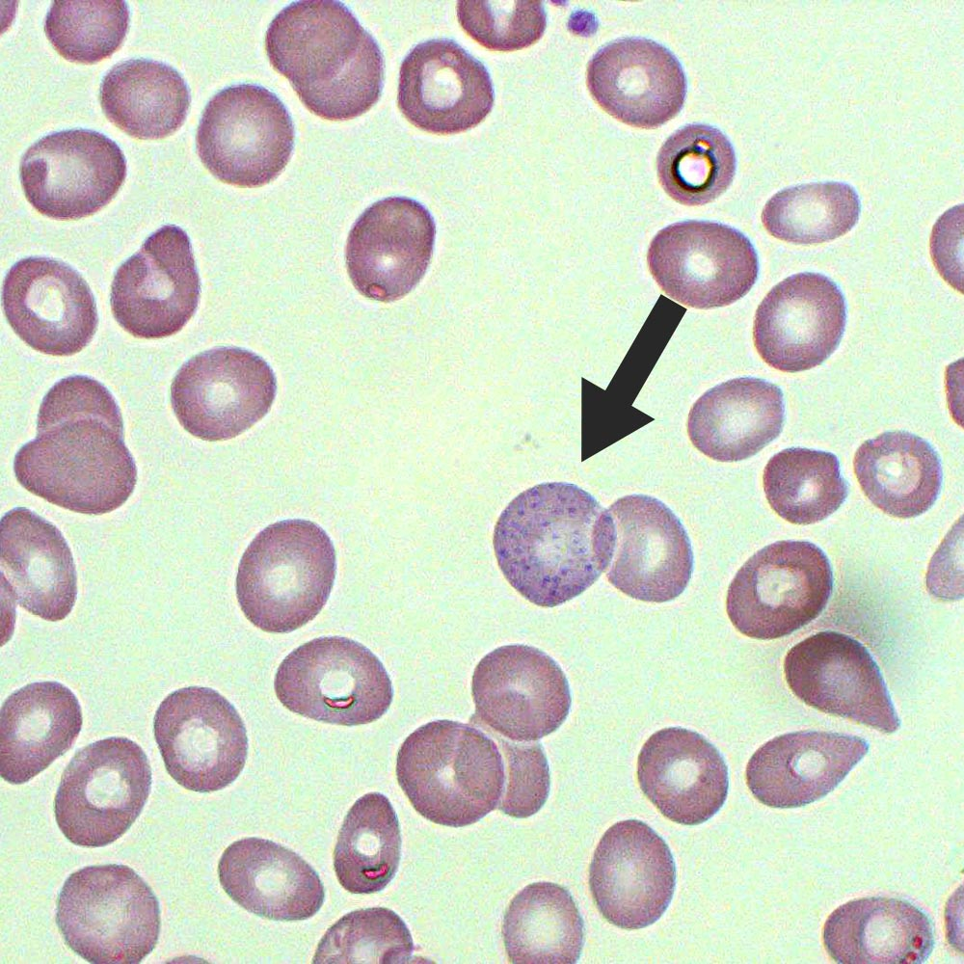

### Causes of Basophilic Stippling

* Thalassaemia
* Sideroblastic anaemia
* Unstable haemoglobins
* Myelodysplastic syndromes
* **Heavy metal poisoning** - lead, arsenic, mercury

## Pappenheimer Bodies

Pappenheimer bodies are basophilic inclusions seen in the periphery of red blood cells, made up of ferritin.

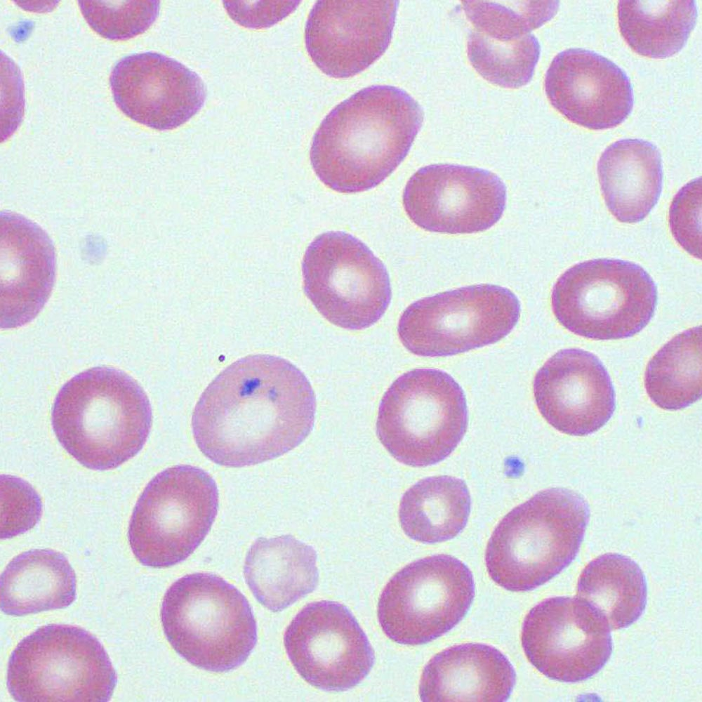

### Causes of Pappenheimer Bodies

* Post-splenectomy
* Sideroblastic anaemia
* Lead poisoning

## Cabot Rings

A cabot ring is a basophilic loop seen within red blood cells, made up of mitotic spindle remnants.

* 

### Causes of Cabot Ring

* **Megaloblastic anaemia** - B12 / folate deficiency, drugs
* Myelodysplastic syndrome
* Myelofibrosis