FH9-B 2021
BCP -18

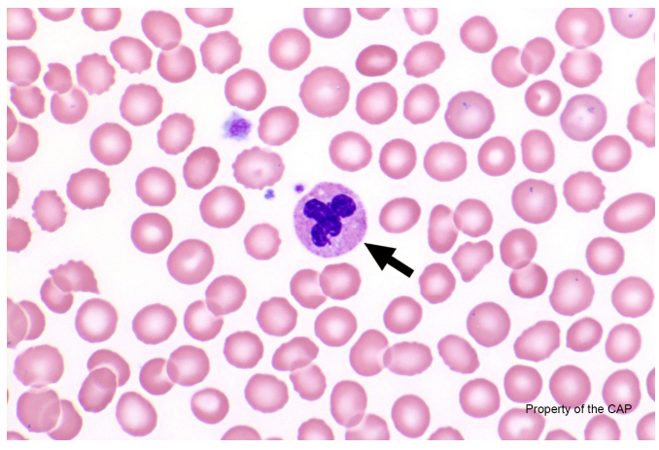

The arrowed cell is a neutrophil. Segmented neutrophils are the predominant blood leukocyte. They are about 10 to 15 μm in diameter, round to oval, and display pale pink cytoplasm with specific granules. The N:C ratio is 1:3, and the nuclear chromatin is highly condensed. The nucleus is segmented or lobated, with a normal range of three to five lobes. The lobes are connected by a thin filament that contains no internal chromatin, giving it the appearance of a solid, dark, threadlike line.

Admittedly, it can be challenging to make that determination on a single photomicrograph, and it is best to review the entire slide and assess the overall granulation of neutrophils.

