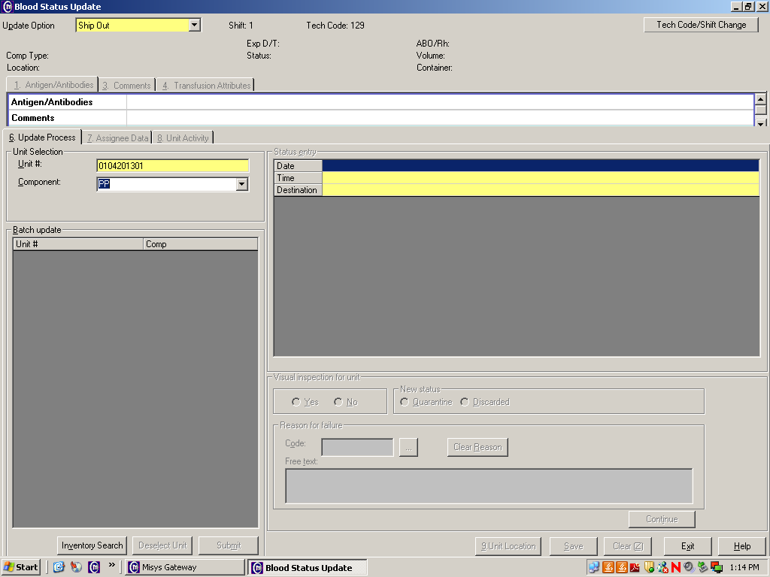

- The facility that is SENDING the blood product “Ships Out” in the computer.

