[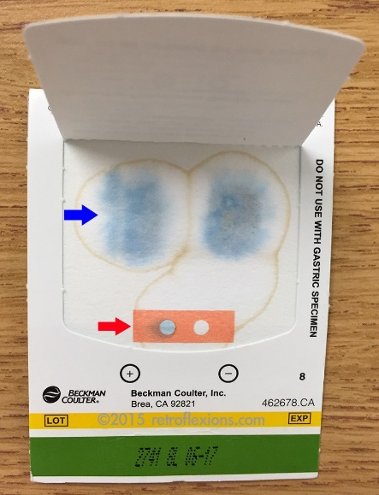](http://www.google.com/url?sa=i&rct=j&q=&esrc=s&source=images&cd=&cad=rja&uact=8&ved=0ahUKEwjxw7LIsoLWAhUFh1QKHSsvCwcQjRwIBw&url=http://retroflexions.com/evidence-based-gastroenterology/occult-gastrointestinal-bleeding-and-the-stool-guaiac-test/&psig=AFQjCNHmpR8qALcEnyStmcHHO_AUVX1qig&ust=1504300422797895) [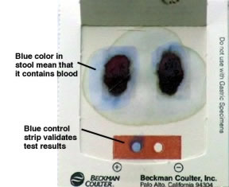](http://www.google.com/url?sa=i&rct=j&q=&esrc=s&source=images&cd=&cad=rja&uact=8&ved=0ahUKEwjms5rYsoLWAhWGjlQKHcsqCCIQjRwIBw&url=http://www.medword.com/Gastro/hemoccult.html&psig=AFQjCNHmpR8qALcEnyStmcHHO_AUVX1qig&ust=1504300422797895)

