ED Meditec Yearly Evaluation Quiz

You will be quizzed on your navigational knowledge of the core ED resources located in Meditech. This quiz has been initiated to help you sharpen your skills and maintain compliance. These are the daily processes of the ED Phlebotomist III, so you must score 100%; each question is worth 20 points, with one additional bonus question. If you score below 100% an assessment/ action plan will be initiated to monitor your functionality and comprehension of the ED Phlebotomists’ role.

- List the steps prior to this screen:

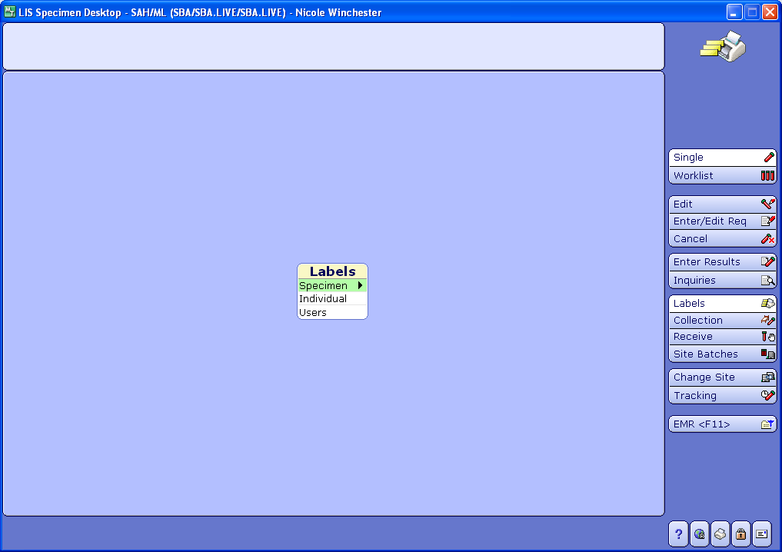

- A verbal order for a cardiac POCT has been ordered prior to you drawing a patient, the doctors asks if you can enter the order. Which is the correct order to lead you to the screen for entering an order in Meditec?
- Laboratory Live, St. Agnes Hos., Specimen desktop, enter edit/ req
- Order Entry Live, St. Agnes Hospital, St. Agnes Hos., enter orders
- Laboratory Live, St Agnes Hosp., Requisition Desktop
- A and C

- Patient states that he/she has had blood drawn in the triage area, but the doctor ordered a cardiac enzymes times two. Explain how you would go about checking to see if you can add this test on, and at what point do you collect the second set of enzymes?

- Where do you find this page, and what is its primary function?

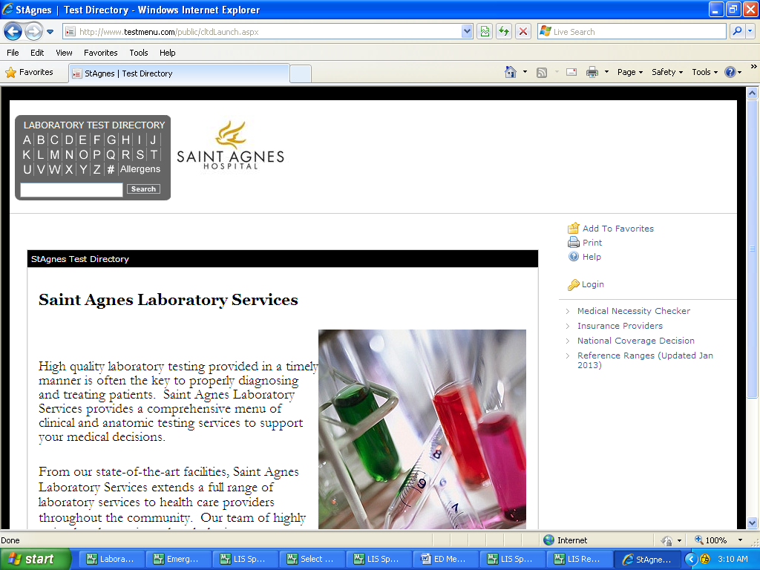

- Name this screen. What queues should be your primary focus? If you need to check if the patient has had blood drawn which function could you utilize on this screen?

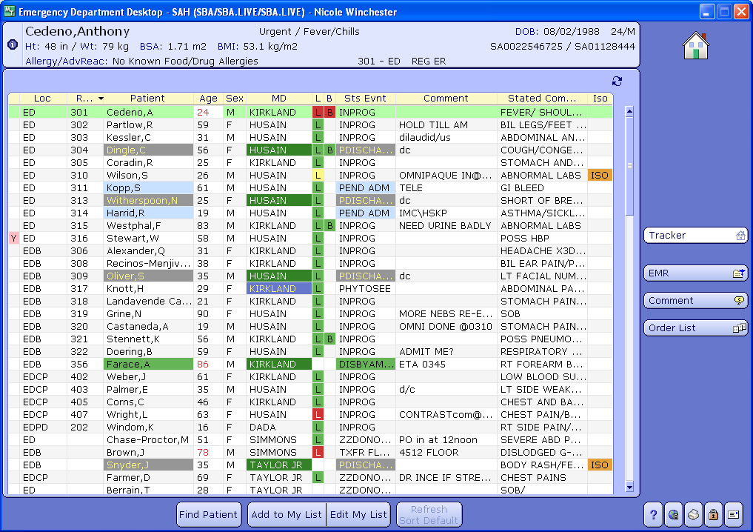

*Bonus*

If a patient is off the unit, what should you do to his/her order? Explain your steps

