Cancellation of test in SNPHL LIMS 11 13 2010
Tests may be cancelled for the following reasons:
- Cancelled by submitting facility
- Cancelled by SNPHL due to unacceptable sample, discrepant requisition, laboratory accident, or duplicate test

Tests cancelled by submitting facility
The submitting facility must provide an SNPHL “Authorization Form for Cancellation of Laboratory Testing”. Forms are located on the shared SNPHL folder under QA forms. Once the written authorization to cancel testing is received then:

- Order Cancelled Test (CTEST)
- Delete tests to be cancelled. NOTE: If HIV or Syphilis test is deleted, print Order screen prior to deleting tests and give to Immunology. These tests must be deleted from the EVOLIS worklist by immunology.
- Post result for CTEST by typing the word “CTEST” into the result field. This is a previously created Macro which will provide the following data fields:

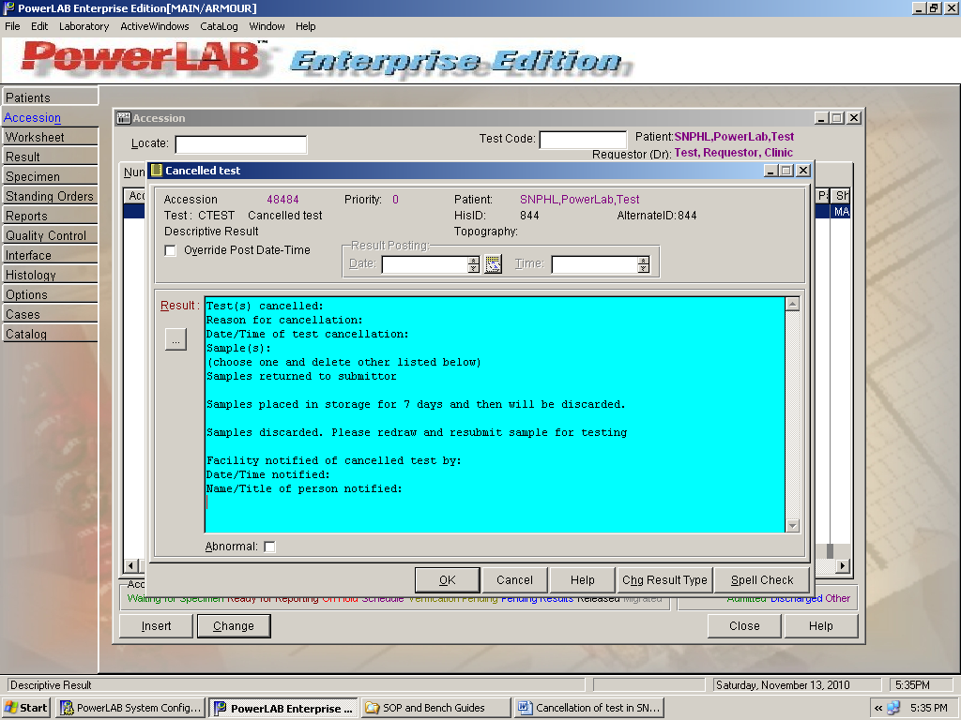

Post information as listed in the Macro. Be sure to enter only (1) sample comment and delete the others listed in the Macro.
When posting contact names into LIMS, use initials or first name only. Enter full names and phone numbers in non-reportable notes.

- Print Cancelled test worksheet. Verify results.
- Attach worksheet and authorization form to original paperwork and scan to LIMS
- Send final report to submittor. If sending tubes back to submittor, include the final report with the tubes in bag.

Tests cancelled by SNPHL
If SNPHL cancels a test due to sample integrity, lab accident, or discrepant requisition, then an “Authorization Form for Cancellation of Laboratory Testing” is not required.

The submitting facility must be notified of the test cancellation.
Follow steps 1-6 listed above for cancellation of tests by SNPHL.

