Alere Determine™ HIV-1/2 Ag/Ab Combo Competency Test

1. The Alere Determine™ HIV-1/2 Ag/Ab Combo tests for:
2. HIV 1 Antibody
3. HIV 2 Antibody
4. HIV-1 p24 antigen
5. All of the above
6. You check the temperature in the lab where the test kits are stored and note the temperature is 89°F. You have a patient scheduled for an HIV test in 15 minutes. You should:
7. See the patient and perform the HIV test
8. Perform Quality Controls prior to performing an HIV test on the patient
9. Order Proficiency Testing Kit and reschedule the patient after the proficiency testing is successfully performed
10. Discard the test kits and reschedule the patient when your new shipment arrives
11. Prior to performing the test, you explain the process to the patient. You tell them:
12. You will collect a blood sample by pricking their finger
13. You will collect a blood sample by drawing blood from a vein in their arm
14. You can collect a blood sample either from their finger or a vein in their arm
15. You can collect a blood sample from their finger or an oral swab
16. To collect the blood sample properly, you would:
17. Raise the hand, perform the fingerstick, and squeeze the finger until an adequate sample is collected without squeezing the bulb of the capillary tube
18. Raise the hand, perform the fingerstick, and milk the finger until an adequate sample is collected by squeezing the bulb of the capillary tube
19. Lower the hand, perform the fingerstick, and milk the finger until an adequate sample is collected by squeezing the bulb of the capillary tube
20. Lower the hand, perform the fingerstick, and milk the finger until an adequate sample is collected without squeezing the bulb of the capillary tube
21. After the blood sample is placed on the sample pad, how long should you wait before adding the drop of chase buffer to the pad?
22. Add the buffer immediately
23. Wait 30 seconds
24. Wait 1 minute
25. Wait 2 minutes
26. The test should be timed and the results should be read:
27. As soon as 10 minutes but not more than 20 minutes
28. As soon as 20 minutes but not more than 30 minutes
29. As soon as 30 minutes but not more than 40 minutes
30. Can be reported sooner if reactive but must wait 30 minutes to confirm non-reactive
31. You perform the test and see the result below. You tell the patient:

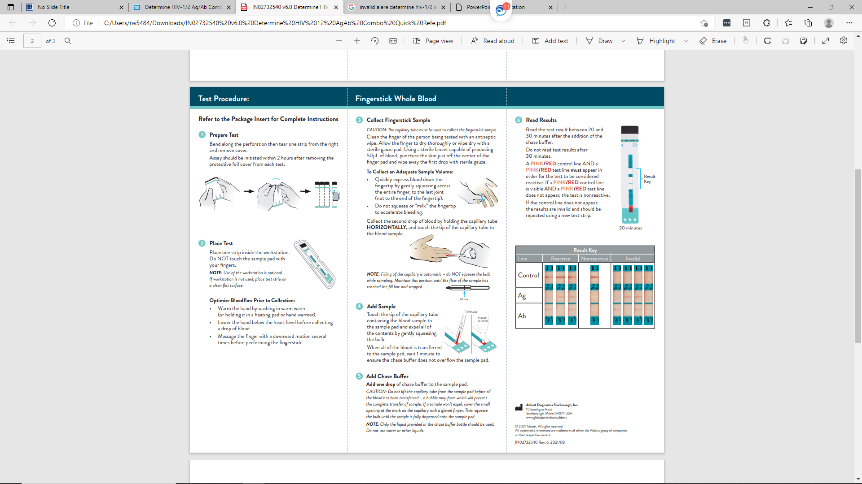

1. Their results are non-reactive (negative) for HIV
2. Their results are reactive (positive) for HIV
3. Their results are invalid and the test should be repeated
4. Their results are indeterminate and they should have their blood drawn for send out instead
5. You perform the test and see the result below. You tell the patient:



1. Their results are non-reactive for HIV
2. Their results are reactive for HIV but the rapid test should be repeated for confirmation
3. Their results are reactive for HIV and confirmatory testing needs to be performed with a blood draw to send out
4. Their results are reactive for HIV and they should be immediately referred to an infectious disease specialist
5. You perform the test and see the result below. You tell the patient:

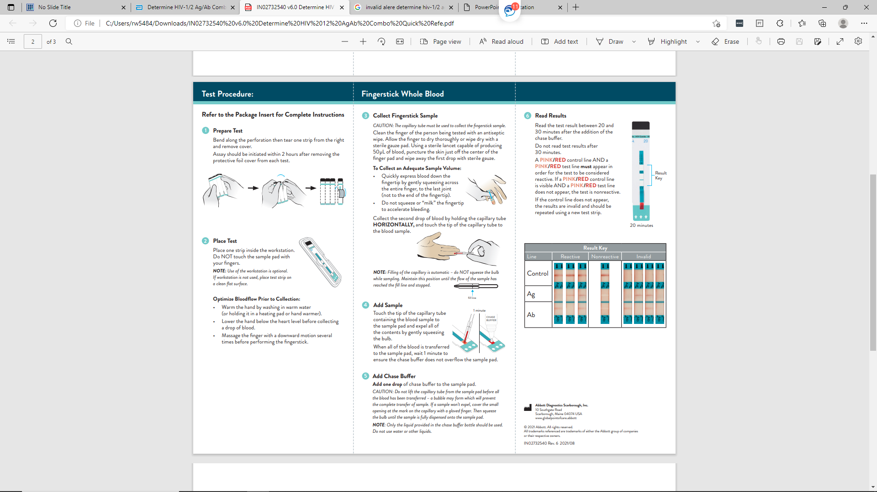

1. Their results are non-reactive for HIV and they should re-test in one year
2. Their results are reactive for HIV and they need confirmatory testing
3. Their results are non-reactive for HIV but it could be too early to detect. They should repeat if they have had any high-risk behavior in the last 45 days
4. Their results are non-reactive for HIV but it could be too early to detect. They should repeat if they have had any high-risk behavior in the last 90 days
5. When should quality controls be performed?
6. When a new shipment arrives
7. Once a day
8. Once a week
9. a and c