**Competency for LCTs: Specimen Collection, Processing, Sendouts and Crediting**

1. The MN Dept of Health receives the following specimens for Newborn Screening. Which of the specimens will be rejected?
2. I, III, and V
3. II and IV
4. IV only
5. All can be used for testing
6. **None can be used for testing (I, III and V are improperly filled, II is not air dried, IV is not filled w/blood)**
7. 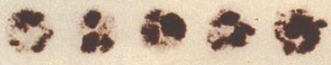
8. 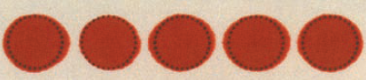
9. 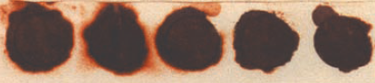
10. 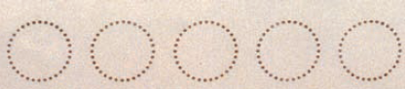
11. 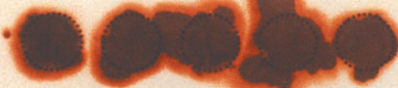
12. According to Lab Guide: What is the preferred tube type for Methotrexate?
13. Green (lithium heparin, gel)
14. Red (no gel)
15. **Purple (no gel)**
16. Green (lithium heparin, no gel)
17. According to Lab Guide: What is the alternate tube type for Methotrexate?
18. Green (lithium heparin, gel)
19. **Red (no gel)**
20. Purple (no gel)
21. Green (lithium heparin, no gel)
22. According to Lab Guide: What is the special “Collection Instructions” for Methotrexate?
    1. No special collection instructions are necessary
    2. Keep specimen at 37oC after collection and let clot for 30 minutes before processing
    3. **Protect from light immediately after collection(wrap tube in foil or paper towel)**
    4. Specimen cannot be sent to the lab using the PTS (pneumatic tube system)
23. According to Lab Guide: What is the test code for Methotraxate?
    1. METH
    2. METX
    3. **MTX**
    4. MTRX
24. When must the phlebotomy charge be credited?
    1. Never
    2. When a specimen with a phlebotomy charge is canceled or credited and none of the tests ordered on that Accession number are to be reported
    3. When a patient is drawn for testing at the same time that includes *2 separate Accession* *numbers* (example: chemistry and blood cultures) AND a phlebotomy is charged to both, one must be credited.
    4. When I remember to do it
    5. **B and C**
25. What is the test code(s) for a phlebotomy charge?
    1. CRVPT
    2. CRCAP
    3. **CRVPT and CRCAP**
    4. None of the above
26. What does CRVPT credit?
    1. A capillary collection
    2. **A venipuncture collection**
    3. Both capillary and venipuncture collection
27. What does CRCAP credit?
    1. **A capillary collection**
    2. A venipuncture collection
    3. Both capillary and venipuncture collection
28. In what LIS function is the crediting done?
    1. Order Entry
    2. MECAN
    3. SMART
    4. **GenLab**
29. How is this done?
    1. **Using “Order Receipt/Modify; select the correct Accession #; order the CRVPT or CRCAP as an additional test. Save and Click “OK”**
    2. Using “Order Receipt/Modify”; select the correct Accession #; click on the workload box and remove (delete) the CRVPT or CRCAP from the left side of the screen. Save and Click “OK”
    3. Using “Credit”; select the correct Accession #; order the CRVPT or CRCAP as an additional test. Save and Click “OK”
30. Why is it important to credit the phlebotomy charge?
    1. To not be fraudulent in our billing practices
    2. We cannot charge for a phlebotomy collection when the test(s) have not been performed
    3. **All of the above**
31. When performing a QTB collection by venipuncture:
    * + - 1. Expect the tubes to fill slowly and collect 1.0 mL of blood.
          2. Leave tube on the needle for 2-3 seconds after the flow has stopped.
          3. Shake the tubes firmly 10 times to ensure the inner surface of the tubes is coated with blood.
          4. **All of the above**
32. What do you do if a QTB tube has a meniscus that falls just barely above the line?
    * + - 1. The test should be cancelled.
          2. **It is acceptable for the tubes to be filled 0.8-1.2 mL.**
          3. Do not incubate, place in refrigerator.
          4. Call the client and have them redraw the specimen.
33. What do you do if one of the QTB tubes is filled only halfway to the line with blood?
    * + - 1. The receiving lab should cancel the test and notify the client that collected the sample.
          2. Place the sample in the incubator for 16-24 hours.
          3. Send a SBAR to Endocrine to cancel the test.
          4. It is OK if the other tubes are filled to the line.
          5. When drawing, be sure to check the volume in each tube. If any tube is not filled appropriately, redraw the patient.
          6. **a and e**

16. Label all three QTB tubes with the same CID.

* + - * 1. **True**
        2. False

1. Which of the following are on-line resources for information on collection, processing, aliquoting and transport of laboratory tests?
   1. Fairview Reference Lab Test – LSMISC
   2. Fairview Labguide
   3. ARUP website
   4. Mayo website
   5. **All of the above**
2. Whole blood ketones must be tested within how long after collection?
   1. 15 minutes
   2. **30 minutes**
   3. 2 hours
   4. 3 days
3. The specimen for whole blood ketones is spun in the centrifuge before testing.
   1. True
   2. **False**
4. If correct information is not included on a sample, laboratory staff will cancel as unlabeled/mislabeled per the Patient Identification and Laboratory Specimen Labeling policy.
   1. **True**
   2. False
5. What is the correct information to be included on a sample label?
   1. Patient first and last name, DOB, date and time collected, specimen source if appropriate
   2. Patient last name and first initial, DOB, specimen source if appropriate
   3. **Patients first and last name, MRN, date and time collected, initials/tech code of person collecting specimen, specimen source if appropriate**
6. A specimen is ready to be centrifuged. The testing location on the label is SDEC. What should you do?
   1. Centrifuge the specimen. Nothing else needs to be done.
   2. Assume it has been decanted in SMART and put it in the centrifuge.
   3. **Perform decant in SMART and label the specimen with the new label. Place the specimen tube in the appropriate rack or centrifuge the sample if ready. Place the new label in bin.**
7. Which of the following are true statements when crediting a test?
   1. For an order with a specimen never collected, nothing resulted and physician does not need to view, cancel by clicking on ‘Remove Results’ in Genlab credit function.
   2. For an order with a specimen that was collected, a result was entered or a comment entered with useful information for the ordering physician, cancel by clicking on ‘Retain Results’ in Gen Lab credit function.
   3. A test cancelled with ‘Retain Results’ requires two steps: resulting in MECAN and crediting in Gen Lab.
   4. **All of the above**
8. When all testing are credited on an order the patient cannot be charged for a collection.
   1. **True**
   2. False