Saratoga Hospital Laboratory
211 Church Street, Saratoga Springs, NY 12866

Chain of Custody Urine Drug Screen Collection: E-Screen

Principle:
All Chain of Custody Urine Drug collections (DOT and non-DOT) are performed consistent with
established Department of Transportation (DOT) Guidelines (49 CFR Part 40). These guidelines define how all
collector training is performed and the reasons for testing.

Reasons for testing include:
- Pre-employment
- Random
- Reasonable suspicion
- Post accident
- Return to duty
- Follow-up

Definitions and Abbreviations:

 | Abbreviation | Definition
Donor |  | Person submitting urine for testing.
Collector |  | Trained individual who instructs and assists donor at collection site, initiates and completes COC Drug Testing form.
Urine Drug Screen | UDS
Chain of Custody | COC | Process used to describe documentation of collection and transfer of urine specimen from Donor to collector, to courier, to lab.
Chain of Custody | COC
Custody and Control Forms | CCF | Drug Testing Forms (DOT and non-DOT), often preprinted, laboratory specific duplicate forms used for chain of custody procedure.
Commercial Driver’s License | CDL
Designated Employer Represenitive | DER
Department of Transportation | DOT | Federal agency: sets standards for all commercial drivers.
Substance Abuse & Mental Health Service | SAMSA | Federal agency: sets standards for drug testing procedures.
NIDA (Federal/Regulated) |  | Term used synonymously with DOT collection.
NON-NIDA (Forensic/Non-regulated) |  | Term used to describe urine drug screen collection process that is not DOT – specific lab and company.
Medical Review Officer | MRO | MD/DO who has met specific criteria for training in field of forensic substance abuse and the legal aspects of drug testing.
UDS Bathroom |  | A secure restroom without potential sources for adulterations of urine specimen (i.e., no soap, bluing agent in toilet, water source off).

DOT Collection: To be performed if the employee states they have a CDL license AND the employee’s company is listed on the client list as a requestor of DOT testing, or if the employee comes in with their own DOTCCF.

NON-DOT Collection: To be performed if the employee’s company is listed on the client list as a requester of NON-DOT testing, or the employee comes in with their own NON-DOTCCF. A CDL license holder can have a non-DOT drug test requested by their employer.

Quality Control:

Internal Quality Control
- Each e-cup lid is equipped with a left internal and a right internal quality control. These controls check the following.
  - Specimen is urine.
  - e-Reader is working correctly.
  - e-Cup has not been altered.
- Internal QC is interpreted digitally through the e-Reader.

External Quality Control
- One Positive and one Negative control must be run:
  - On each new lot of e-Screen containers.
- QC will be performed by a variety of testing personnel including all individuals who perform Urine Drug Screen Testing.

Procedure

- Retrieve two eCups & lids from eCup supply inventory. Record the lot # from the eCup box and the reader Identification number on Attachment 4: eCup QC Test Log.
- Login to the eScreen system and from the Donor Waiting List; click CHECK IN (far right).
- Click NO BARCODE AVAILABLE.
- Enter an "X" in the Employee ID field and click FIND DONOR.
- At Find Donor's Employer Screen, enter the first letter of Client name (C) and click FIND EMPLOYER. You will be searching for Clinic QC Account (100368).
- Find the above client name from Client List and click on client name.
- At the Check in Donor screen, enter the Donor's name as QC for the last name, and Positive or Negative for the first name (dependent on which is being performed.).
- Enter 000-00-0000 for the SSN, the current date for the birth date, and the location’s phone number (The positive and negative controls need different and sequential SSN’s).
- NON-DOT Test should already be selected. Select e-Reader Instant Test.
- Select Pre-employment for "Reason For Test".
- Click on BEGIN TEST.
- Select your User Name and enter your password, and Click on LOG ON.
- At Verify ID and Donor information, click on NEXT STEP.
- Indicate NO for Signs of Adulteration. Click YES for “Is there sufficient quantity of specimen? Click YES for “Is the specimen within temperature range?”
- Click on NEXT STEP.
- Scan or enter barcode from the eCup lid. Click on VALIDATE.
- Pour the QC specimen into the eCup. Assemble the eCup lid and cup.
- Click GENERATE and then click SIGN WITH EPAD (top, far left next to done).
- Sign the ePad with the donor (QC) and click on COMMIT SIGNATURE.
- Sign as collector on the ePad and click on COMMIT SIGNATURE.
- Click NEXT STEP at the CCF screen. Print a copy of the CCF at this time
- Confirm "eReader is ready" appears at the top of the screen. Place the eCup in the eReader and click on PROCEED WITH TEST.
- When the test is complete, a message applet box will appear in the lower right-hand corner of the screen asking the collector to verify a message.

For a Positive QC Sample:
- If a positive sample was run, the eScreen system should respond, with "Send to Lab."
- Record the following on Attachment 5: eScreen Quality Control Test Log.
  - Date
  - eReader ID
  - Control Specimen Info
  - eCup Label
  - Performed By
  - eReader Result
- If the eReader does not generate a "Send to Lab" response on your Positive QC sample, please fax Attachment 5: eScreen Quality Control Test Log to eScreen at the number provided on the Test Log. Do not use e-Screen system reader if quality control does not perform as expected.

Note: The collector must click OK in message applet box before running another test.

For a Negative QC Sample:
- If a negative QC sample was run, the eScreen system should respond with "Discard Specimen".
- Record the following on Attachment 5: eScreen Quality Control Test Log.
  - Date
  - eReader ID
  - Control Specimen Info
  - eCup Label
  - Performed By
  - eReader Result
- If the eReader does not generate a "Send to Lab" response on your Positive QC sample, please fax Attachment 5: eScreen Quality Control Test Log to eScreen at the number provided on the Test Log. Do not use e-Screen system reader if quality control does not perform as expected.

Note: The collector must click OK in message applet box before running another test.

Collection Procedure:
BOTH the DONOR and COLLECTOR maintain visual contact with the specimen AT ALL TIMES until the specimen is sealed and labeled
Observed specimen collections: See section labeled Direct Observation.

- Client Company orders UDS using one of the following methods:
- E-Screen ePassport
- Corporate Health Services (CHS) form.
- Designated Employer Representative accompanies employee.
- Employee arrives with COC form.
- Telephone order from Client Company; documented on the “Verbal Order for Laboratory Test” form.

- Registration registers the individual to an appropriate account.
Note: In post accident cases where the patient has been seen in the Emergency Department, registration must register the UDS under a separate X0# using a short form registration.

- Collector must identify the employee. Individual being tested must provide an acceptable form of donor identification (See Attachment 1 for details):
- Acceptable Forms:
  - Photo ID: Original Driver’s License, or Employee ID.
  - Employer Representative: Supervisor or Human Resource Representative. Need to take the ID of the Representative.

Note: If Donor identity cannot be verified by one of the above methods, contact the DER.
Note: DOT rules state that the collection should proceed, but performer must note in the “remarks” that no photo ID was available. The donor must produce two items of identification bearing his/her signature. Under remarks write the method of identification bearing the donors signature that was used. Also state whether the signatures appeared to match. If they do not match the e-Screen signature, state this under remarks and notify the DER.

The collection should not proceed until positive identification is provided.

- Unacceptable Forms:
- Social Security cards, ATM, credit card, and school IDs. These forms are not issued by a state or federal agency, and are easily reproduced.
- Faxed or photocopied ID cards.
- Coworker other than employee’s supervisor or Human Resource Representative.

- Collector photocopies photo ID.

- Lab staff order COC drug screen in the lab module.

- Collector explains collection procedure to the donor.

- Prepare collection site.
- Secure water sources: unavailable (water shut off or tape faucets).
- Add bluing agent in water of bowl & tank; and/or tank lid secured.
- Remove soap, cleaning agents, disinfectants and other possible adulterants.
- Inspect for foreign or unauthorized substances.
- Secure undetected access.
- E-Screen terminal & printer
- E-screen Reader

- Donor is asked to remove outer garments: coat(s), hat, and jacket.
- Wallet may stay with Donor.
- Purses, briefcases, etc. are locked in hospital lock box.

Note: Collector must request donor to display items in pockets. If item is found that could adulterate specimen, secure item in lock box. If no such items exist, items can be put back in pockets.

Under no circumstances may a Donor be directed to remove clothing and put on a hospital gown

- Collector watches donor wash and dry hands. Donor is informed not to rewash hands until after specimen has been given to collector.

- If Donor has presented a passport, Collector scans the barcode on the passport.

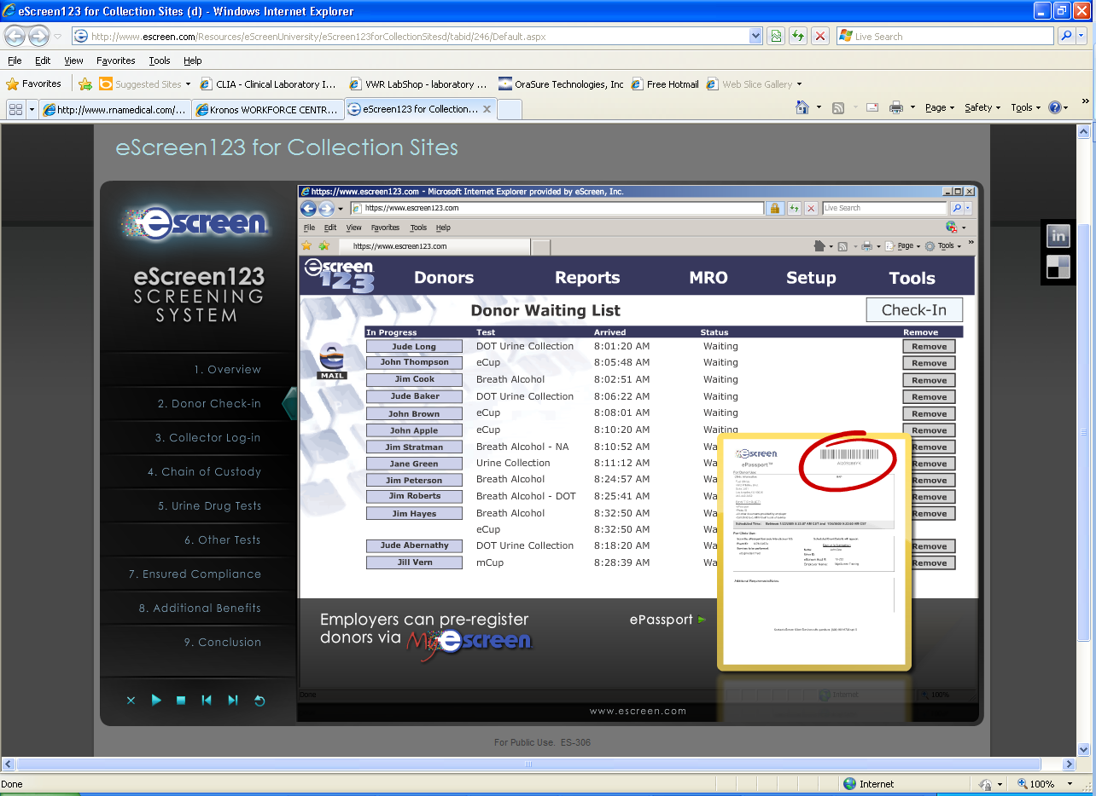

Note: If Donor does not present a passport click “no barcode”.
Note: Scan the barcode on the wall marked “Employees of Saratoga Hospital” for Saratoga Hospital pre-employment screening.

- Collector enters User Name and Password into Logon Screen.
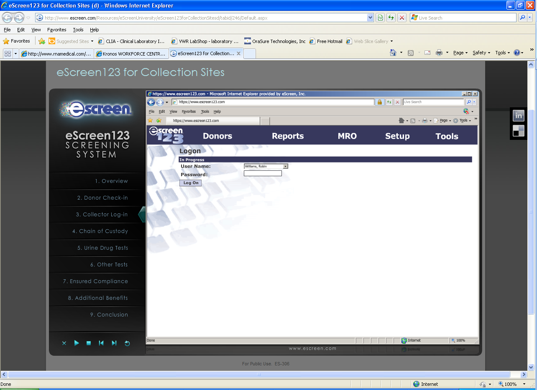

- Collector enters donor’s SSN into the computer and the first few letters of the donor’s employer. Select the correct employer from the list.

- Collector enters the donor’s contact information into the system.

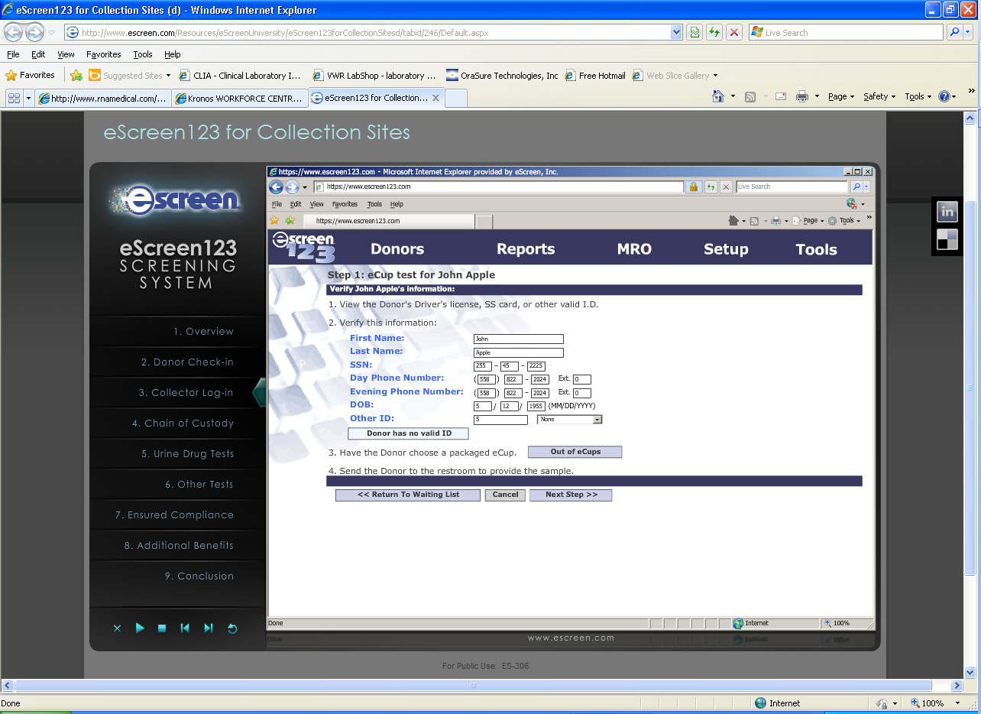

- The donor must verify the following information.
  - Donor’s name.
  - Social Security number OR another ID number must be present.
Note: If only willing to give a partial SS#, collector must enter an alternate ID.
  - Contact number.
Note: At least one contact number is required for the MRO to contact the patient.
  - Date of Birth

- The collector selects the eCup instant test option.

- The DONOR selects a collection container and opens it.

- The donor takes only the collection container into the bathroom.

- Donor is requested to submit 30-60 cc urine in collection container (affixed with temperature strip), not to flush toilet and to open bathroom door when finished.
- Donors that normally urinate through an indwelling catheter may provide a collection directly from the indwelling catheter into the collection container.
- Donors that normally urinate through a catheter that empties into a bag must empty and present the bag to the collector. The donor is then encouraged to drink up to 40 oz of fluid in a three hour period. The urine captured in the bag may then be emptied into the collection container. When the specimen is collected from the bag, the temperature may not fall into the acceptable range. The collector must note the circumstances under the remarks section of the CCF.

- Collector steps outside bathroom and puts gloves on.

- Donor submits urine - within four minutes –for temperature check (acceptable temperature range 90° – 100°F).

Note: Refer to Unusual Occurrences below for specimen outside temperature range.

- Collector follows prompts on computer for signs of adulteration, temperature, and sufficient quantity.

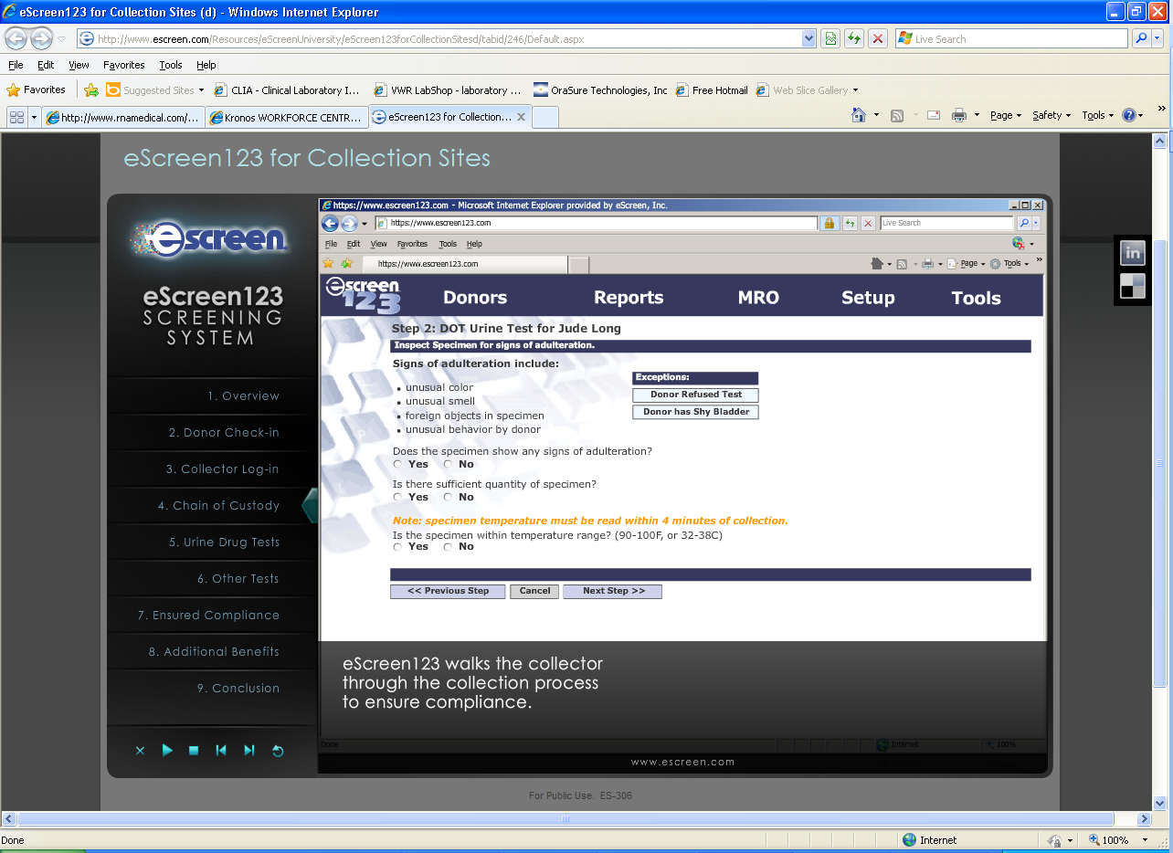

- DONOR selects a lid and opens it.

- The barcode on the lid is scanned by the collector into the computer.

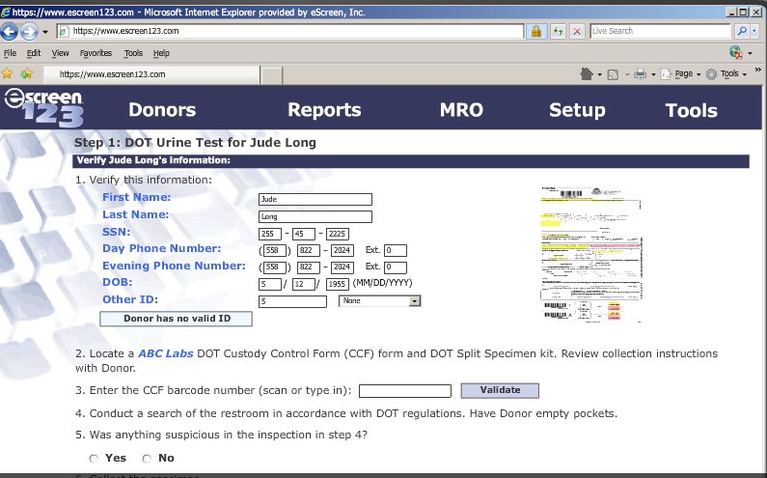

- The collector places the lid on the specimen cup, tightening to align the seal with the raised lines on the cup.

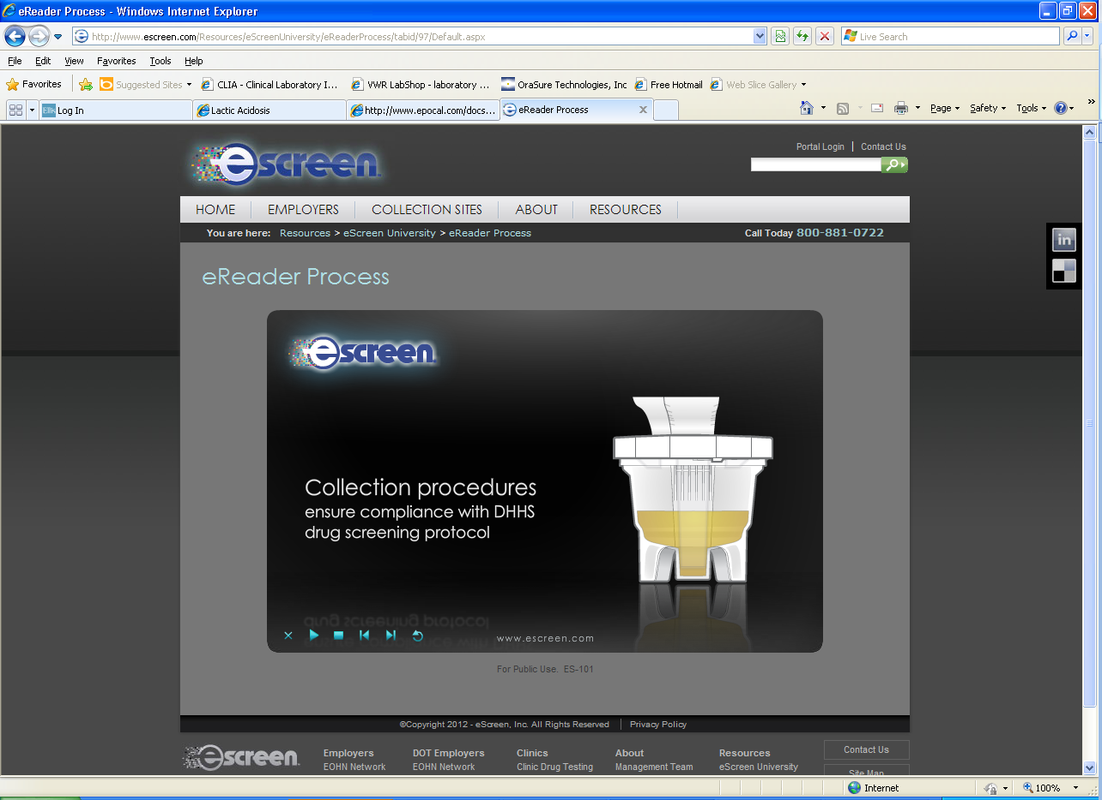

- Chain of Custody (COC) Form completed step by step by Donor and Collector.

- The seal is affixed to the specimen and the donor initials and dates the seal.

- The lid is scanned by the collector into the computer.

- Click eSign COC form and review with the donor.

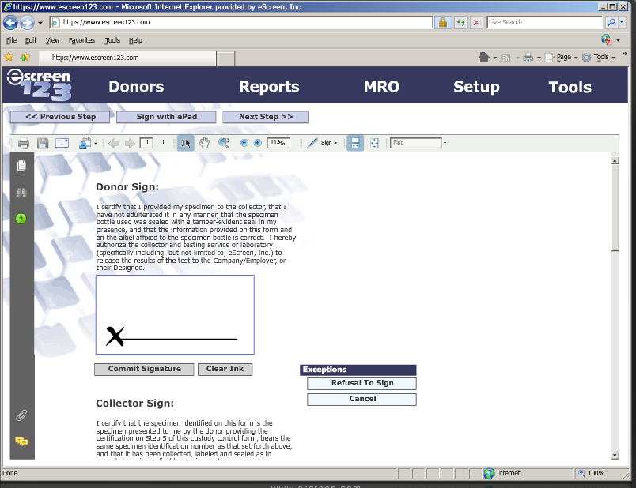

- The collector offers the donor a copy of COC and clicks the print button if desired.

- The donor is dismissed at this time.

UDS Sampling Procedure

- The collector verifies the cup number and then places the cup into the eScreen Reader.

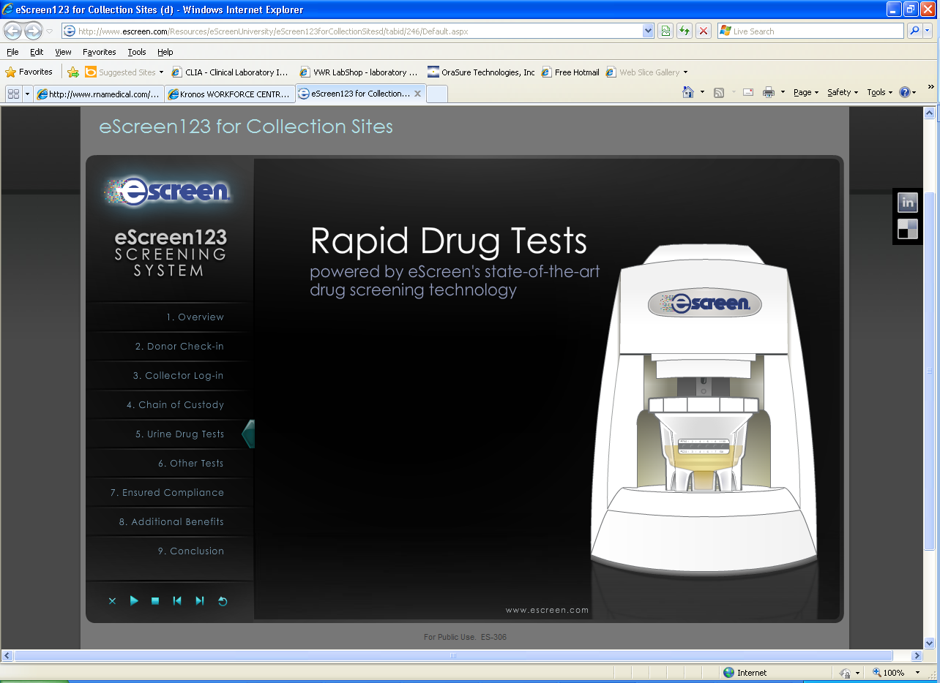

- Click to start the test.
Note: Do NOT close the test window – if the test window is closed, the specimen MUST be sent out to Lab.

- Record Specimen on the Attachment 2: Specimen Log.

- Test window will indicate whether the specimen should be:

 Discard Specimen
  - Dump specimen down sink.
  - Throw cup in trash.

 Ship Specimen to Lab
- Print copy of the COC form.
Note: Identify the laboratory name on the COC Form

Pack LabCorp specimens in an eScreen bag with an Orange Labcorp sticker sealing the bag. Place specimen into the Labcorp drop box and log on Attachment 3: LabCorp Log.
Pack ALERE Specimens in an ALERE bag. Place specimen in a small box then place the box into a FedEx bag. Log specimen on Attachment 4: FedEx Log. Deliver package to Chemistry for FedEx courier pick up.

General Information:
Regulated and non-Regulated collections at same visit: Collect DOT specimen first. Separate voiding, COC forms and collection kits are to be used (this is rarely requested).

Urine specimens are never to be mixed from separate voidings.

Chain of Custody form must be completed in all appropriate sections.

Temperature:
Acceptable temperature range of specimen is 90 – 100°F (32 – 38°C). If temperature strip does not indicate urine specimen is within acceptable range, it is acceptable to attach temperature strip from unused container to outside of the donor container for further verification. Urine must be at the level of the temperature strip to register a temperature, otherwise, it is considered a shy bladder - shy bladder procedures should be followed. If there is adequate amount of urine (30cc single, 45cc split) and temperature is outside the acceptable range, the following steps are taken:

- DOT Collection –The COC Temperature Box for “No” is checked. Remarks section: Note the specimen temperature was NOT in the acceptable range and another specimen is to be collected. Donor is informed that they must provide a second specimen and will be collected under observation. If donor agrees to observed collection, it must be with person of the same gender and this person must witness the specimen flowing from the donors’ body to the collection container. If donor refuses, this information is noted on the second COC form. The COC form is completed. Distribute copies to the appropriate addressee. Notify the appointed DER of the events.

- Non-DOT Collection – Complete collection process. Call company representative for direction (i.e., collection of 2nd specimen with or without direct observation collection; do they want the first specimen sent for testing?).

Specimen Volume:
Single = 45 cc minimum
Split (DOT) = 45 cc minimum

For DOT and non-DOT: If volume of first voiding is less than required amount but temperature of specimen is within acceptable range:
- Discard the specimen, note in “Remarks” section of COC form and collect second specimen. The same COC is used for second collection using a new collection kit.

Note: Donor may be given up to 40 ounces of fluid distributed reasonably over a three-hour period. Document start and stop time on consent form. Majority of people will produce a second urine specimen within an hour with two glasses of water.

If after the three-hour time limit and 40 ounces of fluid ingestion, the donor fails to provide an adequate specimen, notify the Employer Representative for a decision if this is a non-DOT collection. If this is a DOT collection, inability to provide adequate specimen, is considered a refusal and note this on the COC form. The COC form is distributed as usual and the DER notified. Collection attempts are to be documented on the original COC. Donor does not sign the COC form. Collector signs the “Remarks” section.

Suspect or Obvious Adulteration:
If the specimen submitted has any of the following:
- Unusual color (i.e. blue).
- Presence of foreign objects.
- Unusual odor (i.e. bleach).
- Excessive foaming when shaken.

Note: A remark must be entered on the CCF indicating what the collector observed, i.e. “Specimen excessively foamy, 1 of 2 collections, second CCF ID#______”.

- DOT: continue with routine collection as normal BUT inform the donor that a 2nd collection is required and must be under direct observation. If donor refuses the observed collection, note on the 2nd chain of custody form and send to appropriate recipients. Notify the company DER. If donor agrees to an observed collection, use separate collection kits and COC forms – noting appropriately in the “Remarks” section of each collection. Send specimens from both collections to ALERE.

- Non-DOT: Call client company for direction (i.e. 2nd collection, with or without direct observation, the client company may choose to consider this as refusal to test).

Note: If donor is unable to provide sufficient specimen for the second collection, the Shy Bladder procedure is initiated.

Shy Bladder Procedure:
Person who is unable to provide a specimen on demand.
- Reasons for shy bladder:
- Donor may have intentionally voided prior to collection.
- Could not provide a specimen as directed.
- Physical disability.

- If a donor tells the collector, upon arrival at the collection site, he/she cannot provide a specimen; the collector must begin the collection procedure regardless of the reason given.

- At the point in the collection procedure where the collector and Donor open a collection container, the collector:

- Requests the donor to attempt to provide a specimen.
Note: The donor demonstrates his/her inability to provide a valid specimen when the donor comes out of the enclosed toilet stall with an empty collection container.

- Directs the donor to drink fluids.
Note: The donor is given a reasonable amount of fluid to drink (up to 40 oz of fluid in a three hour period) distributed reasonably through a period of up to three hours or until the donor has provided a new sufficient amount of urine; whichever occurs first. The donor may refuse to drink the fluids provided. The collection process is continued until the three hour time limit is up.

Note: The donor must remain under the direct observation of the collector or an agency representative to prevent the donor from possibly compromising the collection process.

- Instruct the donor to communicate when he/she is able to provide a sufficient quantity of specimen. The collector uses the CCF form the first attempt but using a new collection kit.
Note: It is recommended that the collector allow sufficient time to have only one additional
attempt rather than having to document several unsuccessful attempts.

- Maintain a record of the time of each attempt, whether there was no specimen provided or the quantity of specimen provided and the total ounces of fluid given to the donor.
- Example: Insufficient specimen @ 1330; 2nd insufficient specimen @ 1430; adequate specimen @ 1530.
- Example: Attempted, no specimen @ 1330; insufficient specimen @ 1425.
- Example: Attempted, no specimen @ 1420; donor refused to proceed with collection and left the testing area.

- Discards any inadequate specimen and the collection container that was used for the void but retain the CCF.

- Discontinue the collection procedure and notify the agency of a potential “shy bladder” situation if after a period of three hours (i.e., from the time the donor first demonstrated that he/she was unable to provide a sufficient quantity of specimen) the donor is still unable to provide an adequate specimen.

- Indicate “Shy Bladder” on the “Remarks” line of the CCF and attach a copy of the record documenting the attempts to collect a specimen. Copy 1 is discarded since no valid specimen was collected and the other copies of the CCF are distributed appropriately. For DOT collection, the company DER must be notified.

Direct Observation:

Required only when the following has occurred:
- The employee has attempted to tamper with his or her specimen at the collection site.
- Specimen is outside of acceptable temperature range.
- Specimen has unusual color, odor, and or characteristics.
- The collector finds an item in the employee’s pockets or wallet which appears to be brought into the site to contaminate the specimen.
- The collector observes conduct suggestive of tampering.
- The Medical Review Officer (MRO) orders the direct observation because of the following.
  - The employee has no legitimate medical reason for certain atypical laboratory results.
  - The employee’s positive or refusal test result had to be cancelled because the split test could not be performed.

The collection procedure is the same as a routine collection with the addition of a same gender observer physically observes the donor urinate into the collection container.

- The observer requests the employee to raise his or her shirt, blouse or dress/skirt, as appropriate, above the waist, just above the navel.
- The observer requests the employee to lower clothing and underpants to mid-thigh and show the observer, by turning around, that the employee does not have such a device.
Note: If the employee has a device, the collection is stopped. The observer documents the circumstances in the remarks section of the CCF, as well as notified the DER. THIS IS REFUSAL TO TEST.
- After the voiding, the donor passes the specimen to the collector.

Note: Must be documented as a direct observation collection under the “Remarks” section of the COC form.

Refusal:
The collector determines a refusal under the following conditions:
- Donor refuses to remove unnecessary outer clothing.
- Donor refuses to wash hands with soap and water before providing a specimen.
- Donor refuses to allow collector to inspect contents of their pockets.
- Donor refuses to provide a specimen.
- Donor fails to remain at testing site until collection completed.
- Donor refuses to allow direct observation.
- Donor refuses to take second test as requested by collector or MRO.
- Donor wears a prosthetic device designed to interfere with testing procedure.
- Donor admits to collector that they adulterated or substituted specimen.
- Donor purposefully disrupts collection procedure.

The MRO determines a refusal under the following conditions:
- Donor fails to provide sufficient amount of urine.
- Donor provides adulterated or substituted specimen confirmed by the laboratory.
- Donor refuses to take medical exam for shy bladder.

The following does not constitute a refusal:
- Donor refuses to initial seals on bottles. Collector must write a comment in the Remarks section and continue collection process.
- Donor refuses to sign in Step 5. Collector must print donor’s name in Step 5, and document the refusal in Remarks.
- Donor refuses to drink fluids during Shy Bladder scenario.

Collector Training:
All Urine Drug Screen Collectors for Corporate Health Services must complete training:
- Observation of Foley Services Urine Drug Screen Collection Video.
- Observation of collection of a minimum of two consecutive error-free real time or mock DOT collections.
- Observation of collection of a minimum of two error-free real time or mock non-DOT collections.

Refresher collector training will be provided every 5 years unless the collector commits a “fatal flaw” during collection of a DOT specimen causing that specimen collection to be cancelled. Within 30 days, the collector will undergo an Error Correction Training and complete three error-free mock collections. These mock collections will include two on the subject matter of the error and one uneventful collection.

Reference:
- Urine Specimen Collection Handbook for Federal Workplace Drug Testing Programs August 2001, Version 1.01
- Part 40 – Procedures for Transportation Workplace Drug and Alcohol Testing Programs effective August 1, 2001
- https://www.escreen123.com/apolloV2/tools/help/Tipsheets. (n.d.). Retrieved May 1, 2010, from https://www.escreen123.com.

Attachments:
Attachment 1: Quick Reference
Attachment 2: e-Screen Specimen Log
Attachment 3: Labcorp Log
Attachment 4: Fed-Ex Log
Attachment 5: eScreen System Quality Control Test Log

Date of Origin: | 08/29/12 |  | Prepared By: |  |  | Teri Baldwin
Date Placed in Service:
Approved by:
 | Supervisor |  |  | Date |  |  | Laboratory Director |  |  | Date
 | Corporate Health |  |  | Date

Saratoga Hospital Laboratory
211 Church Street, Saratoga Springs, NY 12866

Chain of Custody Urine Drug Screen Collection

Attachment 1: Quick Reference

Section | Page Number
Definitions & Abbreviations | 1
Temperature | 9
Specimen Volume | 9
Suspect or Obvious Adulteration | 9
Shy Bladder | 10
Direct Observation | 11
Refusal | 11

Saratoga Hospital Laboratory
211 Church Street, Saratoga Springs, NY 12866

Attachment 2: e-Screen Specimen Log

Container Lot # | Date | Time | PHLEB INIT | SPECIMEN ID AFFIX ALIQUOT LABEL | Shipped

Saratoga Hospital Laboratory
211 Church Street, Saratoga Springs, NY 12866

Attachment 3: LabCorp Log

SPECIMEN ID AFFIX ALIQUOT LABEL | DATE SENT | PHLEB INIT

Saratoga Hospital Laboratory
211 Church Street, Saratoga Springs, NY 12866

Attachment 4: FedEx Log

SPECIMEN ID AFFIX ALIQUOT LABEL | DATE SENT | FedX # | PHLEB INIT

Saratoga Hospital Laboratory
211 Church Street, Saratoga Springs, NY 12866

Attachment 5: eScreen System Quality Control Test Log
QS-186-04-00

Client Identification
Date | eReader Identification |  | Control Specimen Info |  |  |  | eCup CCF Label & Lot Number | Performed By | eReader | eScreen Review*
Date |  |  | Type | Positive /Negative |  | Lot | eCup CCF Label & Lot Number | Performed By | eScreen Result | eScreen Review*
 |  |  |  |  |  |  | eCup Lot: |  | Send-to-Lab  Discard
 |  |  |  |  |  |  | (Affix CCF Label Here) |  | Send-to-Lab  Discard
 |  |  |  |  |  |  | eCup Lot: |  | Send-to-Lab  Discard
 |  |  |  |  |  |  | (Affix CCF Label Here) |  | Send-to-Lab  Discard
 |  |  |  |  |  |  | eCup Lot: |  | Send-to-Lab  Discard
 |  |  |  |  |  |  | (Affix CCF Label Here) |  | Send-to-Lab  Discard
 |  |  |  |  |  |  | eCup Lot: |  | Send-to-Lab  Discard
 |  |  |  |  |  |  | (Affix CCF Label Here) |  | Send-to-Lab  Discard
 |  |  |  |  |  |  | eCup Lot: |  | Send-to-Lab  Discard
 |  |  |  |  |  |  | (Affix CCF Label Here) |  | Send-to-Lab  Discard
 |  |  |  |  |  |  | eCup Lot: |  | Send-to-Lab  Discard
 |  |  |  |  |  |  | (Affix CCF Label Here) |  | Send-to-Lab  Discard
 |  |  |  |  |  |  | eCup Lot: |  | Send-to-Lab  Discard
 |  |  |  |  |  |  | (Affix CCF Label Here) |  | Send-to-Lab  Discard
 |  |  |  |  |  |  | eCup Lot: |  | Send-to-Lab  Discard
 |  |  |  |  |  |  | (Affix CCF Label Here) |  | Send-to-Lab  Discard
 |  |  |  |  |  |  | eCup Lot: |  | Send-to-Lab  Discard
 |  |  |  |  |  |  | (Affix CCF Label Here) |  | Send-to-Lab  Discard
 |  |  |  |  |  |  | eCup Lot: |  | Send-to-Lab  Discard
 |  |  |  |  |  |  | (Affix CCF Label Here) |  | Send-to-Lab  Discard

Directions for Completing Log
- Date: Enter date of test.
- Control Specimen Type: Type of control being used (Acutech).
- Control Specimen Concentration: Concentration of drug in control (Positive or Negative).
- Control Specimen Lot: List lot number for control being used.
- eCup CCF Label and Lot Number: Record eCup lot number, affix eCup label in space provided.
- eReader Result: Circle the result displayed by the eScreen System.
- eScreen Review: Fax log to eScreen for review (913-234-4547), only when there is a discrepancy between the eReader results and the control type tested.

