[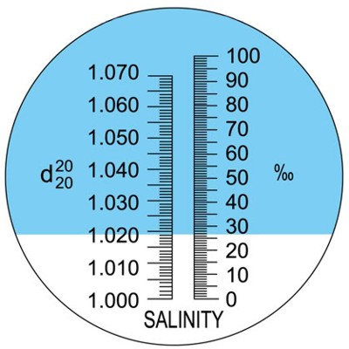](https://www.google.com/url?sa=i&rct=j&q=&esrc=s&source=images&cd=&cad=rja&uact=8&ved=0ahUKEwj_uM28mN3RAhVRySYKHdt9DtkQjRwIBw&url=https://www.agriculturesolutions.com/products/crop-soil-and-water-testing/refractometers-brix-meters/agtec-salinity-refractometer,-aquarium-seawater-dual-scale-detail&psig=AFQjCNEe94ByM7nUBhg0N4IGl9IXzwQo0g&ust=1485430033165891)