Which of the following are appropriate specimen types for performing CT/NG testing on the GeneXpert?  Vaginal/Cervical swab on a female  Urethral swab on a male  Unclean catch ("dirty") urine on a male or female  Clean catch urine on a male or female  A and C only  Answer required |  |  | Explanation  Only cervical swabs from women and dirty urine (unclean catch collected without cleaning area or starting mid-stream) from men or women are acceptable specimen types. A urethral swab on a male must be a special collection kit (Gen-Probe), and be sent to LabCorp. A urine can be poured into the correct collection vial from a sterile cup within 3 days of collection as long as it is a dirty urine, and not a clean catch urine.
2 | A swab obtained from a leg wound is an acceptable specimen for MRSA PCR testing on the Cepheid GeneXpert system.  True  False  Answer required |  |  |  | Explanation  FALSE. The Cepheid GeneXpert testing performed at ARMC is only approved for Nasal Swabs in the determination of nasal colonization or colonization susceptibility in patients. It is not to be used for determining whether any Staph from a Staph infection is Methicillin resistant or susceptible.

3 | After cleaning the work area, the tech should wash his/her hands before putting on new gloves to prepare the testing device.  True  False  Answer required |  | Explanation  It is not necessary to wash your hands after cleaning the work area. You should change gloves between patients; however.
4 | Bubbles are our friends.  True  False  Answer required |  | Explanation  FALSE. When pipetting, make sure to avoid putting bubbles into the Sample Chamber of any of the testing devices. This also means that if a cartridge is tousled badly or dropped during the preparation process, it must be discarded.

5 | If I am preparing a cartridge for CT/NG testing on the GeneXpert, I can use any sterile pipette as long as I transfer approximately 1 mL of liquid into the Sample Chamber.  True  False  Answer required |  | Explanation  FALSE. CT/NG cartridges MUST be prepared using the calibrated and marked pipette included in the CT/NG kit. The sterile pipette with 4 markings (.25,.5,.75,1mL) may only be used in preparation of the MRSA or C.Diff cartridges.
6 | The elution reagent for the C. Diff GeneXpert testing can ONLY be used with the C.Diff test cartridge. It may NOT be used in MRSA testing.  True  False  Answer required |  | Explanation  True. The reagents are not interchangeable. The C. Diff elution reagent must be used with C. Diff swabs in C. Diff testing. The MRSA elution reagent must be used with MRSA swabs in MRSA testing.

7 | The result for this C. Diff by PCR is _______.  Toxigenix C. Diff Positive  Toxigenic C. Diff Negative  Invalid  Answer required |  |  | Flip  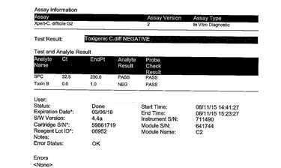 |  | Explanation  The internal control (SPC) is positive and the Toxin B probe is Negative, so the result is Negative for Toxigenic C. Diff.
8 |  | The result for this MRSA by PCR is _______.  MRSA Positive  MRSA Negative  Invalid  Answer required | Flip  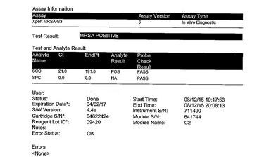 |  | Explanation  The probe for SCC is positive, so this test is positive for MRSA. Note that the internal control (SPC) must only be positive if the probe for the analyte is negative, thus it still passed because fluorescence was seen with the positive SCC probe.

9 | Critical Thinking! Why is this result for the CT/NG by PCR Invalid?  The probe check failed for the CT1 probe.  The probe check failed for the NG4 probe.  The SAC internal control probe failed to produce any fluorescence, and thus failed.  The SPC internal control probe failed to produce any fluorescence, and thus failed.  The CT/NG cartridge used is expired.  Answer required | Flip  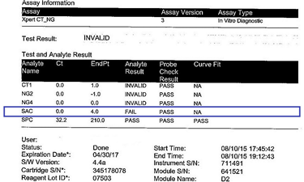  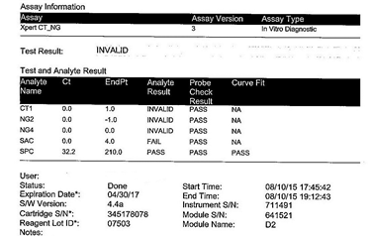 | Explanation  The probe check passed for all 5 analyte probes. This sample would have been considered negative for CT and NG because neither produced any fluorescence. However, one of the internal control probes (SAC) also did not produce any fluorescence. The "Endpoint" of 4 means little to no fluorescence detected, so the "Analyte Result" is FAIL. Because the SAC internal control failed, the test result is considered INVALID.

Copyright © MTS 2019 | Privacy

