1 | Click on the best answer to the question; then click the right arrow to continue. Veins in the antecubital fossa are labeled A, B, and C in this figure. Choose the answer which identifies each correctly.  Answer required |  | Flip  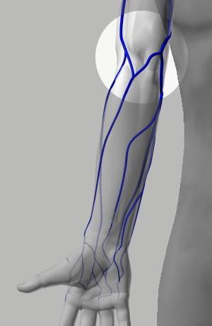  Median Cubital VeinCephalic VeinBasilic Vein  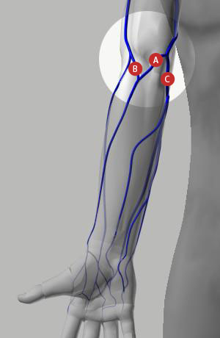 |  |  | Explanation  The veins are identified in the adjacent illustration.
  A=Basilic, B=Cephalic, C=Median Cubital
  A=Basilic, B=Median Cubital, C=Cephalic
  A=Cephalic, B=Median Cubital, C=Basilic
  A=Median Cubital, B=Cephalic, C=Basilic
2 |  | Evacuated tubes containing an anticoagulant additive must be gently mixed to:  Answer required |  | Error loading player:  No playable sources found  Show Tube Mixing | Explanation  If the tube contains an additive, invert it gently several times after removal to mix the blood and additive. Additional mixing can be performed while other tubes are filling. This prevents blood from clotting.
  Provide the correct ratio of blood to additive
  Activate the additive's chemical function
  Ensure reflux occurs
  Prevent blood from clotting

3 | Which of the following are characteristics of veins of the systemic circulation system?  Answer required | Error loading player:  No playable sources found  Flex Muscle | Explanation  Veins in the systemic circulation system carry deoxygenated blood to the heart.  Unlike arteries, the blood in veins is not under pressure.  Within a vein, muscles facilitate the movement of blood and the valves prevent backflow.
  Carry oxygenated blood, have valves
  Carry blood toward the heart, do not have valves
  Carry deoxygenated blood, have valves
  Carry blood away from the heart, do not have valves
4 | The additive in this evacuated tube is:  Answer required | Flip  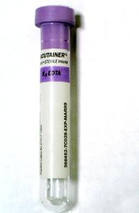  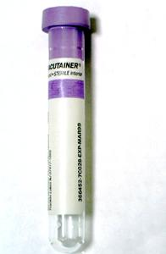 |  | Explanation  The color of the tube top indicates whether there is an additive, and, if so, the type of additive in the tube.  The lavender tube contains potassium or sodium EDTA. This is an anticoagulant and prevents blood from clotting.
  No additive
  Sodium fluoride and potassium oxalate
  Potassium or sodium EDTA
  Sodium citrate
  Lithium or sodium heparin

5 | A butterfly needle (winged infusion set) is used in which of the following situations?  Answer required |  | Flip  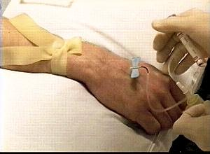  Error loading player:  No playable sources found  Show Detail |  |  | Explanation  Butterfly needles (winged infusion sets ) are designed to provide the phlebotomist more control when drawing from small veins, veins in the hand, and fragile veins.
  When drawing from fragile veins
  When drawing from small veins
  When drawing from veins in the hand
  All of the above
6 |  | After blood draw, the needle should be discarded as follows:  Answer required |  | Error loading player:  No playable sources found  Show Needle Disposal | Explanation  A needle should NEVER be recapped, and should ONLY be disposed of in designated sharps containers.  Both of these steps are important in order to minimize the risk of a needle stick injury to the person performing the phlebotomy, and anyone who may be in contact with the needle or its transport container.
  Discard in a biohazard bag; the needle is not recapped
  Discard in a designated sharps container after the safety device is activated.
  Discard in a designated sharps container; do not activate the safety device.
  Discard in a biohazard bag; the needle is first recapped

7 | The final outcome of test results is always invalidated if the:  Answer required |  | 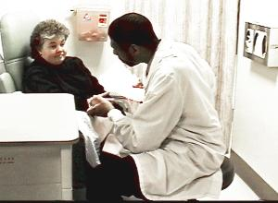 |  |  | Explanation  Correct identification of a patient is critical for blood test results to be valid for the patient drawn. Blood collected from a misidentified patient will be linked to the wrong patient and may put two patients at risk.  Always:  1. Ask the patient to state his/her full name and date of birth, spelling the last name.  2. Verify that the requisition (order) and sample labels, if applicable, match.  For a hospitalized patient, check the patient's identification band to verify that the name and hospital identification number match the order. If the patient isn't wearing an identification band, do not perform the venipuncture.
  Vein is not anchored during draw
  Patient is not correctly identified
  Patient subsequently develops a hematoma
  Blood is drawn from a hand vein
  Patient faints during procedure
8 |  | The proper procedure when cleansing a venipuncture site is to:  Answer required |  | Error loading player:  No playable sources found  Show Site Cleansing | Explanation  The correct procedure for cleaning the venipuncture site is to use 70% isopropyl alcohol. Pressure is applied on the alcohol pad and a rubbing motion used, beginning at the puncture site and moving outward in a spiraling motion.  Thirty to sixty seconds of drying time is needed to allow alcohol to evaporate so that the specimen will not be contaminated, or the site can be wiped off with sterile gauze or cotton after the site is prepared; otherwise, the puncture site will sting, and the alcohol can interfere with test results, such as blood alcohol levels. Blowing on the site to hasten the drying process is not advised because doing so may recontaminate the site
  Dab alcohol onto the site and puncture before the alcohol has dried
  Rub the site with alcohol in an outward, spiraling motion and allow a 30-60 second drying time before the puncture
  Wash the site with warm water and soap, then dry with a disposable towel
  Rub site with alcohol in an up and down motion, then puncture within thirty seconds

9 | Where should the tourniquet be placed on the patient before draw?  Answer required |  | 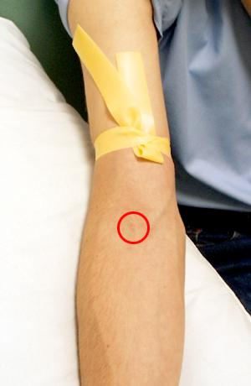  Intended SiteTourniquet | Explanation  Venous flow is toward the heart. When a tourniquet is applied, pressure in veins increases below the tourniquet.  A properly tied tourniquet is located 3 to 4 inches above the intended site. When a tourniquet is tied too low, the vein may collapse during the draw.
  No more than one inch above the intended site
  Three to four inches below the intended site
  No more than one inch from the intended site, either above or below
  Three to four inches above the intended site
10 |  | Which is the proper order of preference for vein selection when performing a venipuncture in the anticubital fossa?  Answer required | Flip  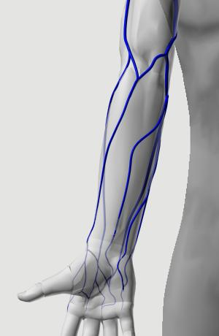  3 Basilic1 Median Cubital2 Cephalic | Explanation  The median cubital vein is the first choice for venipuncture because it is large, well-anchored, least painful to the patient, and least likely to bruise.  The cephalic vein is the second choice for venipuncture because it is also large; however, it is not as well-anchored and is more painful when punctured than the median cubital.  The basilic vein is the third choice for venipuncture. It is generally easy to palpate, but it is not well-anchored. It lies in the area of the brachial artery and the median nerve, either of which can be accidentally punctured when this site is selected.
  basilic, cephalic, median cubital
  cephalic, median cubital basilic
  medial cubital, basilic, cephalic
  median cubital, cephalic, basilic

11 | Which of the illustrations demonstrates the proper needle insertion angle?  Answer required | Flip  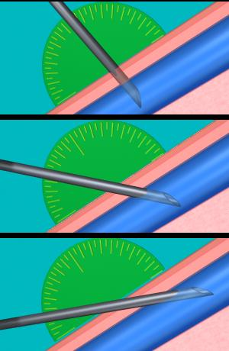  90 degrees45 degrees20 degrees (correct angle)  ABC |  |  | Explanation  Inserting the needle at an angle of 15-30 degrees avoids the following problems:  1. A needle angle greater than 30 degrees may puncture the far wall of the vein.  2. A needle angle less than 15 degrees makes it difficult to enter the lumen of the vein.
  A
  B
  C
12 | Tubes should be immediately labeled:  Answer required |  | Error loading player:  No playable sources found  Show Tube Labeling | Explanation  In order to prevent mislabeling, the tubes are labeled after blood is drawn while the patient is still present.  Labeling the tubes at any other time increases the possiblility of specimen misidentification.
  Before washing hands
  After patient identification
  After filling tubes
  After patient is no longer present

13 | Which of the following describes the remedy to the problem illustrated?  Answer required | Flip  Error loading player:  No playable sources found  Show Remedy  Error loading player:  No playable sources found  Show Problem | Explanation  A vein may roll if it is not correctly anchored.  Remove the tube from the needle to preserve the vacuum, withdraw the needle until the bevel is just under the skin, anchor the vein, and redirect the needle into the vein.  If there is still no blood flow, remove the tourniquet, ensure the patient's hand is open, withdraw the tube, and remove the needle from the patient's arm.
  Release tourniquet and withdraw needle from patient's arm
  Remove tube from needle, withdraw needle to just below skin surface, anchor vein, redirect needle into vein
  Tighten tourniquet until blood flow is established
  Pull the needle back slowly until blood flow is established
14 | Which of the following is the most likely cause for the problem illustrated?  Answer required | Flip  Error loading player:  No playable sources found  Show Collapse  Error loading player:  No playable sources found  Show Problem |  | Explanation  The vein may collapse when the tourniquet is tied too close to the puncture site.  Sometimes the vacuum draw of the tube can cause a vein to collapse.  As the vein collapses, the blood flow in the tube slows to a stop.
  A. Collapsed vein
  B. Needle went all the way through vein
  C. Angle of needle is too shallow
  D. Tourniquet is too tight
  E. Vein is scarred

15 | Which of the following describes the remedy to the problem illustrated?  Answer required | Flip  Error loading player:  No playable sources found  Show Remedy  Error loading player:  No playable sources found  Show Problem | Explanation  If the bevel of the needle is resting against the vein wall, blood will not flow freely into the tube.  To remedy this:  Pull back slightly on the needle.  If there is still no blood flow, remove the tourniquet, ensure the patient's hand is open, withdraw the tube, and remove the needle from the patient's arm.  Rotating the needle in the vein risks damaging the vessel wall.  Changing the angle of the needle requires removing the tube, pulling the needle completely out of the vein into tissue, and a major redirection of the needle. This may lead to significant tissue damage.
  Adjust needle angle
  Pull back slightly on needle
  Change to a smaller diameter tube
  Rotate needle
16 | Which of the following describes the remedy to the problem illustrated?  Answer required | Flip  Error loading player:  No playable sources found  Show Remedy  Error loading player:  No playable sources found  Show Problem |  | Explanation  When you see a hematoma forming, immediately remove the tourniquet, ensure the patient's hand is open, withdraw the tube, and remove the needle from the patient's arm.  Elevate the arm above the patient's heart and apply pressure. Do not bend the patient's arm.  A hematoma may create patient anxiety and discomfort. If pressure from the tourniquet is maintained or if the needle remains in the arm, the hematoma will become larger.
  Tighten the tourniquet and push the needle further into the vein
  Push the needle fully into the lumen of the vein
  Withdraw the needle to just below the skin surface and redirect the position of the needle into the vein
  Remove the tube from the needle, release the tourniquet, and withdraw the needle

17 | What is the most likely cause for the color of the plasma in the specimen labeled "Abnormal"?  Answer required | Flip  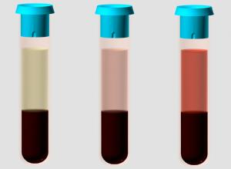  NormalMild HemolysisSevere Hemolysis  Error loading player:  No playable sources found  Show Hemolysis  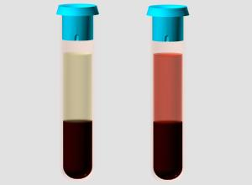  NormalAbnormal | Explanation  Hemolysis results when red blood cells are damaged. This condition can occur either in the process of phlebotomy or improper handling of the specimen.  Hemoglobin is released from the red blood cell into the plasma turning it pink to red. Other cellular contents are also released.
  Petechiae
  Reflux
  Hemolysis
  Syncope
18 | Why is it important to fill evacuated tubes to the level their predetermined vacuum draws?  Answer required | Flip  Error loading player:  No playable sources found  Fill Tubes  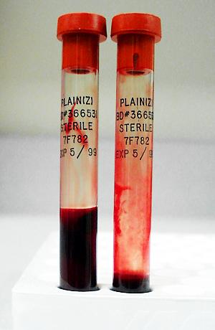 | Explanation  In most cases, it is necessary to fill evacuated tubes to the level their predetermined vacuum draws.  Partially filled tubes with additives will contain an incorrect blood to additive ratio.  Partially filled tubes may not contain enough blood to perform ordered laboratory tests.  In either case, a redraw may be necessary leading to additional patient discomfort, delay in results to the health care provider, and added cost.
  A: A correct ratio of blood to additive is necessary to perform tests
  B: To supply the laboratory with enough blood to perform ordered tests
  C: To equalize the vacuum before removing the needle
  D: To prevent hemolysis
  Both A and B

19 | Which of the following is the best way to avoid reflux?  Answer required |  | Error loading player:  No playable sources found  Show Reflux | Explanation  In rare instances, it is possible for blood to backflow (reflux) into a patient's veins from the collection tube during the venipuncture procedure. Tube additives, especially EDTA, can cause adverse reactions in patients.  To prevent reflux, keep the patient's arm in a downward position so that the collection tube remains below the venipuncture site and fills from the bottom up.
  Anchor vein before inserting needle
  Fill tube completely
  Release tourniquet before removing needle
  Fill tube from bottom up
20 | Which of the following is the correct order of tube draw when using the evacuated system?  Answer required | Flip  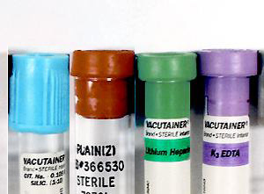  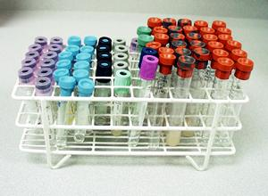 |  |  | Explanation  For evacuated tube system venipunctures, the proper order is Light Blue-Red-Green-Lavender.  The color of the stopper indicates whether or not an additive is present, and, if so, which one.  To avoid additive carry-over and contamination, the tubes always must be filled in the correct order and facility protocol must be followed
  Red, Light Blue, Green, Lavender
  Light Blue, Red, Green, Lavender
  Lavender, Red, Green, Light Blue
  Red, Green, Light Blue, Lavender

Hello, Jacee | My Account | Support | Logout
Manage:

First Name

Last Name

Email / Username

Password

Group Settings

Group name

Assignments Due Date
Allow users to retake document tests
Please select at least one program for your group.
Program

Administrators

Pre-Analytic

Specimen Processing

Version

Specimen Processing
1 | Which of the following best describes plasma?  Answer required |  | 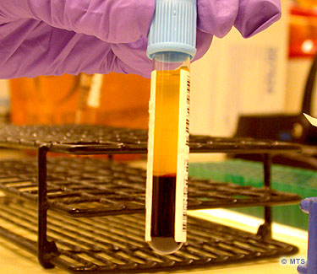 | Explanation  Blood collected with an anticoagulant does not clot; therefore, the clotting factors remain in the yellow, liquid component of the blood-- plasma.  Blood collected without an anticoagulant will naturally clot. In this case, the clotting factors are consumed during the formation of the clot resulting in a liquid portion without clotting factors-- serum.
  Another name for whole blood
  The yellow, liquid component of blood containing clotting factors
  The yellow, liquid component of blood containing no clotting factors
  The blood clot
2 |  | A patient sample is placed in slot "A" in the centrifuge. To balance this centrifuge, a balance tube should be placed in which slot?  Answer required | 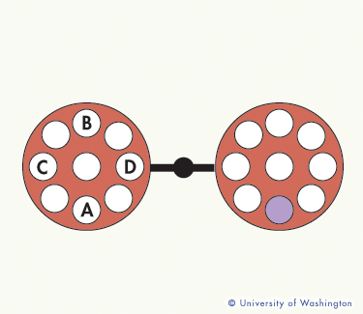 | Explanation  To balance a centrifuge, tubes of similar weight or balance tubes must be loaded into bucket slots opposite from one another. In this case, a balance tube should be placed in slot B which is opposite the patient tube located in slot A.
  No balance tube is required
  B
  C
  D

3 | Which of the following specimens should be processed first?  Answer required |  | 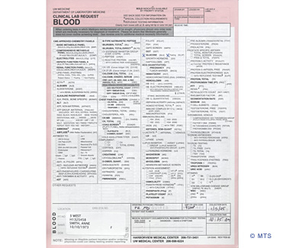 | Explanation  Pericardial, pleural, peritoneal, and cerebrospinal fluid should all be handled STAT regardless of the urgency specified on the request form.
  A blood specimen in a red top tube
  A blood specimen in a purple top tube
  A cerebrospinal fluid specimen
  A urine specimen
4 |  | True or False: Based on the information in this image, this specimen should be rejected for testing by specimen processing.  Answer required | 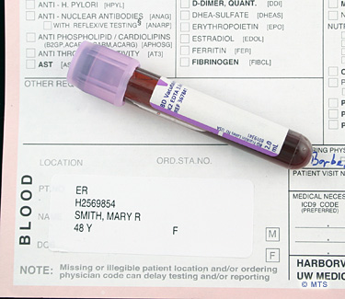 | Explanation  True. Unlabeled tubes, even when they accompany a valid request form, must be rejected for testing by specimen processing.
  True
  False

5 |  | Which of the following best describes pericardial fluid?  Answer required | Flip  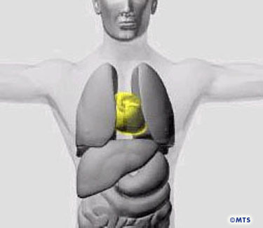  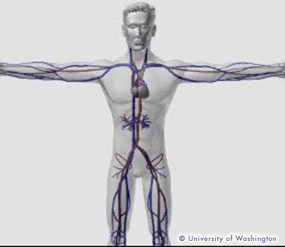 | Explanation  The pericardium is a thin membranous lining which covers the walls of the pericardial sac surrounding the heart. A thin film of fluid called pericardial fluid coats the surface of the pericardium and provides lubrication for movement.
  A thin membrane around the heart
  A thin membrane around the lung
  A fluid that surrounds the heart providing lubrication for movement
  A fluid that surrounds the lungs providing lubrication for movement
6 | A patient delivers a timed urine collection container with 200cc of urine. The request specifies a 24 hour collection period. What should the specimen processor do?  Answer required |  | 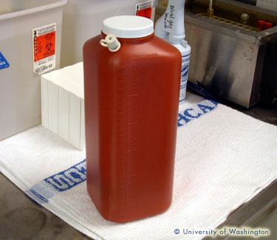 | Explanation  Early resolution of discrepancies is in everyone's best interest. Since normal urine volumes for a 24 hour collection are 800 to 1200cc, the staff member receiving the specimen should review the requirements with the patient.
  Accept the specimen
  Reject the specimen
  Review collection instructions with patient and resolve any discrepancies
  Send the specimen to the physician for evaluation

7 |  | CSF is collected in a series of tubes. Which of the following CSF samples is most likely to produce falsely elevated cell counts?  Answer required | 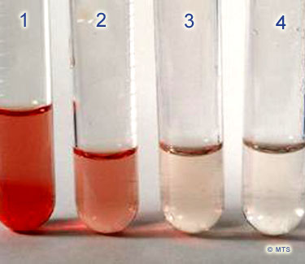 | Explanation  The first tubes collected are most likely to produce falsely elevated cell counts as a result of a traumatic tap.
  1 or 2
  3
  4
  Any of the above
8 | When disposing of hardcopies of patient reports, which of the following is the most important consideration?  Answer required |  | 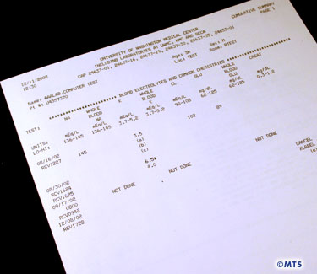 | Explanation  When disposing of hardcopies containing Protected Health Information (PHI), maintaining patient confidentiality is of primary importance. Documents containing PHI should be disposed of according to the institution's policy.
  Recycling the paper
  Maintaining patient confidentiality
  Signing the report
  Sending a copy to the patient

9 | Which of the following is a reason this sample cannot be accepted for coagulation testing?  Answer required |  | 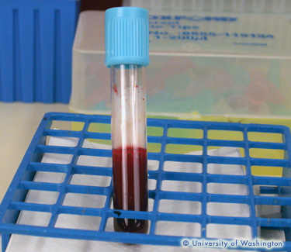 | Explanation  This specimen is inadequate for coagulation testing because the quantity of blood is not sufficient. A blue top (citrate) tube must be completely filled to maintain the proper blood to additive ratio. A re-draw is required.
  The quantity of blood is not sufficient
  Wrong tube type
  The specimen is hemolyzed
  The specimen is lipemic
10 |  | While unloading a room temperature centrifuge, a sample is found that should have been refrigerated during centrifugation. The specimen processing technician should:  Answer required | 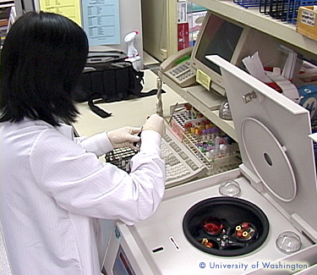 | Explanation  Errors in handling should be pointed out to your lead and to the testing lab technician. The lab technician will determine how the mishandling would affect the results and decide if the testing should continue with notations or cancelled altogether.
  Re-spin the sample in a refrigerated centrifuge
  Throw the sample away
  Notify their lead and the testing lab technician of the error and the time out of refrigeration
  Quickly put the sample on ice and pass it on to the testing lab technician

Notify
 | Name | Location | Assigned | Completed | Score %
 | Angelia Jones | Phlebotomy
 | Jasmine Bristol | tech and phlebotomy
 | Rebecca Overman | ARMC Lab

Image File (.jpg)

Question

Choices | Correct

Image File (.jpg)

Explanation

Template Name Enter template name

