1. Please identify the following cellular element: __________________

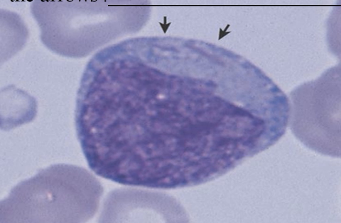

1. Please identify the following cell: ______________

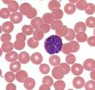

1. Please identify the following cellular element: __________________

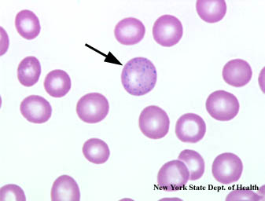

1. Please identify the following two larger cells: ______________

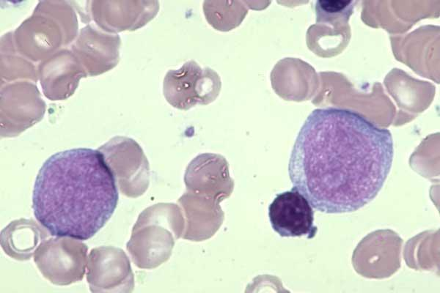

1. Please identify the following cell: ______________

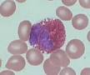

1. Please identify the following cellular element: __________________

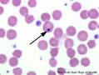

1. Please identify the following larger cells: ______________

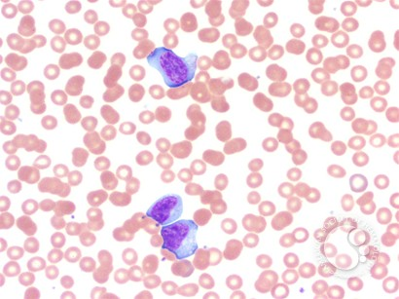

1. Please identify the following cell: _______________

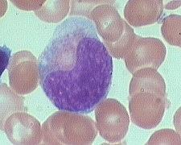

1. Please identify the following larger cell: ______________

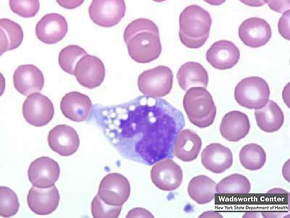

1. Please identify the following two larger cells: ______________

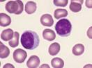

1. Please identify the following white blood cells: ______________

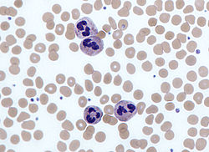

1. Please identify the following cell in the middle: ______________

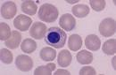

1. Please identify the following predominant RBC morphology: ______________

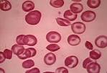

1. Please identify the following cell in the middle: ______________

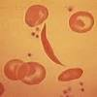

1. Please identify the following cell in the middle:______________

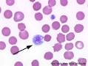

1. A slide is sent for a path review EVERY time it meets the criteria:
   1. True
   2. False
2. Please identify the following larger cell: ______________

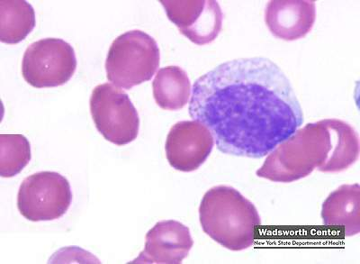

1. Please list any morphologic effects to this WBC: _________________

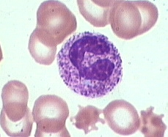

1. According to our policy, a manual diff is performed for which of the following occasions:
   1. Whenever you feel like it
   2. When the WBC count is above 10,000
   3. When WBC count is a critical value
   4. When there are no values obtained for any one of the cell types
   5. B & C
   6. C & D
2. Which of the following is NOT required as a slide review comment?
   1. RBC morphology
   2. WBC estimate
   3. Plt estimate
   4. Probable diagnosis
3. The hematology stain must be checked and documented daily:
   1. True
   2. False
4. A 50-cell count can be done (and multiply results x 2) if the WBC count is between 0.5 and 1.0 and the cells appear morphologically normal:
   1. True
   2. False
5. Which of the following inclusions are not visible with regular Romanowsky stains?
   1. Pappenheimer bodies
   2. Heinz bodies
   3. Basophilic stippling
   4. Howell Jolly bodies
6. Please number the cells according to maturity (1 being the most immature)

___ Promyelocyte

___ Segmented neutrophil

___ Myeloblast

___ Band neutrophil

___ Metamyelocyte

___ Myelocyte

1. Please identify the following element: ___________________

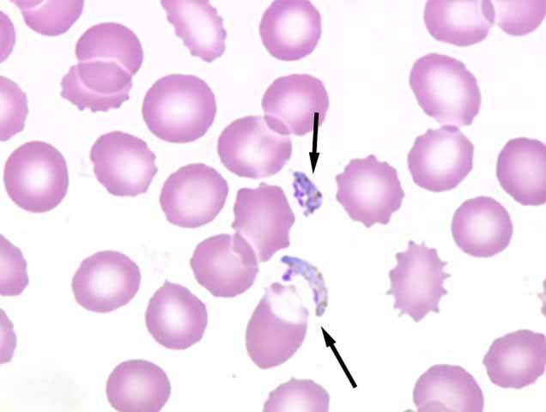

1. Poikilocytosis is variation in red blood cell shape.
   1. True
   2. False
2. Please describe the following phenomenon: _________________

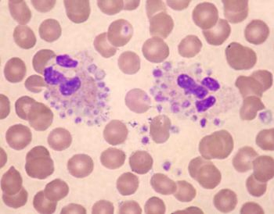

1. What is the proper way to obtain an accurate platelet count if the above occurs: ______________________
2. Please identify the following elements: ___________________

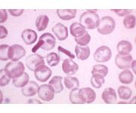

1. Please identify the following larger cell: ______________

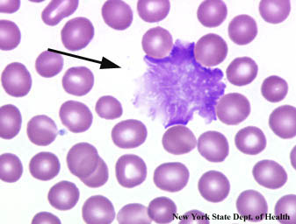

1. Anisocytosis is variation in red blood cell size.
   1. True
   2. False
2. What is seen below? _________________________

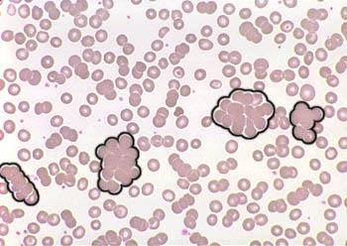

1. Please identify the following predominant RBC morphology: ____________________

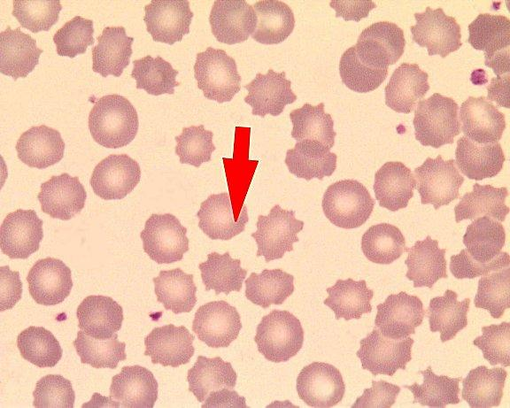

1. To be considered hypersegmented, how many lobes should be present in a neutrophil?
   1. Three or more
   2. Four or more
   3. Six or more
   4. Twenty-two or more
2. A slide should be made within which time frame of collection:
   1. 1 hour
   2. 2 hours
   3. 3 hours
   4. Same day