**Question 1 / 10**

When running QC in Manual Mode, what is the correct prefix to be entered before manually typing in the QC lot number?  
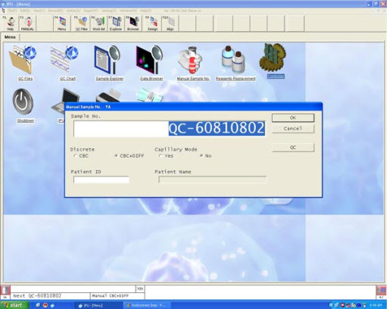

|  |  |
| --- | --- |
|  | QC- |
|  | qc: |
|  | QC: |
|  | qc- |

**Question 3 / 10**    Mark: 

How can I compare the results of the new lot number to the current lot number?

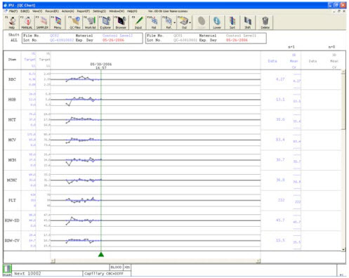

|  |  |
| --- | --- |
|  | Click on the Ref Icon or [F11] key and both files will display. The first file in blue print and the new file in black print. |
|  | Click on sample explorer and print out patient results and compare them with your QC file. |
|  | Delete the current file and print the new file. |
|  | Call the nearest hospital in your area and find out their results and compare them with yours. |

**Question 4 / 10**    Mark: 

How should my QC material be mixed?

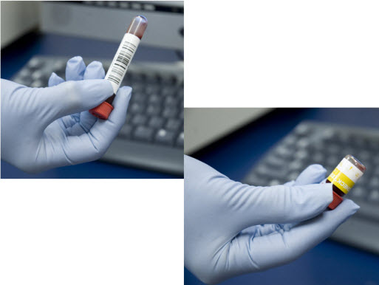

|  |  |
| --- | --- |
|  | Place control material on a mechanical mixer or rocker for 15 minutes. |
|  | Roll the control material between your hands for 5 minutes. |
|  | It doesn't matter how I mix the control materials. |
|  | Gently invert the control material end-to-end until the button of cells is suspended. |

**Question 5 / 10**    Mark: 

How often should QC be run?

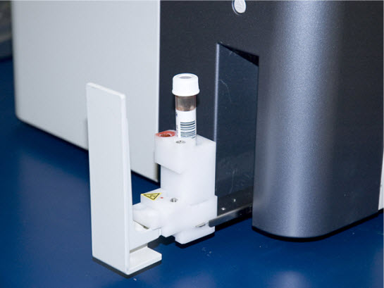

|  |  |
| --- | --- |
|  | Weekly |
|  | Daily |
|  | Monthly |
|  | As needed |

**Question 6 / 10**    Mark: 

When do I establish my historical limit % values?

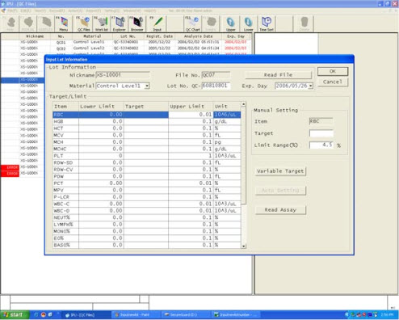

|  |  |
| --- | --- |
|  | After 6 lot numbers of QC have been analyzed. |
|  | After the current lot number expires. |
|  | After approximately 6 months fo QC data. |
|  | Next year. |

**Question 7 / 10**    Mark: 

When viewing the QC results, how do you know if a parameter exceeds the acceptable limit?

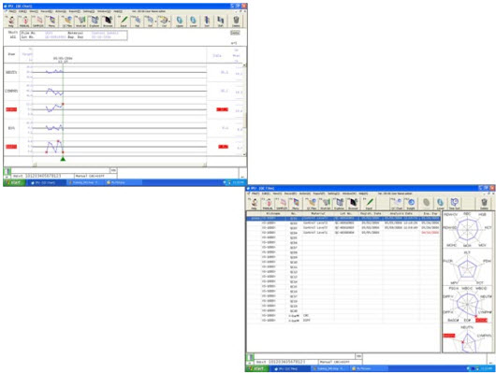

|  |  |
| --- | --- |
|  | An error dialog will display telling you which parameter limit has been exceeded. |
|  | The parameter will be plotted as a red X on the Radar or L1 chart. |
|  | A list of all parameter limits that have been exceeded will be displayed next to the Radar or L1 chart. |
|  | An alarm will sound when the QC analysis is completed. |

**Question 8 / 10**    Mark: 

How do I know how well my QC target and ranges compare to other facilities with the same analyzer?

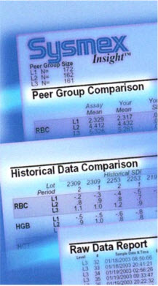

|  |  |
| --- | --- |
|  | Participate in the Insight Program. |
|  | Call other facilities and ask. |
|  | Print my QC data and send it to the neighboring hospital. |

**Question 9 / 10**    Mark: 

What happens if you click Cancel when reviewing the QC analysis Results diablog box?

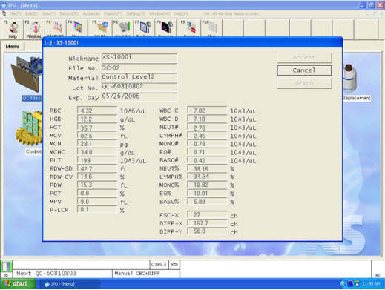

|  |  |
| --- | --- |
|  | The results are deleted and a new analysis is automatically started. |
|  | The results are deleted and you will need to set up a new QC analysis. |
|  | Clicking Cancel stores the results in the Sample Explorer, but the results are not plotted as QC data. |
|  | The results are stored in the Sample Explorer and plotted as QC data. |

**Question 10 / 10**    Mark: 

How long should you let the control material warm to room temperature before mixing?

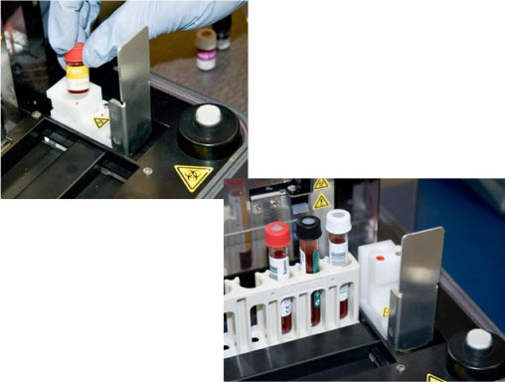

|  |  |
| --- | --- |
|  | At least 15 minutes |
|  | At least 5 minutes |
|  | At least 20 minutes |
|  | At least 10 minutes |