Change in Blood Gas and Co-Oximetry Orders Coming August 18

***This affects all Physicians, Residents, APPs, Nurses, Respiratory Therapists, Anesthesia, Laboratory staff and clinicians at Davie Medical Center, High Point and Lexington Medical Center locations. Clinical leaders: Please share this information with appropriate staff. This does NOT affect the Winston or Wilkes Locations.***

**Situation**   
Effective August 18, 2020, Orders for Blood Gas and Co- Oximetry will change as detailed below.

**Background**

DMC, High Point, and Lexington Medical Center will be using a new methodology for performing the Blood Gas and Co-Oximetry testing. As part of this project, the orders and reference ranges have been streamlined and standardized for these locations. Upon ordering, a list of tests available at each location will pop up. More than one test may be chosen as needed. Upon Collection, the collector will be given questions to answer that relate to that test.

**Assessment**Providers, nurses and clinicians should be aware of the following change to the orders.

There will be only 2 orders available for clinicians to choose from for Blood Gas and Co-oximetry testing:

* Arterial Blood Gas Lab Panel and RT to draw – Not for Venous Samples
* Venous Blood Gas lab Panel Nurse draw

Upon ordering, the clinician will be given a list of tests available based on the location. The clinician will need to select the desired tests.

An example for **DMC lab** is below:

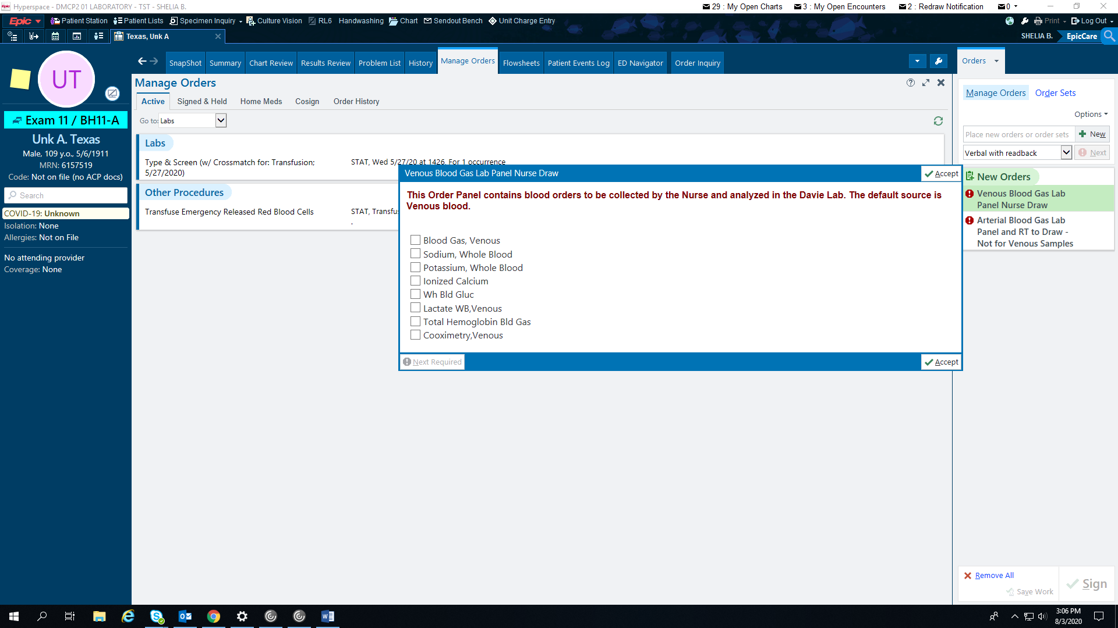

Upon collection, the collecting staff member will have specific questions to answer for patient: FIO2, Temperature and Specimen Type.

An example is below:

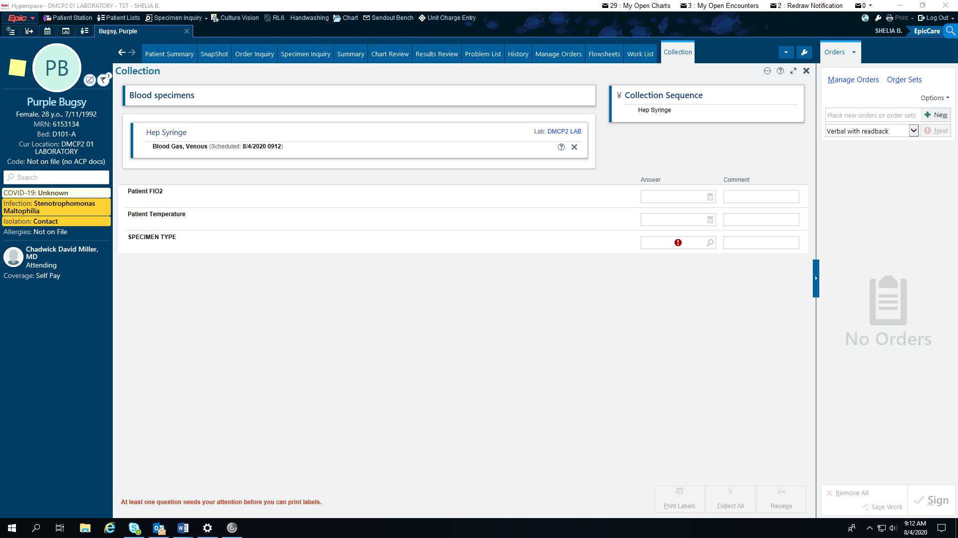

* With this new order, the questions answered at time of collection will automatically transfer to the laboratory.
* **ATTENTION:**

1. Specimen type will be a **hard stop**
2. Reference Ranges will auto- fill based on the specimen type, so that question must be answered accurately prior to collection.

**Recommendation**

Begin using the 2 new blood gas orders for blood gas and Co-Oximetetry testing August 18th.

* Arterial Blood Gas Lab Panel and RT to draw – Not for Venous Samples
* Venous Blood Gas lab Panel Nurse draw

Ensure collection staff are aware of the new questions to be answered at time of collection.

* **Please note**: IF the incorrect specimen type is chosen at collection, the order will need to be cancelled and re-ordered with the correct specimen type. Otherwise, the reference ranges will be **incorrect**.

If you have questions, please contact the Laboratory DMC, 336-998-2555