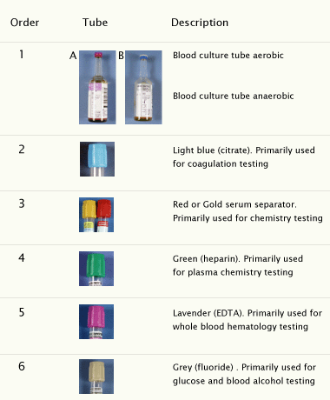

Normal skin bacteria can contaminate the tip of the needle, enter with the blood flow and cause the blood culture to be falsely positive. In other words, the blood culture becomes positive because of the presence of normal skin bacteria, not the actual pathogen causing the septicemia.
Studies show that a contaminated blood culture:
- may increase patient’s stay in the hospital by 4-5 days
- may cost an additional $5000 in ER or IP healthcare costs
- could risk unnecessary delay in treatment
Thus, due to blood collector error, patients could often remain sick and possibly die from not getting the correct antibiotic in time.

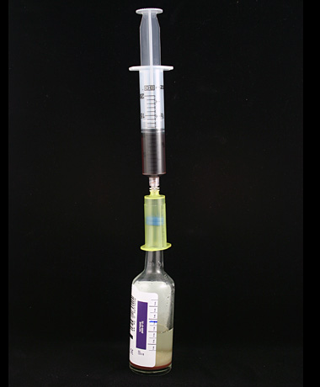

Safety Syringe
The most recent research recommends that blood collectors draw an initial 20ml into the syringe and then transfer 10ml into the aerobic tube, followed by 10ml into the anaerobic tube.

Remember that the syringe system is an Open System that increases the likelihood of blood exposure and contamination of blood cultures. Use all appropriate precautions.

