**MTS Jan to June 2021 Coagulation**

1. If a patient is on Bivalirudin (a direct thrombin inhibitor), they can be monitored by either the aPTT or the anti Xa assay
   1. True
   2. False
2. If an inhibitor screen for aPTT has an aPTT= 50.7 secs and the immediate PNP mixture (1:1 patient and PNP) has an aPTT= 35.0 secs, this suggests:
   1. Factor inhibitor
   2. Recent aspirin therapy
   3. Factor deficiency
   4. Normal result
3. Which of the following is an anti-Xa direct oral anticoagulant (DOAC)?
   1. Warfarin
   2. Heparin
   3. Rivaroxaban
   4. Aspirin
4. The following drugs will affect the PFA result except:
   1. Advil
   2. Aspirin
   3. Clopidogrel
   4. Warfarin
5. Which one of the following groups would cause an elevated Thrombin Time?
   1. Heparin, direct thrombin inhibitors and dysfibrinogenemia
   2. Direct thrombin inhibitors, aspirin, and high d-dimers
   3. Heparin, dysfibrinogenemia, and coumadin
   4. Plavix, coumadin and aspirin
6. Fibrinogen results are calculated using a x10 dilution. If a fibrinogen has a clot time >100 seconds, which is above linearity, what should be done next?
   1. Report as a critical result
   2. Decrease the dilution to x5 and repeat analysis
   3. Increase the dilution to x20 and repeat analysis
   4. None of the above
7. The PFA results for a patient who has ingested aspirin will be prolonged COL/EPI and prolonged COL/ADP
   1. True
   2. False
8. Interpret this Thrombin Time clot curve:

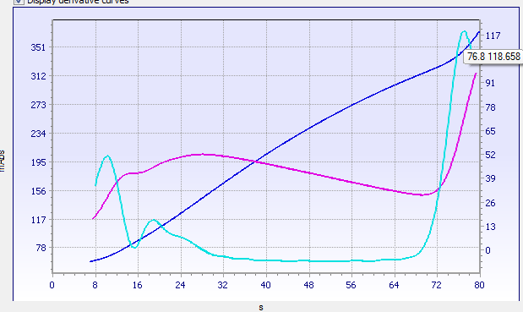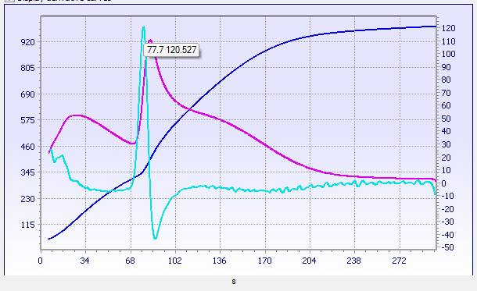

Extended Thrombin Time= FAILED result

Thrombin Time = FAILED result

* 1. Report >300 seconds
  2. Cancel test
  3. Report TT=77.7 seconds
  4. Repeat test

1. D-dimer formation is the result of the action of plasmin on:
   1. Fibrin monomer
   2. Fibrinogen
   3. Cross-linked fibrin
   4. FDPs
2. Which of the following is a function of thrombin?
   1. Conversion of fibrinogen to fibrin
   2. Activation of factor XIII to stabilize fibrinolysis
   3. Conversion of factor VII to XIIa
   4. Enhancement of factor V, VIII, and XI activity