Please Identify the cells below.

Cell 1: _____________________________________________________

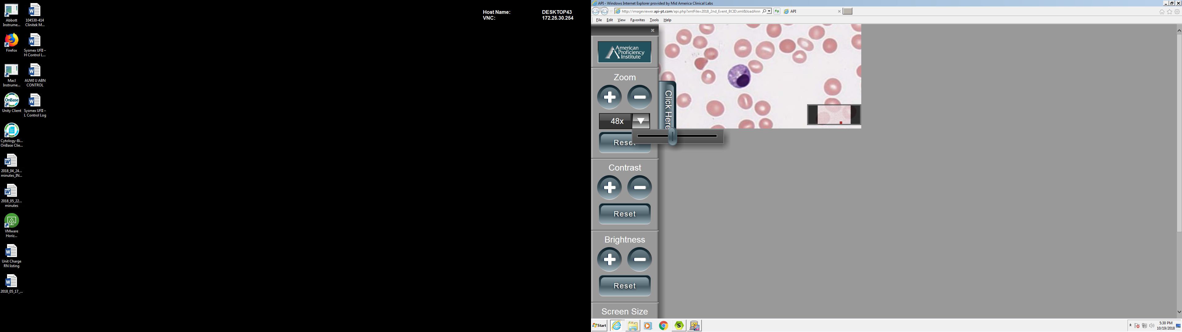

Cell #1

Cell 2: ____________________________________________________________

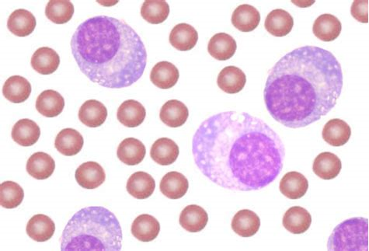

Cell #2

Technologist: ________________________________________ Date: _______________________