NAME:________________________________ Date: _____________ PASS____ FAIL____

1. The HIV 1/2 Oraquick test kits can be stored at 2- 27°C. Our clinics will store the kits at room temp. **TRUE FALSE**
2. Test should be read at 20 minutes but not exceeding 40 minutes: **TRUE FALSE**
3. Control requirements are: ***select all that apply***
4. Every shipment and/or lot number
5. Any time the test device storage temp goes out of range
6. Any time performance is in question
7. Each new user
8. Controls for the Oraquick HIV 1/2 test are refrigerated (2-8°C): **TRUE FALSE**
9. How long are the controls good for once opened? _____________________
10. A patient under the age of 12 can have the Oraquick HIV 1/2 test: **TRUE FALSE**
11. A patient who ate or drank can have the test as long as it was 30 minutes prior to the test being performed:  **TRUE FALSE**
12. Reactive results must be confirmed by
13. Blood test
14. Oral fluid
15. No confirmation test is required
16. How is a Reactive test reported in EPIC?
17. Positive
18. Preliminary Positive
19. How long are the controls good for once opened?
    1. Printed expiration date
    2. Two weeks
    3. Eight weeks

**INTERPRET THE FOLLOWING TEST RESULTS (circle correct answer)**

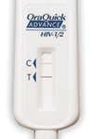 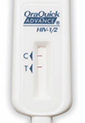

Reactive (Preliminary Positive) Reactive (Preliminary Positive)

Non-reactive (Negative) Non-reactive (Negative)

Invalid Invalid

_____________________________________________________________________________________

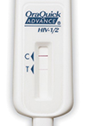 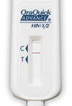

Reactive (Preliminary Positive) Reactive (Preliminary Positive)

Non-reactive (Negative) Non-reactive (Negative)

Invalid Invalid

_____________________________________________________________________________________

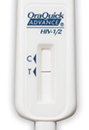 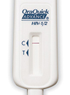

Reactive (Preliminary Positive) Reactive (Preliminary Positive)

Non-reactive (Negative) Non-reactive (Negative)

Invalid Invalid