[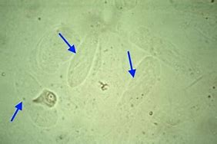](https://www.bing.com/images/search?view=detailV2&ccid=yGIopLSp&id=1F920F3FE7B8886E161C155FBB516C594891B651&thid=OIP.yGIopLSpPS23xBXyfcpCAgAAAA&mediaurl=https%3a%2f%2fp5759554.vo.llnwd.net%2fe1%2fcourses%2fimgs%2f609-23027_0_201221_164716.jpg&exph=266&expw=400&q=hyaline+casts+in+urine&simid=608050235149452978&selectedIndex=68&adlt=STRICT)