This urine sample is from a 37-year-old man with advanced kidney disease, admitted through the emergency room (ER) for lower abdominal discomfort and painful urination. Laboratory data include: specific gravity = 1.017, pH = 5.0; blood, leukocyte esterase, protein, glucose, ketones, and nitrite = positive.

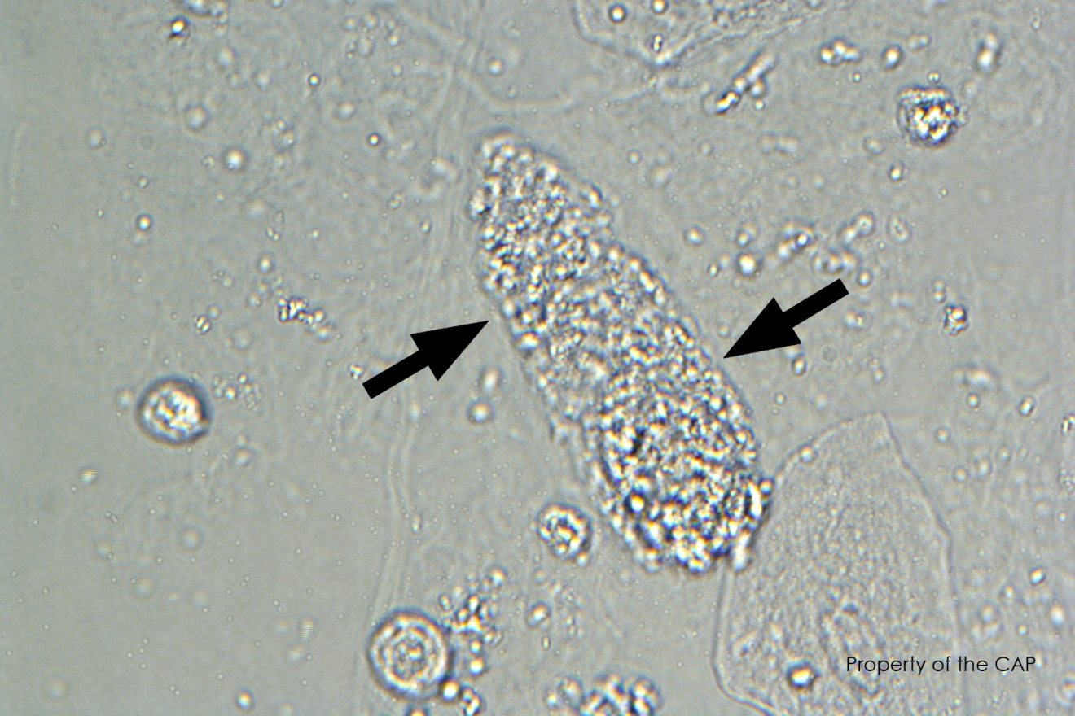

1. Hyaline cast
2. RBC cast
3. Granular cast

Explantion:

Urinary casts are cylindrical objects that form in the distal tubules and collecting ducts as a result of

solidification of protein within the renal tubular lumen. Casts are sub-classified based on their matrix

composition (hyaline, waxy), inclusions (granules, fat, hemosiderin), or cellular composition (white cells, red cells, renal tubular epithelial cells, bacteria). Granular casts as depicted in this image are a common finding in urine specimens. This cast is made up of plasma proteins from degenerated cellular products and may have a fine or coarse granular appearance that is often evenly dispersed throughout the cast. Most granular casts are not pathological; however, these casts can be seen in urine from individuals with renal disease.

This urine sample is from a 37-year-old man with advanced kidney disease, admitted through the emergency room (ER) for lower abdominal discomfort and painful urination. Laboratory data include: specific gravity = 1.017, pH = 5.0; blood, leukocyte esterase, protein, glucose, ketones, and nitrite = positive.

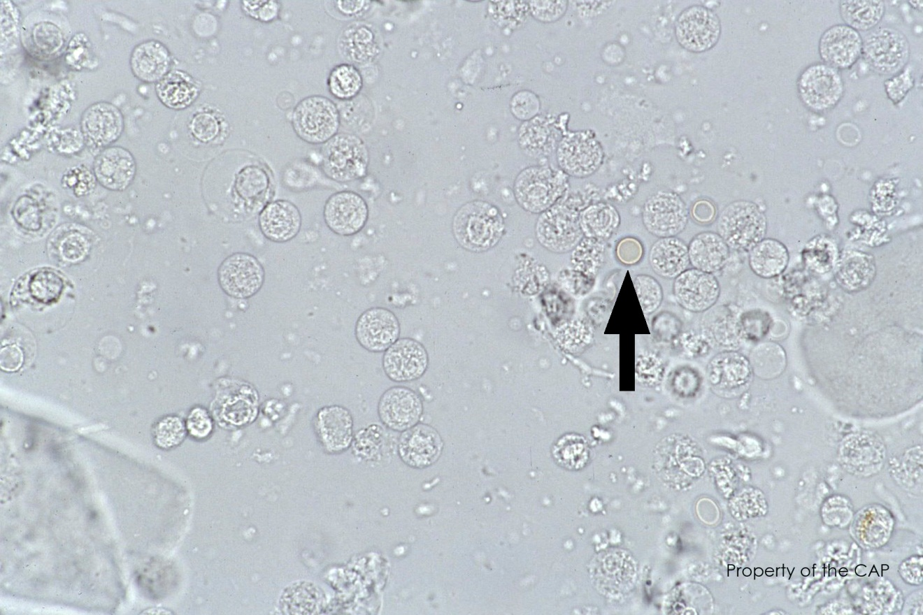

1. RBC
2. WBC
3. Transitional epithelial

Explanation:

Red blood cells in wet preparations appear as pale yellow-orange discs that are usually about 7 to 8 μm in diameter. The appearance of red blood cells depends upon the age and condition of the urine specimen. Old hypotonic urine specimens make red blood cells appear as “ghost-like,” faint, colorless circles. Red blood cells in hypertonic urine samples can appear more crenated. Oil droplets can mimic red blood cells but the refractile nature of oil droplets is a helpful distinction. Crenated red cells may be confused with white blood cells, which unlike red blood cells have multilobated nuclei. Generally, only a small number of red blood cells are seen in urine (less than 3/HPF); however, increased numbers of red blood cells can be associated with kidney disease, inflammation, trauma, or bleeding disorders.

This urine sample is from a 37-year-old man with advanced kidney disease, admitted through the emergency room (ER) for lower abdominal discomfort and painful urination. Laboratory data include: specific gravity = 1.017, pH = 5.0; blood, leukocyte esterase, protein, glucose, ketones, and nitrite = positive.

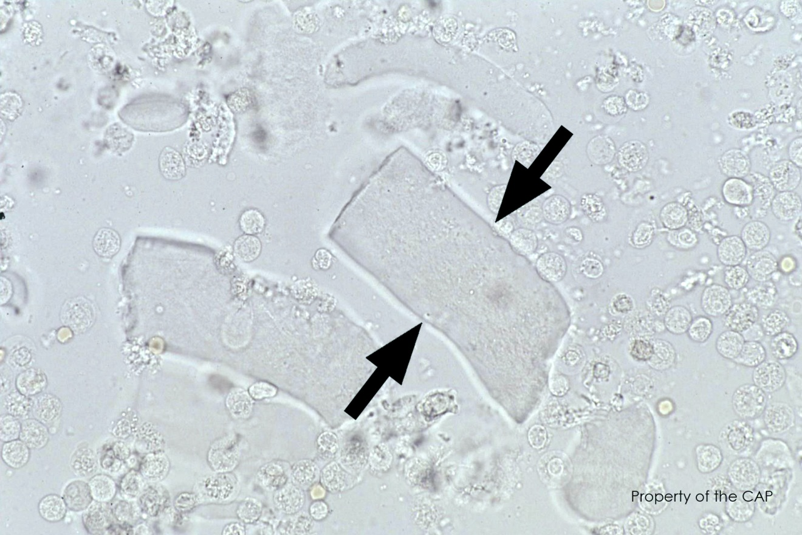

1. Hyaline cast
2. Fiber
3. Waxy cast

Explanation:

Waxy casts are usually broad and stubby with a homogenous smooth and dense appearance. The ends are often blunted with well-defined parallel margins that may be serrated or notched which reflect its brittle nature. Waxy casts are thought to arise from the degeneration of cellular casts and are frequently associated with severe or progressive chronic renal disease. These waxy casts can be differentiated from hyaline casts due to their highly refractile nature.

This urine sample is from a 37-year-old man with advanced kidney disease, admitted through the emergency room (ER) for lower abdominal discomfort and painful urination. Laboratory data include: specific gravity = 1.017, pH = 5.0; blood, leukocyte esterase, protein, glucose, ketones, and nitrite = positive.

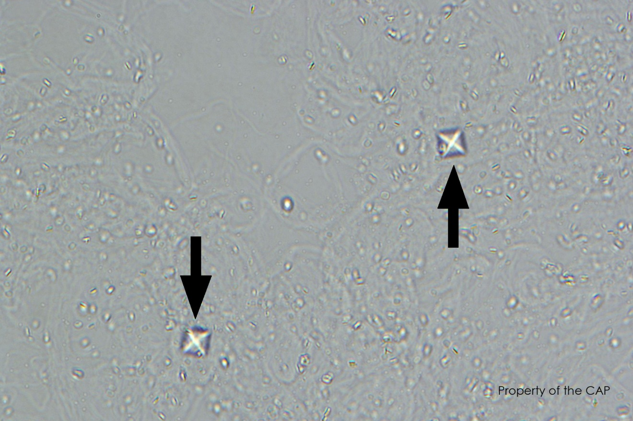

1. Triple phosphate crystal
2. Uric Acid crystal
3. Calcium Oxalate crystal

Explanation:

Calcium oxalate crystals can have various forms. The classic form is the dihydrate form, as depicted in this image, which appears as a colorless octahedron with the morphologic features of an envelope. The

monohydrate form has an oval, elliptical, or dumbbell shape. Large numbers of oxalate crystals can be seen in chronic renal disease, ethylene glycol (antifreeze) toxicity, or in patients who consume foods rich in oxalic acid (ie, tomatoes, apples, asparagus, oranges, or carbonated beverages). Calcium oxalate crystals can cause renal calculi.

5. Which of the following is not used as a control on the manual refractometer?

1. Deionized Water
2. Sodium Chloride Solution
3. Quantimetrix Quality Control

6. How should the IRISpec CA/CB controls be handled pre-analytically?

1. Bottles are allowed to warm to room temperature for 15 minutes, then aliquoted and analyzed
2. 2mL aliquots are warmed to room temp for 5 minutes in a drawer prior to analysis and the bottles are immediately returned to the refrigerator and stored protected from light
3. Bottles are uncapped and warmed to room temp for 5 minutes, then 2mL aliquots are analyzed

7. The waste strip box on the Velocity should be pushed all the way in when reinstalling after it has been emptied.

1. True
2. False

8. Which of the following UA GUI keyboard configurations is correct?

1. LMCIRS – Clinitek dipstick with manual microscopy
2. LMCMAN – IRIS dipstick with manual microscopy
3. LMCIRS – Clinitek dipstick with IRIS iQ200 microscopy
4. LMCIRS – IRIS dipstick with IRIS iQ200 microscopy