Quiz Question Ideas FY2022

Body fluids-

Body fluid hemocytometer calculations

Cytospin speeds for body fluids (program 1, 1500rpm for 10 minutes)

* You run a synovial fluid on the sysmex. The results are TCBF=9 and RBCBF=45,000. What should you do?

-report result as is, since there are no op alerts

-Verify the TCBF results with a hemocytometer count because the TCBF is <10 cells/uL . The RBC can be reported as is

-Need to perform a hemocytometer count for both the TCBF and RBCBF even through the RBC plot looks good.

-Do a dilution because the RBC results are above AMR.

Is this an acceptable graph for a body fluid ran on the sysmex?

Yes

No

This graph has no cell differentiation between cell types. In this case a manual count should be performed. May be caused by debris or crystals.

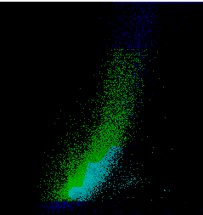

Acceptable?

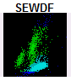Yes/NO

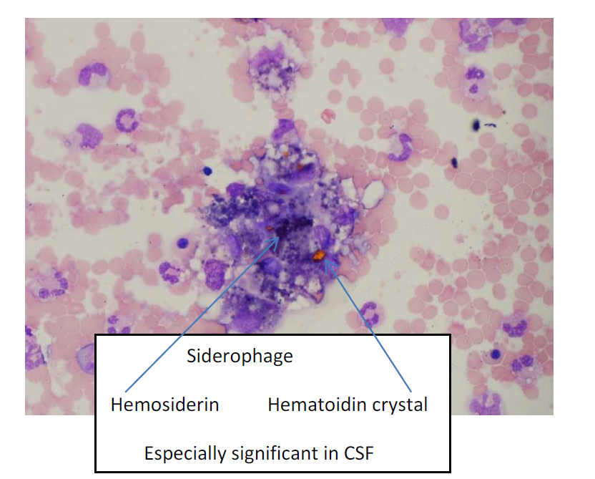

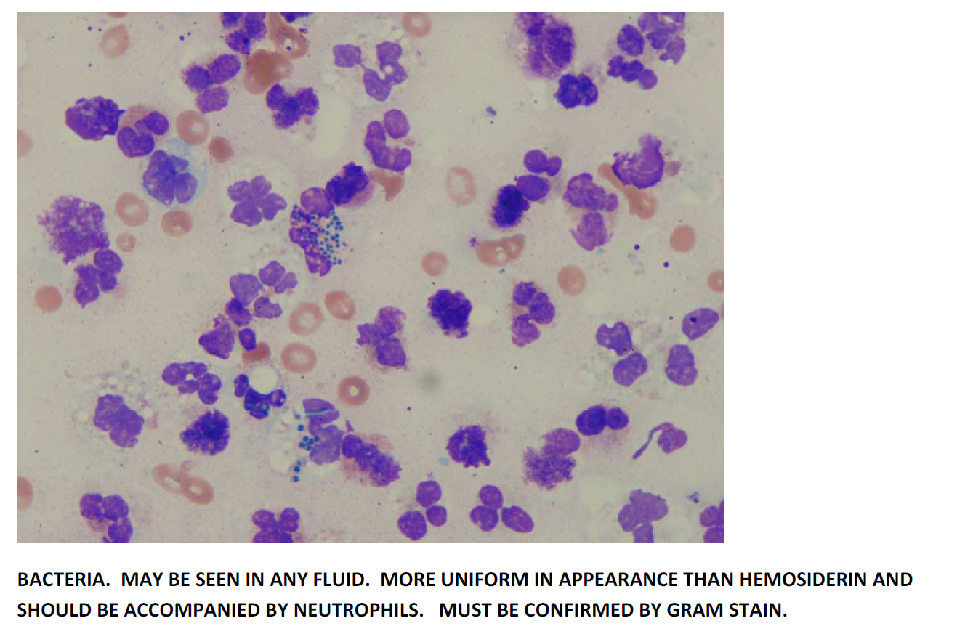

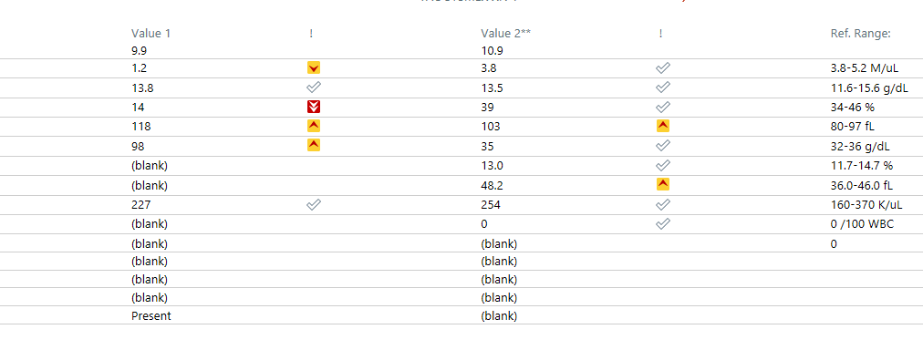

In the following scenario, what would you do? You process a CBC and obtain the following results:

WBC 10.9 (Norm 3.8-10.5)

RBC 1.2 (Norm 3.8-5.2)

Hgb 13.5 (Norm 11.6-15.6)

Hct 14 (34-46)

MCHC 98 (Norm 32-26)

You receive a WAM OPALERT for Turbidity/HGB Interference

-Warm sample 15 minutes and repeat

-Warm sample for a minimum of 30 minutes and repeat

-Proceed to do a dilution

-Ask for a recollection, contamination is a good possibility. If available, compare chemistry results as well.

After warming sample for 45 minutes you obtain:

