|  |  |  |  |  |
| --- | --- | --- | --- | --- |
| **Biochemical results:** | | | | |
| **pH** | **8.0** |  | **glucose** | **neg** |
| **ketones** | **neg** |  | **protein** | **1+** |
| **blood** | **trace** |  | **bilirubin** | **neg** |
| **urobilinogen** | **normal** |  | **nitrite** | **neg** |
| **leukocyte esterase** | **neg** |  |  |  |

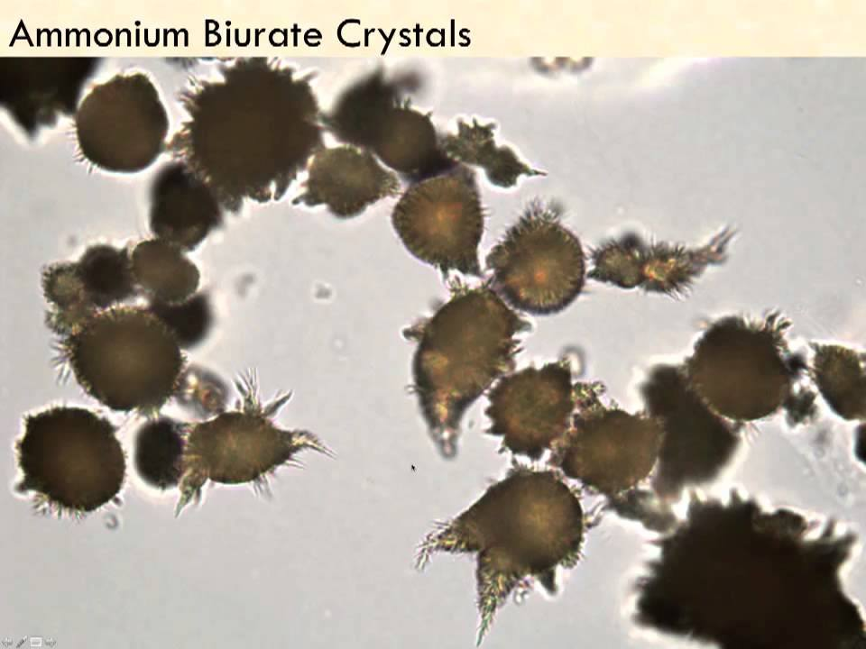1. Identify the crystals present:

1. Bilirubin crystals
2. Ammonium biurate crystals
3. Sulfa crystals
4. Calcium oxalate crystals

Ammonium biurate crystals are commonly formed in alkaline urine that is older. They have a characteristic “thorn apple” appearance.

2. A sample is run on Arkray 4022 which proceeds to give a W002 error. Upon inspection, the sample is grossly bloody. What are the next steps?

1. Test results are fine to release
2. Reject sample due to interference
3. Repeat test and compare rerun results along with checking microscopy
4. Run on Arkray 4050 instead

W002 error means “abnormally high reflectance.” This may be due to interfering substances or when interfering color samples are run on the analyzer such as grossly bloody samples. Repeating the sample and comparing repeat results to each other along with microscopy will determine if interfering color comment should be put in.

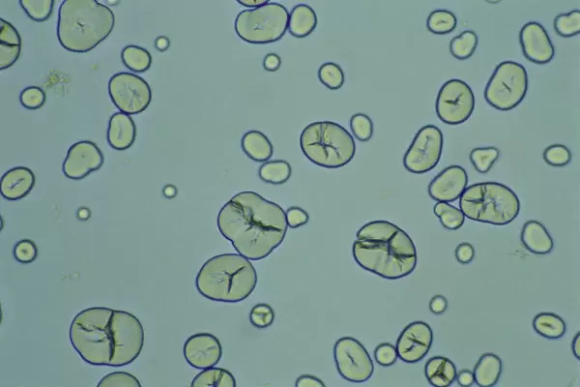

3. Identify the structures present:

1. Sulfa crystals
2. Starch granules
3. Leucine crystals
4. Calcium carbonate crystals

Starch granules often have a central indented or slit-like area and are commonly present. They are contaminants often from the use of cornstarch or talcum powder.

4. True/False On the Arkray 4050, a background check must be performed after a urine is run which gives the system message “WBC high.”

True

Interpreting Results

* What to do when hemoglobin does not match microscopic RBCs
* Crystal questions

Analyzer

* WBC high error – subsequent steps after