**Lab labels for Quality Control of reagents, kits, and Controls**

**April 2013**



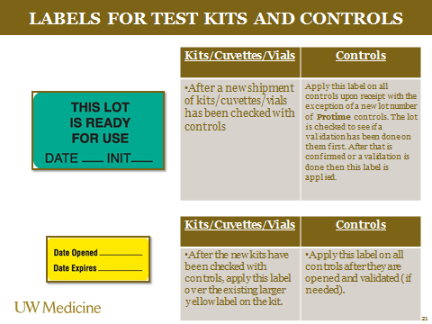

Order from [www.marketlab.com](http://www.marketlab.com)

|  |  |  |  |  |  |  |  |  |  |  |  |
| --- | --- | --- | --- | --- | --- | --- | --- | --- | --- | --- | --- |
| **ML8034** | | “Date Received__ Date Opened__ Expiration Date__ Room Temp_ Refrigerator_ Lot No.” • Yellow with black text • 3.5"W x 0.875"H [More Details](http://achelpers.marketlabinc.com/ProductTechData/ProductTechDataPublicViewer.aspx?sku=ML8034) | | [Enlarge Photo](javascript:PopUp('/popuplargeimage.asp?strImage=8034_LD.jpg&strImageType=VersionTechImage1&strPageTitle=“Date%20Received__%20Date%20Opened__%20Expiration%20Date__%20Room%20Temp_%20Refrigerator_%20Lot%20No.”%20•%20Yellow%20with%20black%20text%20•%203.5doublequotemarkW%20x%200.875doublequotemarkH','_blank','scrollbars=no,width=700,height=700')) | | 1000/pk | | $31.20 | | |  |
| **ML8030** | “DO NOT USE THIS LOT NUMBER” • Fluorescent orange with black text and area for date rec’d • 2.5"W x 1.5"H [More Details](http://achelpers.marketlabinc.com/ProductTechData/ProductTechDataPublicViewer.aspx?sku=ML8030) | | [Enlarge Photo](javascript:PopUp('/popuplargeimage.asp?strImage=8030_LD.jpg&strImageType=VersionTechImage1&strPageTitle=“DO%20NOT%20USE%20THIS%20LOT%20NUMBER”%20•%20Fluorescent%20orange%20with%20black%20text%20and%20area%20for%20date%20rec’d%20•%202.5doublequotemarkW%20x%201.5doublequotemarkH','_blank','scrollbars=no,width=700,height=700')) | | 1000/pk | | $46.70 | |  |

|  |  |  |  |  |
| --- | --- | --- | --- | --- |
| **ML8028** | “THIS LOT IS READY FOR USE DATE__ INIT__” • Green with black text • 1.75"W x 1"H [More Details](http://achelpers.marketlabinc.com/ProductTechData/ProductTechDataPublicViewer.aspx?sku=ML8028) | [Enlarge Photo](javascript:PopUp('/popuplargeimage.asp?strImage=8028_LD.jpg&strImageType=VersionTechImage1&strPageTitle=“THIS%20LOT%20IS%20READY%20FOR%20USE%20DATE__%20INIT__”%20•%20Green%20with%20black%20text%20•%201.75doublequotemarkW%20x%201doublequotemarkH','_blank','scrollbars=no,width=700,height=700')) | 1000/pk | $29.00 |

|  |  |  |  |  |
| --- | --- | --- | --- | --- |
| **ML7839** | “Date Opened __ Date Expires__” • Yellow with black text • 1.5"W x 0.625"H [More Details](http://achelpers.marketlabinc.com/ProductTechData/ProductTechDataPublicViewer.aspx?sku=ML7839) | [Enlarge Photo](javascript:PopUp('/popuplargeimage.asp?strImage=7839_LD.jpg&strImageType=VersionTechImage1&strPageTitle=“Date%20Opened%20__%20Date%20Expires__”%20•%20Yellow%20with%20black%20text%20•%201.5doublequotemarkW%20x%200.625doublequotemarkH','_blank','scrollbars=no,width=700,height=700')) | 1000/pk | $31.90 |