1)Which one of the following describes proper storage conditions for Sofia Influenza A+B Test kits

|  |
| --- |
| * Store in freezer, allowing equilibration before use |
| * Refrigerate, allowing equilibration before use |
| * Store at room temperature |
| * Any of the above |

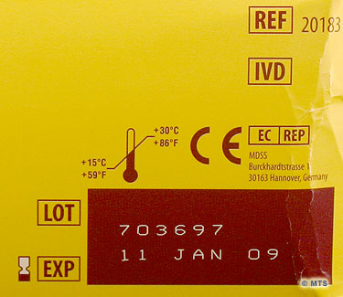

2) What is the lot and expiration number of this kit?

3) Once the swab is rolled in the Reagent tube, how long do you leave the swab in the reagent tube?

* 1 minute
* 3 minutes
* 15 minutes
* None of the above

4)How long do you allow the test to develop before placing it into the Sofia?

* 0 minutes
* 5 minutes
* 10 minutes
* 15 minutes
* 30 minutes

5)Once scanned in the Sofia, the cassette is stable for how many minutes?

* 0 minutes
* 10 minutes
* 15 minutes
* 30 minutes
* indefinitely