Direct Exam Competency 2018

1. Identify the following parasite seen on Trichrome stain. It measures 10 µm long:

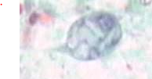 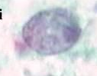

1. *Entamoeba histolytica* trophozoite
2. *Chilomastix mesnili* trophozoite
3. *Entamoeba hartmanni* trophozoite
4. *Endolimax nana* trophozoite
5. Identify the following parasite seen on Trichrome stain. It measures 12-15 µm long:

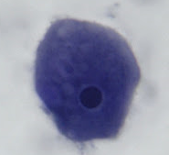 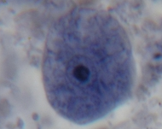

1. *Entamoeba histolytica* trophozoite
2. *Entamoeba coli* trophozoite
3. *Endolimax nana* trophozoite
4. *Iodamoeba beutschlii* trophozoite
5. The following is seen on a CSF gram stain. What are the next steps?
6. MAF question
7. The following is seen on an expectorated sputum from a floor. What should be done?
8. The following is seen on a gram stain from a placenta. What are the next steps?
9. This was seen on gram stain. What should you do next?