[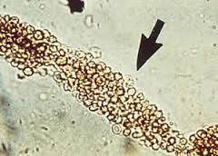](http://www.google.com/imgres?imgurl=http://missinglink.ucsf.edu/lm/IDS_102_cases_glomerular/images/RBC_cast_arrow.jpg&imgrefurl=http://www.worldaccordingtomaggie.com/photographyylms/granular-casts-in-urine-sediment&h=216&w=300&tbnid=WX6yuyZjiiJGhM:&zoom=1&docid=CkghbnjfXWkPkM&ei=CeUdVYSLJoedNonIgNAL&tbm=isch&ved=0CFAQMygsMCw)