[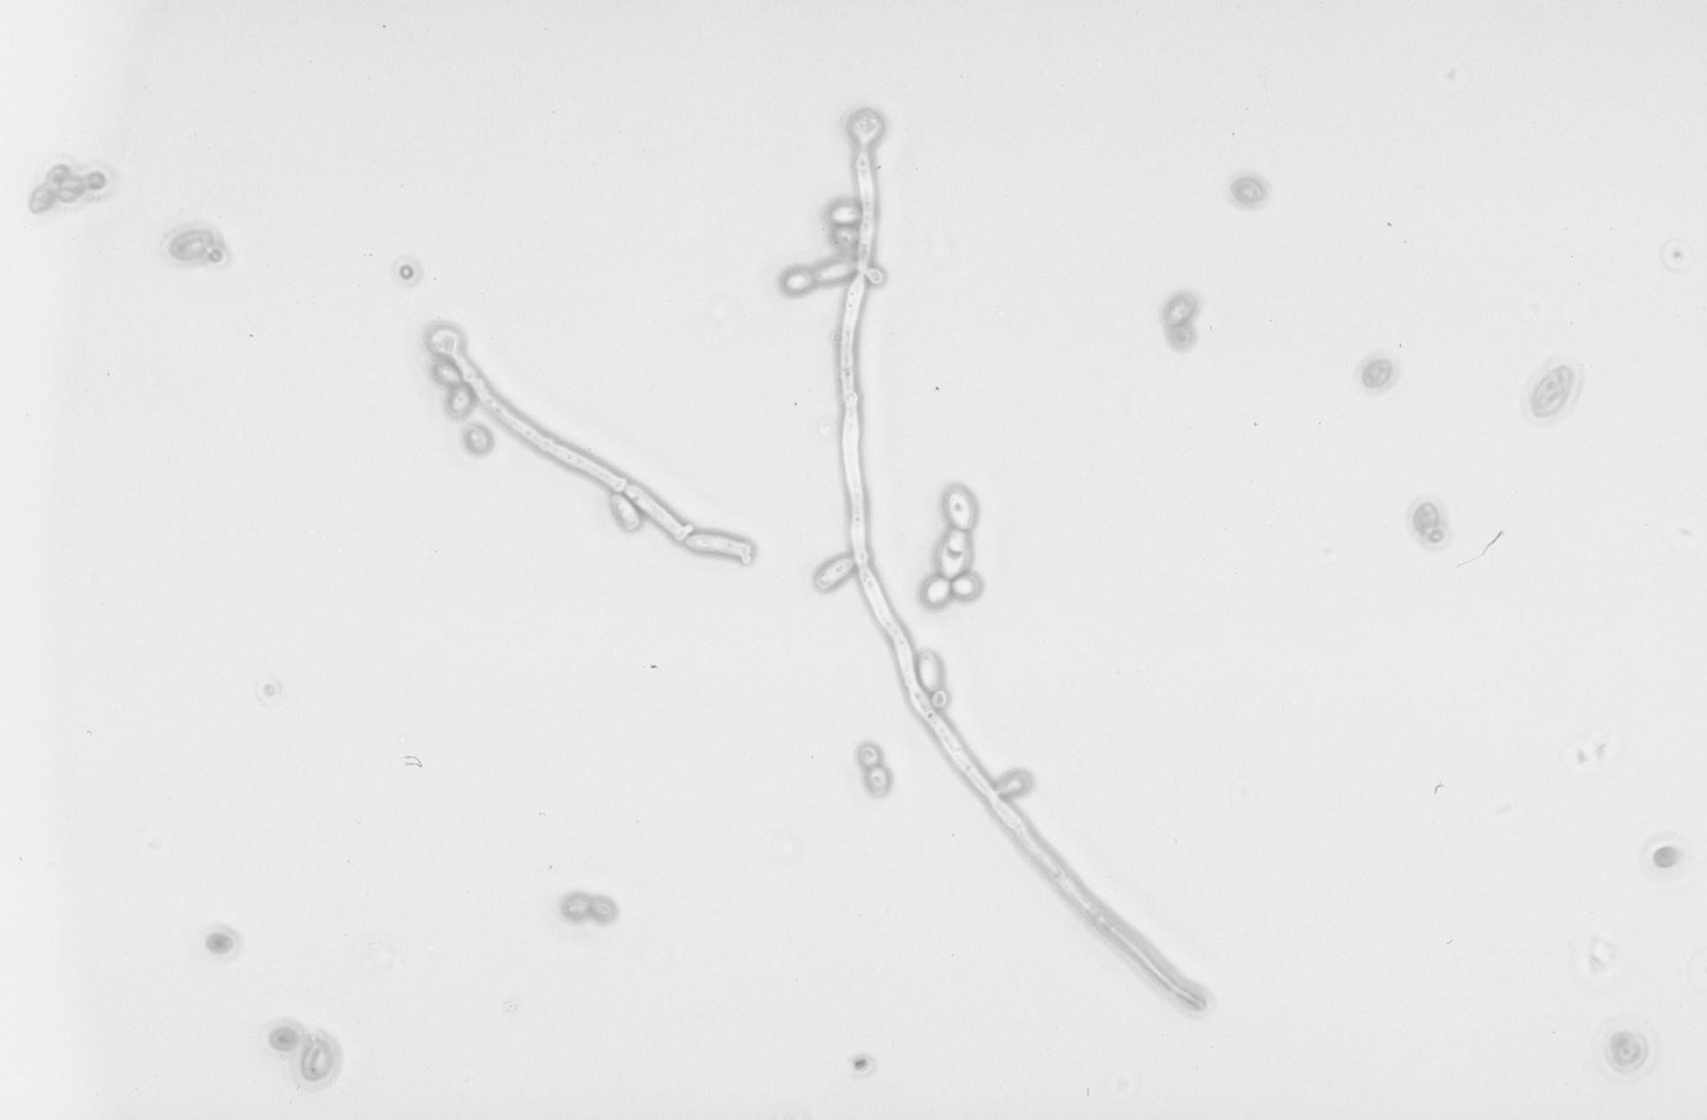](https://www.google.com/url?sa=i&rct=j&q=&esrc=s&source=images&cd=&cad=rja&uact=8&ved=0ahUKEwiEipPehabOAhVI5SYKHUOSCccQjRwIBw&url=https://www.studyblue.com/notes/note/n/15midspecial/deck/14402495&psig=AFQjCNHb_fHBUoFKEss0_OX4s0m70DZoWA&ust=1470340314655437)