[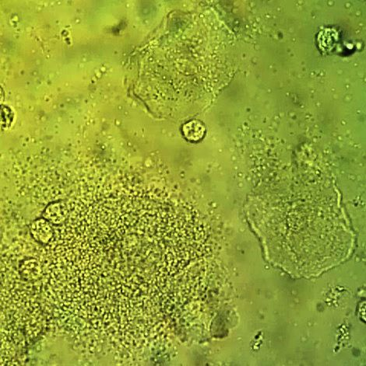](https://www.google.com/url?sa=i&rct=j&q=&esrc=s&source=images&cd=&cad=rja&uact=8&ved=0ahUKEwiM0sjWqNrOAhVBTSYKHeG4CL4QjRwIBw&url=https://en.wikipedia.org/wiki/Clue_cell&psig=AFQjCNHQxV60VZnPTz2B-hXtBRkPHCOj4g&ust=1472137228888543)