**Name:**

**Date:**

**Score:**

**Competency Quiz 2016**

1. Which procedure would you refer to if your current blood type does not match the historical blood type?
   1. BB01-034
   2. BB06-026
   3. BB01-028
   4. BB09-052
2. What must be written on the saline cubes when they are opened?

A. Initials and date opened

B. Date opened and expiration date of 24 days

C. Date opened, initials, and expiration date of 35 days

D. Date opened, initials, and expiration date of 30 days.

1. All of the following are examples of indirect antiglobuin tests (IATs), except:

A. Weak D testing

B. Antibody identification panel

C. AHG crossmatch.

D. Antibody elution

E. Antibody titration

1. You perform a poly IgG DAT and you get a negative result. You then add check cells to confirm your negative result and they do not check, what should you do first?

A. Result the test as invalid.

B. Perform the extended DAT with monoclonal IgG and C3.

C. Repeat the poly DAT

D. Notify the supervisor

1. You performed an elution on your patient due to a positive DAT. Your screen and your last wash were positive. What do you do?
2. Continue with your antibody identification panel because your last wash

should be positive.

B. Notify medical coverage.

C. Repeat elution because your last wash must be negative

D. Notify supervisor and repeat elution.

1. A patient was typed as O-pos 2 weeks ago. Today the patient’s type is O-neg on the Provue. You then repeat the typing on the bench and you get O-pos. You see that the patient has received O-neg blood recently. The correct thing to do is to enter a comment about the patient receiving Rh-neg blood and result the patient as O-pos. Lastly, leave the supervisor an email.

A. True

B. False

7. What is the blood type? 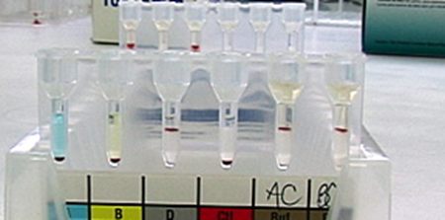

A. AB-pos

B. Invalid

C. O-neg

D. O-pos

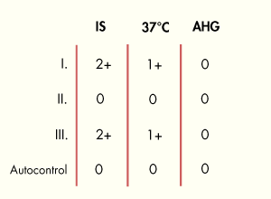

8. What kind of antibody is this most likely to be?

1. A warm auto antibody
2. A cold reacting IGM antibody
3. It’s nothing the screen is negative
4. Both A and B
5. A type and screen is ordered for a 74 year old male with chronic lymphocytic leukemia (CLL). The forward and reverse grouping results are shown below.

|  |  |  |  |  |
| --- | --- | --- | --- | --- |
| **Anti- A** | **Anti -B** | **Anti -D** | **A1 cells** | **B-cells** |
| 4+ | 0 | 4 | 0 | 0 |

Retesting after incubation for 15minutes at 4 C demonstrates the results shown below.

|  |  |
| --- | --- |
| **A1 cells** | **B cells** |
| 0 | 2+ |

The ABO discrepancy is caused by:

1. Clerical error
2. Technical error
3. Weak or missing isohemagglutinins
4. Weak or missing antigen
5. Rouleaux
6. Which form would you use to document when a new lot of reagent is opened?
7. BBQC01-01 Form B Daily Reagent Identification
8. BBQC01-01 FORM C- REAGENT QC FLOW CHART
9. BBQC01-03 Form B Day of Use QC
10. BB09-045 Form A1 BB Reagent-Critical Materials Receipt
11. No longer documented
12. You perform a fetal screen on a patient and the positive control is negative, what do you do first.
13. Continue testing because you already know what a negative fetal screen looks like.
14. Repeat the test.
15. Call Supervisor
16. What should you do to a plasma unit that was returned to the blood bank with a temperature of 11C?
17. Save for supervisor
18. Discard the unit
19. It’s ok because it is within acceptable range
20. Quarantine the unit

1. **True or False**. You must always write an occurrence if you discover or make an error.
2. Which procedure do you refer to for Titers?

A. BB07-026

B. BB07-034

C. BB02-004

D. BB02-008

15. What must be entered in the transfusion requirements in PPI for babies the first time blood is ordered?

A. Use Irradiated

B. CMV-neg and HBS-neg

C. Use Irradiated, Use CMV-neg and Use HBS-neg

D. Use Irradiated and Use HBS-neg