SDS, MSDS, GHS

What are these abbreviations: SDS, MSDS, GHS?

SDS- Safety Data Sheet which replaced the MSDS, Material Safety Data Sheet as the primary source for detailed hazard information about chemical products. SDS follows a standardized format while MSDS are permitted to take on a variety of formats.

GHS-Global Harmonization System is an international system used to classify hazardous chemicals and standardize hazard information on product labels and safety data sheets, called SDS.

Why did OSHA adopt the GHS?

GHS will improve comprehension of hazard information found on product labels and ultimately be more effective in injury and illness prevention.

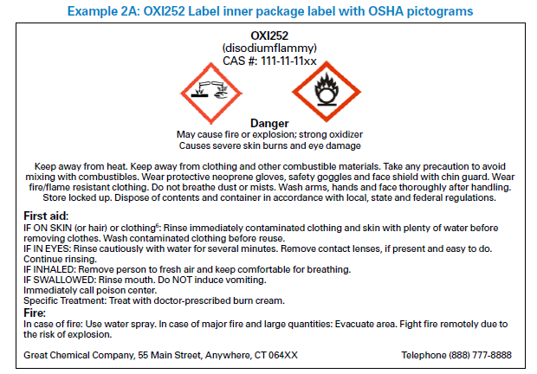

**Pictograms**

**Warning word**

**Manufacturer contact info**

**Emergency Instructions**

**Handling instructions**

**First Aid Instruction**

**Questions:**

1. What is the name of the system Shared Lab uses to store SDS?
2. MSDS online
3. Chemical list
4. 3eOnline
5. SDS online
6. Which one of the following is the icon for the system?

A  B  C 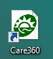 D 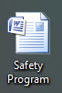

1. Where do you find the icon to this SDS system?
2. MyHealth online
3. LabQMS
4. S drive
5. Desktop
6. What are the username and password to log in to the system?
7. Employee ID and Network password
8. SHSL and SHSL
9. Network login and Network password
10. Kronos login and password
11. Tom, a new CLS, is about to work with Biolplex HSV-1 and HSV-2 IgG Reagent Pack and would like to know which chemicals he will be working with. Please help him find the three hazardous ingredients listed in Section 3 of SDS. Please submit printed SDS.
12. Sodium Azide, Methanol, Formalin
13. Glacial acetic acid, Formaldehyde, ethanol
14. Glycerol, ProClin 300 and Sodium azide
15. Glycerol, acetone, Perchloric acid
16. Tom is to store some bleach in a secondary container for cleaning purpose. Please help him label his bleach container with proper chemical label from the system that stores our SDSs. Which type of label will you print?
17. United States B. Canada C. GHS North America D. Europe
18. Why did you print this type of label?
19. We live in United States.
20. United States has adopted GHS and United States is in North America.
21. Our policies are very similar to Canada.
22. We follow European standards.
23. With the new GHS, what is the collective term for the symbols on chemical labels?
24. Pictographs
25. Pictures
26. Cartoons
27. Pictograms
28. With the new SDS format, the following will be included. Please identify the following.

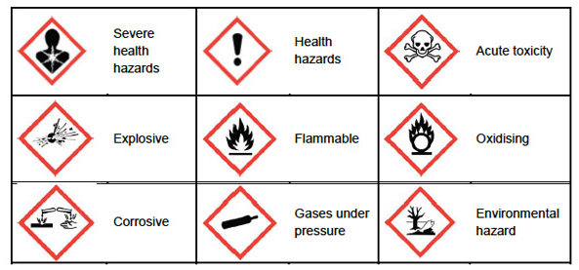

**Answer Key:**

1. 3eOnline
2. B
3. desktop
4. SHSL/SHSL
5. Glycerol, ProClin 300 and Sodium azide
6. C. GHS North America
7. United States has adopted GHS and United States is in North America
8. Pictorgrams
9. See next page

