MAY 2014 GRAM STAIN COMPETENCY

SLIDE ONE

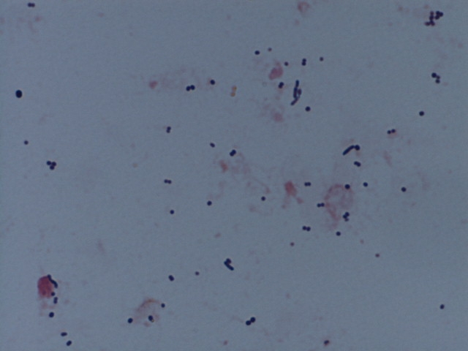

Gram Stain from an abdominal wound culture of a 58 yr old male.

