MAY 2014 GRAM STAIN COMPETENCY

SLIDE FIVE

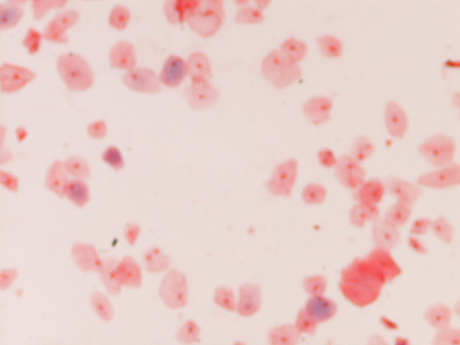

Gram Stain from a sputum culture of an 88 year old male.

LOW POWER FIELD

