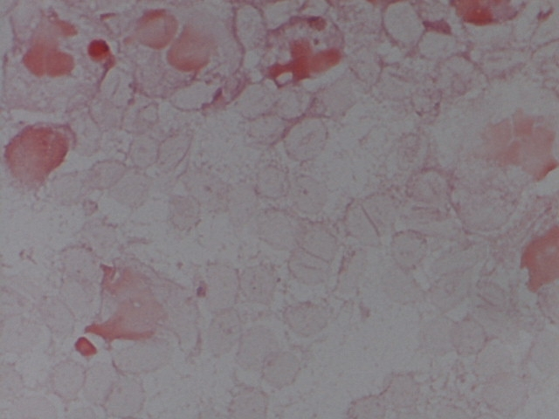

SLIDE FIVE

SOURCE: PERICARDIAL FLUID (CONCENTRATED)

