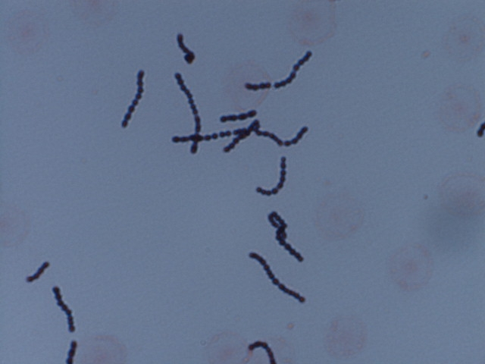

SLIDE ONE

SOURCE: BLOOD

Additional question to be answered on form:

This morphology type resembles what?

What test, if any, would be done next?

