**Competency Assessment for PPM –KOH Prep for Skin and Nails**

**2016**

[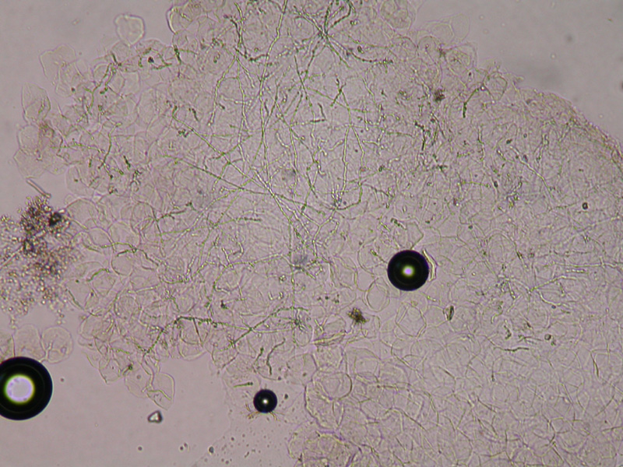](http://www.vgrd.org/archive/cases/2005/tinea/tinea.htm)

**Slide 1.**

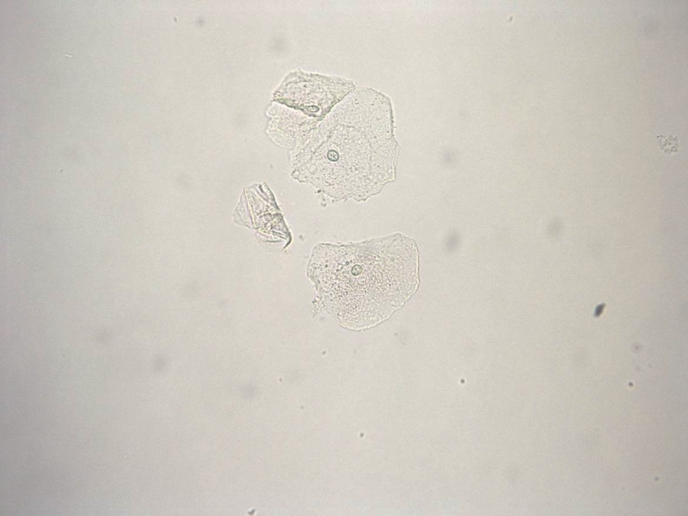

**Slide 2.**

[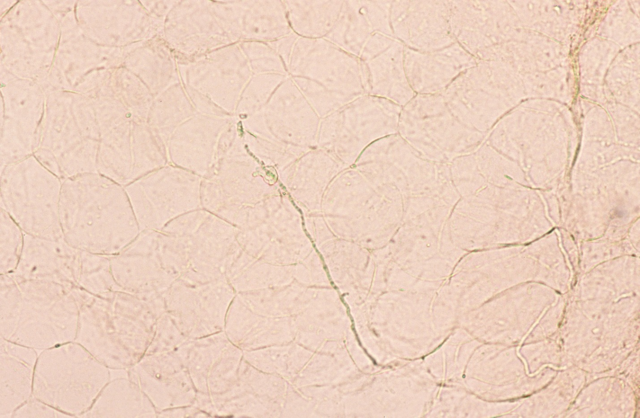](http://www.google.com/url?sa=i&rct=j&q=&esrc=s&source=images&cd=&cad=rja&uact=8&ved=0ahUKEwi9xOLf-MzMAhXJwj4KHUX3ByMQjRwIBw&url=http://www.regionalderm.com/Regional_Derm/Tfiles/tinea_corporis.html&psig=AFQjCNFo22T9IwX_NMfWJ3ICFjGSMj--Zw&ust=1462881572622402)

**Slide 3.**

[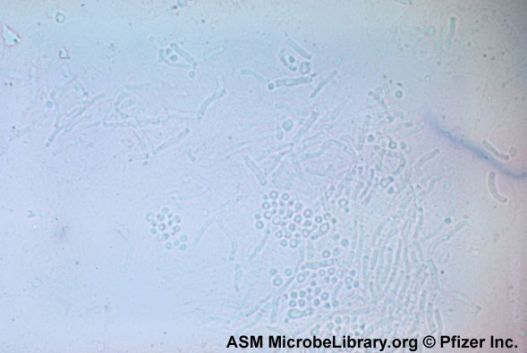](http://www.google.com/url?sa=i&rct=j&q=&esrc=s&source=images&cd=&cad=rja&uact=8&ved=0ahUKEwjD6O60tc3MAhUCET4KHVScBxcQjRwIBw&url=http://www.medical-labs.net/tinea-versicolor-caused-by-malassezia-furfur-infection-and-laboratory-diagnosis-2856/&psig=AFQjCNEeY8dmIrmV2UGdOQUI1QT6DcDnsw&ust=1462897748051795)

**Slide 4.**

**For each of the KOH Prep photographs above, indicate whether fungal elements or yeast are present by checking the appropriate box.**

**Photo 1.**  Fungal elements and/or yeast present.

 No fungal elements and/or yeast present.

**Photo 2.**  Fungal elements and/or yeast present.

 No fungal elements and/or yeast present.

**Photo 3.**  Fungal elements and/or yeast present.

 No fungal elements and/or yeast present.

**Photo 4.**  Fungal elements and/or yeast present.

 No fungal elements and/or yeast present.

**Date:** ________________ **Signature:** ____________________________________________________