1. Copy and paste this link to the address bar: <https://my.augusta.edu/pathology/clinical>
2. Sign in: 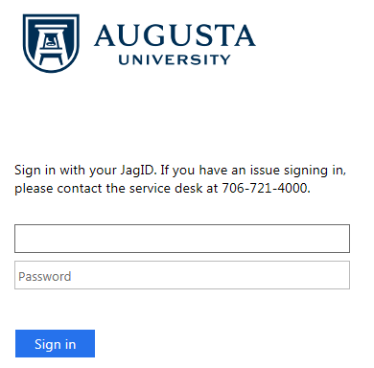
3. Choose: 
4. Choose the appropriate test procedure from the menu: 