True Metrix Pro (Blood Glucose Monitor)

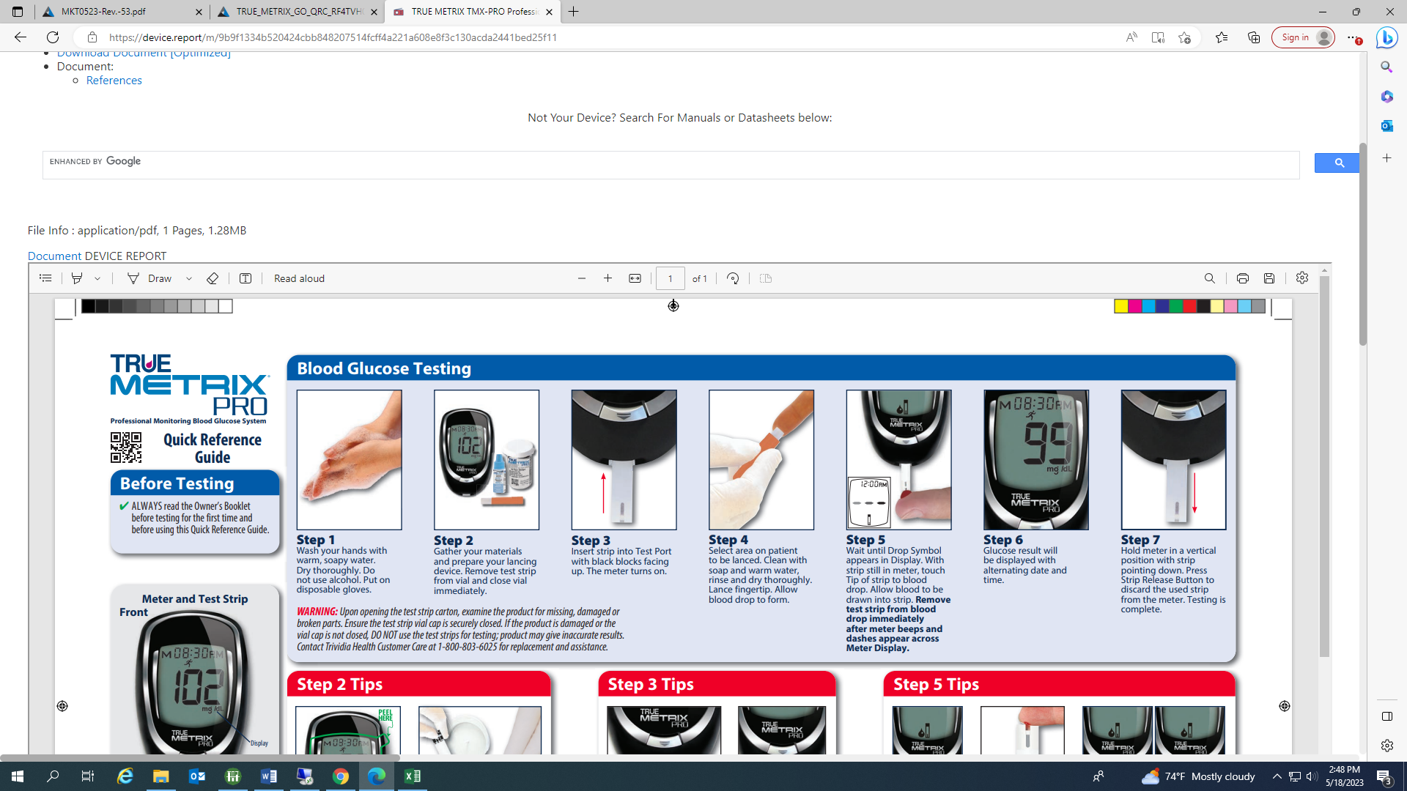

1. Insert test 2. Lance finger 3. Once drop 4. Glucose 5. Remove

Strip and allow appears on results will strip and

blood drop the display, appear in disinfect

to from allow the 4 seconds the meter

blood to be

drawn into

the strip

